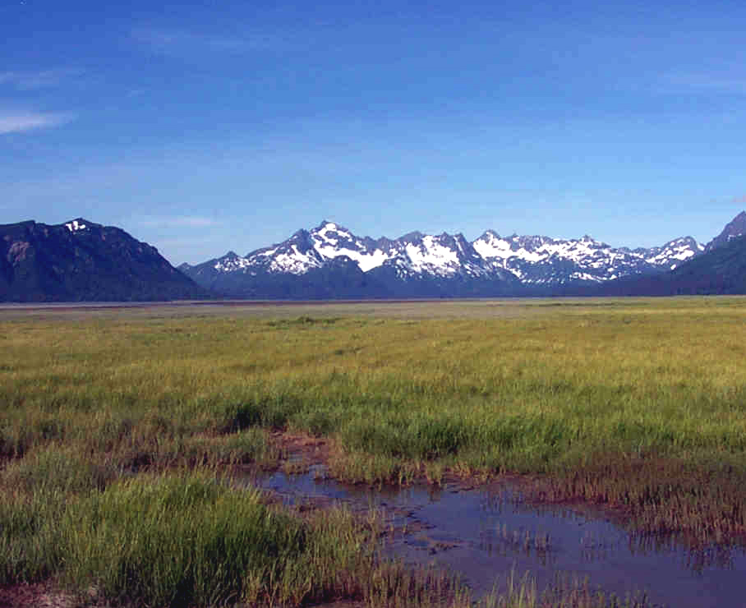

**Ducks Unlimited, Inc.**

**BLM-Alaska Technical Report 31**

BLM/AK/ST-02/009+6500+931

2002

**Kvichak**

**Earth Cover Classification**

U.S. Department of the Interior

Bureau of Land Management

**Mission Statement**

The Bureau of Land Management (BLM) sustains the health, diversity and productivity of the public lands for the use and enjoyment of present and future generations.

**Partners**

The Department of the Interior’s Bureau of Land Management and Ducks Unlimited, Inc. completed this project under a cooperative agreement.

**Cover**

The cover photo shows a portion of the Kvichak Project Area. It depicts the remoteness of the area and the need to use helicopters for data collection.

**Technical Reports**

Technical Reports issued by the Bureau of Land Management‑Alaska present the results of research, studies, investigations, literature searches, testing, or similar endeavors on a variety of scientific and technical subjects. The results presented are final, or are a summation and analysis of data at an intermediate point in a long‑term research project, and have received objective review by peers in the author’s field.

The reports are available while supplies last from BLM External Affairs, 222 West 7th Avenue, #13, Anchorage, Alaska 99513 (907) 271-3318 and from the Juneau Minerals Information Center, 100 Savikko Road, Mayflower Island, Douglas, AK 99824, (907) 364‑1553. Copies are also available for inspection at the Alaska Resource Library and Information Service (Anchorage), the United States Department of the Interior Resources Library in Washington, D. C., various libraries of the University of Alaska, the BLM National Business Center Library (Denver) and other selected locations.

A complete bibliography of all BLM‑Alaska scientific reports can be found on the Internet at:

http://www.ak.blm.gov/affairs/sci_rpts.html.

Related publications are also listed at: [**http://juneau.ak.blm.gov**](http://juneau.ak.blm.gov).

Kvichak

Earth Cover Classification

Technical Report

October 2002

U. S. Department of the Interior

Bureau of Land Management

Alaska State Office

222 W. 7th Ave., #13

Anchorage, AK 99513

Ducks Unlimited, Inc.

3074 Gold Canal Drive

Rancho Cordova,CA 95670

# Acknowledgements

This project was funded under a cooperative agreement between the United States Department of the Interior’s Bureau of Land Management (BLM), and Ducks Unlimited, Inc (DU). This project was administered by John Payne (BLM), and Beate Sterrenberg (Ducks Unlimited).

Special thanks are extended to those who worked in the field: Charlie Schrader-Patton (Spatial Solutions, Inc./DU), Jeff Denton (BLM), Scott Guyer (BLM), Alex Fehringer (DU), Dan Fehringer (DU) and Rebecca Strauch (State of AK). Thanks to Louis Drapeau from Evergreen Helicopters, for safe air service. Thanks also to Terry Hobbs and Scott Guyer (BLM) for coordinating field logistics and Bob McAlpin from Alaska Fire Service for help in coordinating helicopter contracting, Charlie Schrader-Patton for image processing, Mark Pearson (GoeNorth, Inc.) for programming the DUFF field database; and Jing Huang (DU) for programming the accuracy assessment program.

# Table of Contents

Acknowledgements iii

Table of Contents v

List of Figures vii

List of Tables ix

List of Tables ix

Abstract xi

Introduction 1

Project Objective 1

Project Area 2

Data Acquisition 3

Methods 5

Classification Scheme 5

Image preprocessing 5

Field Verification 7

Field Data Analysis 9

Classification 9

Accuracy Assessment 13

Results 17

Field Verification 17

Classification 17

Accuracy Assessment 23

Final Products 27

Summary 29

Literature Cited 31

Appendices 33

Appendix A. Alaska Earth Cover Classification Class Descriptions 33

Appendix B. Earth cover classification decision tree. 39

Appendix C. Plant species and cover type list. 43

Appendix D. Kvichak Accuracy Assessment Error Matrices 47

# List of Figures

Figure 1. Kvichak project location. 2

Figure 2. Satellite imagery used for the Kvichak earth cover mapping project. 3

Figure 3. Custom field data collection form. 8

Figure 4. The customized database and user interface for field data entry (DUFF). 10

Figure 5. The image processing flow diagram. 11

# List of Tables

**Table 1.** Classification scheme developed at the BLM Earth Cover Workshop. 6

**Table 2**. Field sites per mapped class 18

**Table 3**. List of field data collection participants. 18

**Table 4.** Acreage of earth cover classes within the project area. 22

# Abstract

The Bureau of Land Management (BLM) – Alaska and Ducks Unlimited, Inc. (DU) have been cooperatively mapping wetlands and associated uplands in Alaska using remote sensing and GIS technologies since 1988. The goal of this project was to continue the mapping effort by mapping the Kvichak project area, which contains Lake Iliamna and the lower portions of the Nushagak and Kvichak Rivers. Portions of four Landsat TM satellite scenes (Path 71, Rows 18, and 19, acquired 09/99; and Path 72, Rows 18 and 19, acquired 09/00) were used to classify the project area into 30 earth cover categories. An unsupervised clustering technique was used to determine the location of field sites and a custom field data collection form and digital database were used to record field information. A helicopter was utilized to gain access to field sites throughout the project area. Global positioning system (GPS) technology was used both to navigate to pre-selected sites and record locations of new sites selected in the field. Data were collected on 296 field sites during a 9-day field season from 7/1/00 through 7/9/00. Approximately 25% (64) of these field sites were set aside for accuracy assessment. A modified supervised/unsupervised classification technique was performed to classify the satellite imagery. The classification scheme for the earth cover inventory was based on Viereck et al. (1992)and revised through a series of meetings coordinated by the BLM – Alaska and DU. The overall accuracy of the mapping categories was 79.7% at the +/-5% level of variation in interpretation of the accuracy assessment reference sites.

# Introduction

The Bureau of Land Management (BLM) – Alaska and Ducks Unlimited, Inc. (DU) began cooperatively mapping wetlands and associated uplands in Alaska using remote sensing and GIS technologies in 1988 (Ritter et al. 1989). Early mapping projects focused exclusively on wetlands (Ritter et al. 1989) but it was apparent that mapping the entire landscape was more cost effective and ultimately more useful to land managers. The BLM is creating a satellite-based earth cover inventory of all BLM managed lands in Alaska. Many other agencies in Alaska (e.g., National Park Service, U.S. Fish and Wildlife Service, U.S. Forest Service, Alaska Department of Natural Resources, Alaska Department of Fish and Game) are also using similar techniques, and cooperating on these mapping projects. This earth cover mapping effort provides an inventory of Alaska’s land base that can be used for regional management of land and wildlife. Earth cover databases allow researchers, biologists, and managers to define and map crucial areas for wildlife; perform analysis of related habitats; detect changes in the landscape; plot movement patterns for large ungulates; generate risk assessments for proposed projects; and provide baseline data to which wildlife and sociological data can be related.

Landsat Enhanced Thematic Mapper (ETM) satellite imagery was chosen as the primary source for the BLM/DU earth cover mapping effort. Satellite imagery offered a number of advantages for region-wide projects. TM data was cost effective, processed using automated mapping techniques, and collected on a cyclical basis, providing a standardized data source for future database updates or change detection studies (Kempka et al. 1993). In addition, TM imagery included a mid-infrared band, which was sensitive to both vegetation and soil moisture content and was useful in identifying earth cover types. When combined with other GIS data sets, (e.g., elevation, slope, aspect, shaded relief, and hydrology), Landsat TM data produced highly accurate classifications with a moderately detailed classification scheme.

The Kvichak Earth Cover Mapping project area contained diverse landscapes and was deemed important for its wildlife and recreational values. The project area extended from the upper Chulitna River in the north, to the Naknek River and town of King Salmon in the south, to the Iniskin Peninsula and Chinitna Bay in the east, and west to Kvichak Bay. The project area entirely encompasses Lake Iliamna.

The project area was essentially un-roaded and supported remote recreational use with many hunting and fishing camps scattered throughout the area. These camps were accessed primarily via boat or plane. The project area included an abundant moose and tundra swan population, and large herds of caribou. The earth cover data aid in the critical process of resource planning in this valuable and diverse area.

## Project Objective

The objective of this project was to develop a baseline earth cover inventory using Landsat TM imagery for the Kvichak and associated areas. More specifically, this project purchased, classified, field verified, and produced high quality, high resolution digital and hard copy resource base maps. The result of this project was an integrated GIS database that can be used for improved natural resources planning.

## Project Area

The Kvichak mapping project consisted of 6.5 million acres centered roughly on Lake Iliamna, the largest freshwater lake in Alaska. The Kvichak River drains Lake Iliamna to the west into Kvichak Bay. The project area includes small portions of the Katmai and Lake Clark National Parks and it is contained on the following USGS 1:250 scale quadrangles: Dillingham, Naknek, Iliamna, and Lake Clark. The community of King Salmon is on the Naknek River in the southwest portion of the project area.

The project area encompassed a wide variety of environments ranging from glaciated mountains to lowland shrub-tundra complexes and tidal flats. Steep mountainous terrain with broad valleys comprised mostly of shrub and deciduous cover types were located to the east and north of Lake Iliamna. The eastern portion of the project area was comprised mostly of small shrub and lichen cover types. Many caribou and moose were observed in this area. Innumerable small lakes and ponds supported the pond lilies and other aquatic vegetation that make up an important summer food source for breeding tundra swans. Brown bears were observed primarily in the western portion of the study area, particularly on the tidal marshes. With the imagery acquisition dates of July 1999, and July 2000 most all wildfires that had burned over the study area were indicated on the 1999 satellite imagery.

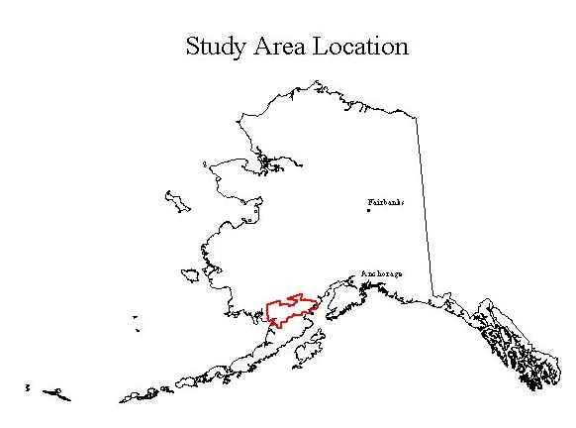

**Figure 1.** Kvichak project location.

## Data Acquisition

Four Landsat-7 ETM scenes were obtained to cover the project area. Imagery from Sept, 1999 were acquired from the BLM (Path 71 Rows 18 and 19) and two scenes were purchased from EROS Data Center in Albers Equal Area projection and were terrain corrected by ImageLinks, Inc., Melbourne, FL (Path 72 Rows 18 and 19 – Sept 2000). The image data contained moderate cloud cover in two or three general locations in the project area. The imagery shows abundant snow and ice in the northeast part of the project area, despite the late summer acquisition date.

Field data were collected on 296 field sites during an 8-day field season from 7/1/01through 7/9/01. The ancillary data used in this project included: 1:60,000 aerial photographs (color infrared transparencies from 1978-94, USGS 1:250,000 scale Digital Elevation Models (DEM), and training site data from a land classification effort in 1992.

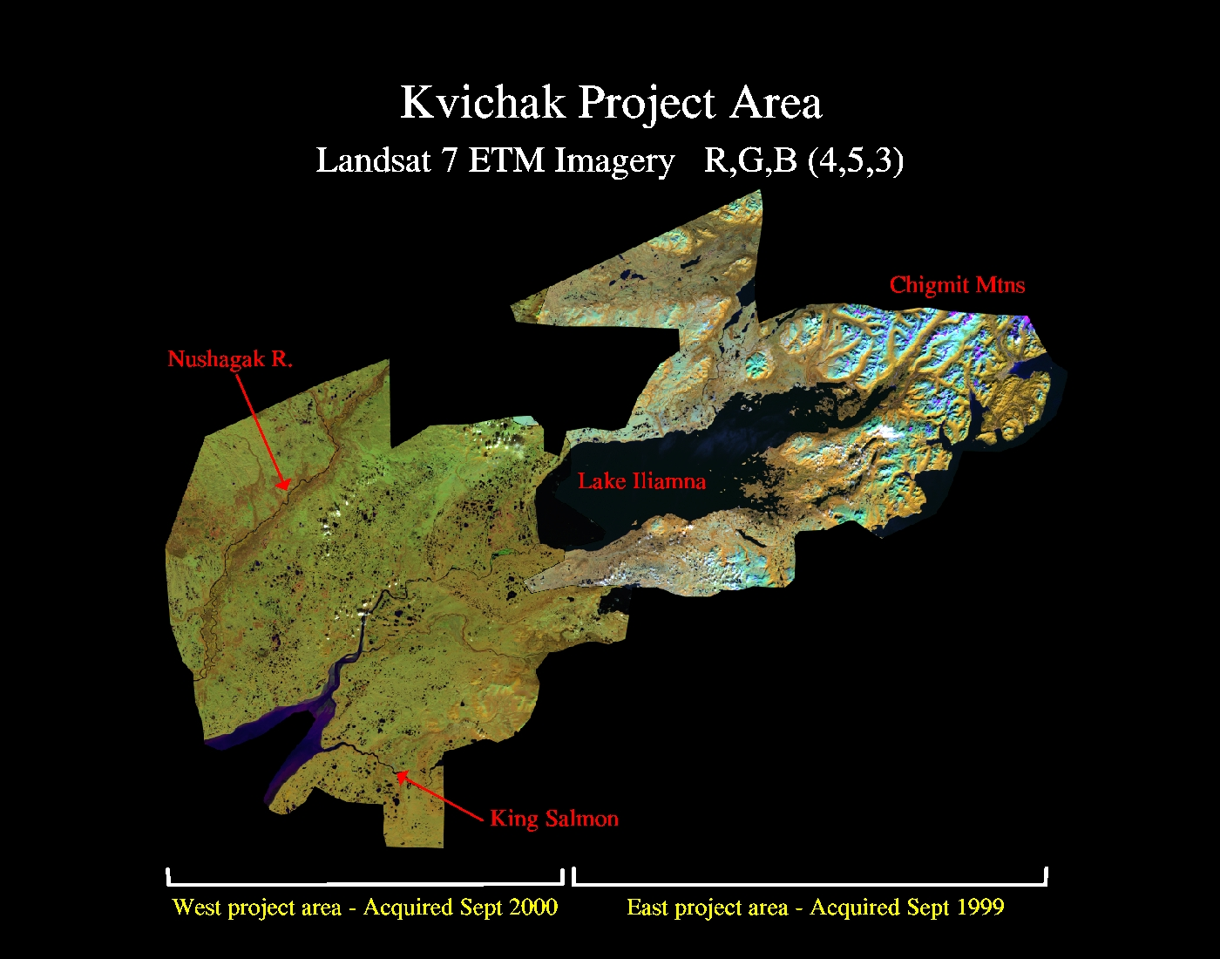

**Figure 2.** Satellite imagery used for the Kvichak earth cover mapping project.

# Methods

## Classification Scheme

The classification system categorized the features to be mapped. The system was derived from the anticipated uses of the map information and the features of the earth that could be discerned by TM data. The classification system had two critical components: (1) a set of labels (e.g., forest, shrub, water); and (2) a set of rules, or a system for assigning labels. The set of rules for assigning labels was mutually exclusive and totally exhaustive (Congalton 1991). Any given area fell into only one category and every area was to be included in the classification.

Until recently, the BLM/DU classification systems were project specific. As projects expanded in size and as other cooperators began mapping and sharing data across Alaska, the necessity for a standardized classification system became apparent. At the BLM Earth Cover Workshop in Anchorage on 3-6 March 1997, a classification system based on the existing Alaska Vegetation Classification (Viereck et al. 1992) (Table 3) was designed to address this need. The goal of this meeting was to (1) develop an earth cover classification system for the state of Alaska that can be used in large regional mapping efforts, and (2) build consensus for the system among multiple land management agencies. The classification system has been slightly improved since the last meeting.

The classification scheme consisted of 10 major categories and 27 subcategories. A classification decision tree and written description (Appendices A and B) was developed in order to clarify the classification. Though based largely on Level III of the Viereck et al. (1992) classification, some classes have been modified, added or omitted for these mapping projects: e.g., rock, water, ice, cloud and shadow classes were added. Other classes that could not reliably be discerned from satellite imagery had to be collapsed, such as open and closed low shrub classes, or dryas, ericaceous, willow, and dwarf shrub classes. Because of the importance of lichen for site characterization and wildlife, and because the presence of lichen can be detected by satellite imagery, shrub and forested classes with and without a component of lichen were distinguished. A few classes from Level IV of the Viereck et al. (1992) classification were also mapped because of their identifiable satellite signature and their importance for wildlife management. These Level IV classes included tussock tundra, low shrub tussock tundra and low shrub willow/alder.

## Image preprocessing

Each image was examined for quality and consistency. Each band was examined visually and statistically by reviewing histograms. Combinations of bands were displayed to check for band-to-band registration and for clouds, shadows, and haze. Positional accuracy was checked by comparing the image to available ancillary data such as adjacent imagery, hydrography, and DEMs. The images of the same date and path were mosaiced together and clipped

**Table 1.** Classification scheme developed at the BLM Earth Cover Workshop.

|  |  |  |
| --- | --- | --- |
| Level II | Level III | Level IV |
| 1.0 Forest | 1.1 Closed Needleleaf |  |
|  | 1.2 Open Needleleaf | 1.21Open Needleleaf Lichen |
|  | 1.3 Woodland Needleleaf | 1.31 Woodland Needleleaf Lichen |
|  |  |  |
|  | 1.4 Closed Deciduous | 1.41 Closed Paper Birch |
|  |  | 1.42 Closed Aspen |
|  |  | 1.43 Closed Balsam Poplar/Cottonwood |
|  |  | 1.44 Closed Mixed Deciduous |
|  | 1.5 Open Deciduous | 1.51 Open Paper Birch |
|  |  | 1.52 Open Aspen |
|  |  | 1.53 Open Balsam Poplar/Cottonwood |
|  |  | 1.54 Open Mixed Deciduous |
|  |  |  |
|  | 1.6 Closed Mixed Needleleaf/Deciduous |  |
|  | 1.7 Open Mixed Needleleaf/Deciduous |  |
|  |  |  |
| 2.0 Shrub | 2.1 Tall Shrub |  |
|  | 2.2 Low Shrub | 2.21 Low Shrub Willow/Alder |
|  |  | 2.22 Low Shrub Tussock Tundra |
|  |  | 2.23 Low Shrub Lichen |
|  |  | 2.24 Low Shrub Other |
|  |  |  |
|  | 2.3 Dwarf Shrub | 2.31 Dwarf Shrub Lichen |
|  |  | 2.32 Dwarf Shrub Other |
|  |  |  |
| 3.0 Herbaceous | 3.1 Bryoid | 3.11 Lichen |
|  |  | 3.12 Moss |
|  |  |  |
|  | 3.2 Wet Herbaceous | 3.21Wet Graminoid |
|  |  | 3.22 Wet Forb |
|  |  |  |
|  | 3.3 Mesic/Dry Herbaceous | 3.31 Tussock Tundra |
|  |  | 3.32 Mesic/Dry Sedge Meadow |
|  |  | 3.33 Mesic/Dry Grass Meadow |
|  |  | 3.34 Mesic/Dry Graminoid |
|  |  | 3.35 Mesic/Dry Forb |
|  |  |  |
| 4.0 Aquatic Vegetation | 4.1 Aquatic Bed |  |
|  | 4.2 Emergent Vegetation |  |
|  |  |  |
| 5.0 Water | 5.1 Snow |  |
|  | 5.2 Ice |  |
|  | 5.3 Clear Water |  |
|  | 5.4 Turbid Water |  |
|  |  |  |
| 6.0 Barren | 6.1 Sparsely Vegetated |  |
|  | 6.2 Rock/Gravel |  |
|  | 6.3 Mud/Silt/Sand |  |
| 7.0 Urban |  |  |
|  |  |  |
| 8.0 Agriculture |  |  |
|  |  |  |
| 9.0 Cloud/Shadow | 9.1 Cloud |  |
|  | 9.2 Shadow |  |
| 10.0 Other |  |  |

to the project boundary. Due to differences in target and sensor conditions, it is not recommended to mosaic and process imagery acquired on different dates. Because we used imagery from Sept 99 for the east part of the project area, and imagery from Sept 2000 for the west part of the project area, we had two separate classification efforts to cover the project area - east and west. A boundary line between the east and west areas was carefully digitized to maximize use of cloud free parts of each raw image.

In order to optimize helicopter efficiency, field sites were identified and plotted on field maps before fieldwork began. Sufficient samples for each mapped class were selected to span the variation of spectral responses within that class throughout the entire image. For example, a shrub class in the southern part of an image may have a different spectral response than the same shrub class in the northern part of that image. Many factors contribute to such variation, including aspect, terrain shadow, or small differences in soil moisture. In addition, each earth cover type encompassed a variety of subtypes; e.g., the open needleleaf class included forested areas with 25%-60% crown closure, trees of varying height, and a diverse understory composition.

An unsupervised classification was used to identify spectrally unique areas within the study area. The image analyst individually selected training sites from these spectrally unique areas. Whenever possible, training sites were grouped in clusters to reduce the amount of travel time between sites. The image analyst also placed training sites near landmarks that were easily recognizable in the field, such as lakes or streams. The coordinates of the center points of the field sites were then uploaded into a Y-code Rockwell Precision Lightweight GPL receiver (PLGR) for navigational purposes. Training sites were overlain with the satellite imagery and plotted at 1 inch = 1 mile scale. These field maps were used for recording field notes, placing additional field sample sites, and navigating to field sites.

## Field Verification

The purpose of field data collection was to assess, measure, and document the on-the-ground vegetation variation within the project area. This variation was correlated with the spectral variation in the satellite imagery during the image classification process. Low-level helicopter surveys were a very effective method of field data collection since a much broader area was covered with an orthogonal view from above, similar to a satellite sensor. In addition, aerial surveys were often the only alternative in Alaska due to the large amount of roadless areas.

In order to obtain a reliable and consistent field sample, a custom field data collection form (Kempka et al. 1994) was developed and used to record field information (Figure 3). A four-person helicopter crew performed the field assessment. Each crew consisted of a pilot, biologist, recorder, and navigator.. The navigator operated the GPS equipment and interpreted the satellite image derived field maps to guide the biologist to the pre-defined field site. It was valuable for the image processor to gain first-hand knowledge of the project area, so therefore the image processor had the navigator role. The biologist identified plant species, estimated the percent cover of each cover type, estimated the overall earth cover class, and photographed the site. The recorder wrote species percentages and other data on

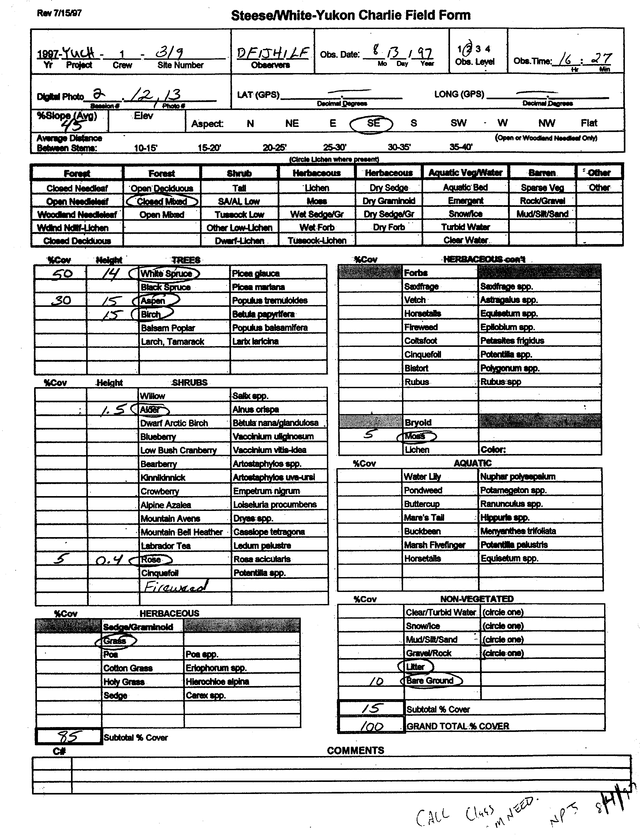

**XXXX**

**XXX**

**Sample Field Form**

**Figure 3**. Custom field data collection form.

the field form and generally assisted the biologist. An alternate person was responsible for crew check-ins, data entry, and substitution in case of sickness. This person remained at the base of operations. The majority of sites were observed without landing the helicopter. Ground verification was performed when identification of dominant vegetation was uncertain.

These DU/BLM procedures for collecting field data have evolved into a very efficient and effective means of data collection. The navigator used a GPS to locate the site and verified the location on the field map. As the helicopter approached the site at about 300 meters above ground level the navigator described the site and the biologist took a picture with a digital camera. The pilot then descended to approximately 5-10 meters above the vegetation and laterally moved across the site while the biologist called out the vegetation to the recorder. The biologist took another picture with the digital camera for a close-up view of the site. The pilot then ascended to approximately 100 meters so that the biologist could estimate the percentages of each species to the recorder. The navigator then directed the pilot to the next site. On average, it took approximately 4-6 minutes to collect all of the information for one site.

## Field Data Analysis

The collected field information was entered into a digital database using a custom data entry application (DUFF), designed jointly by the BLM and DU and programmed by GeoNorth. The relational database was powered by SQL Anywhere while the user interface was programmed in Visual Basic. The user interface was organized similarly to the field form to facilitate data entry (Figure 4). The application utilized pull down menus to minimize keystrokes and checked for data integrity to minimize data entry errors. The database program also calculated an overall class name for each site based on the recorded species and its cover percentage. Digital images from each site were stored in the database and accessible from within the user interface. The number of field sites per earth cover class was tracked daily to ensure that adequate samples were being obtained within each class.

## Classification

Every image is unique and presents special problems in the classification process. The approach used in this project (Figure 5) has been proven successful over many years. The image processor was actively involved in the field data collection and had first hand knowledge of every training site. The image processor’s site-specific experience and knowledge in combination with high quality ancillary data overcame image problems to produce a high quality, useful product.

ERDAS Imagine (vers. 8.5) was used to perform the classification as well as to manage the field site polygons. Various word processing and data analysis software packages were also used during the image classification including MS Word, Excel, Access, and ESRI ArcView 3.2a.

Generation of New Bands

The Landsat TM imagery contained 7 bands of data: 3 visible bands, 1 near-infrared band, 2 mid-infrared bands, and 1 thermal band. One new band was generated for this project. This new band was created using a band-4/band-3 ratio, a band ratio that typically reduces the effect of shadows in the image and enhances the differences between

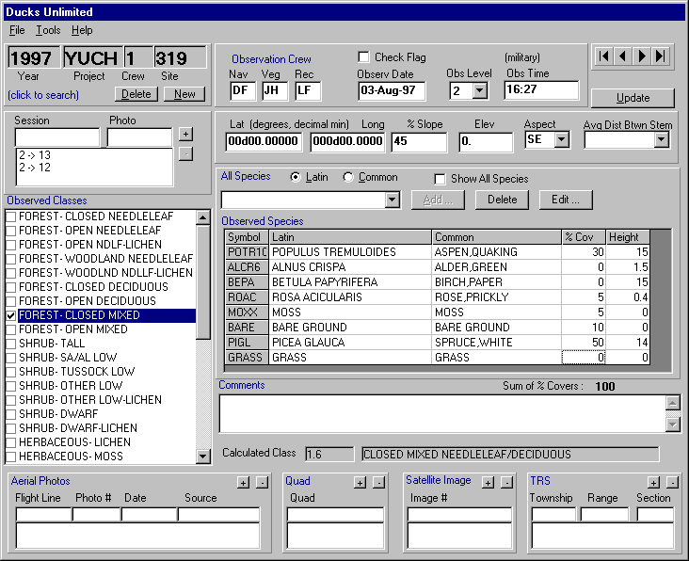

**XXXX**

XXX

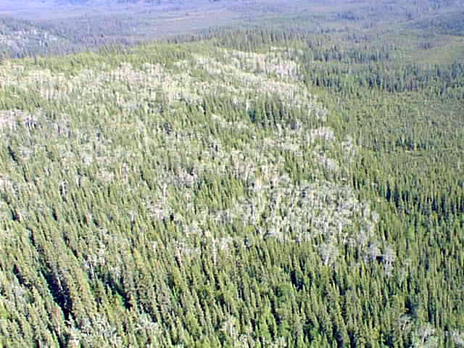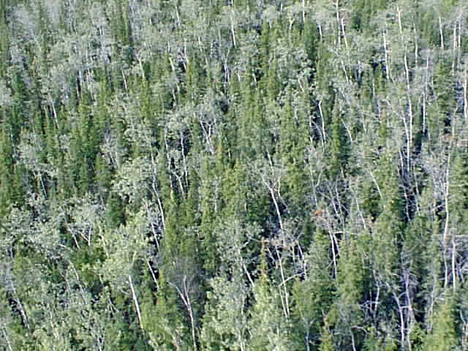 **Sample Field Site – Closed Mixed Needleleaf/Deciduous**

**High site photo Low site photo**

**DUFF INTERFACE**

**Figure 4.** The customized database and user interface for field data entry (DUFF).



**Figure 5.** The image processing flow diagram.

vegetation types (Kempka et al. 1995, Congalton et al. 1993). This 4/3 ratio band replaced thermal band (band 6) to retain a 7-band image for classification.

Removal of Clouds and Shadows

The majority of clouds and cloud shadows that were present on the imagery were removed from before field sites were selected. This process eliminated any confusion between clouds, cloud shadows, and other vegetation types. They were removed using an unsupervised classification and manual on-screen editing. Clouds were separated from shadows and classes were recoded to their respective class number. The cloud/shadow layer is then combined with the rest of the classified image during the last step in the classification process.

Seeding Process

Spectral signatures for the field sites to be used as training areas were extracted from the imagery using a “seeding” process in ERDAS Imagine. A pixel within each training area was chosen as a “seed” and adjoining pixels were evaluated for inclusion in each training site using a threshold value based on a spectral euclidean distance. The standard deviations of the seeded areas were kept close to or below 3 and all seeded areas were required to be over 15 pixels (approximately 3.75 acres) in size. Along with the field training areas, additional “seeds” were generated for clear water, turbid water, and snow classes. These classes were easily recognized on the imagery and aerial photography. The output of the seeding process in Imagine was a signature file that contains all of the statistics for the training areas. The signature file was then used in the modified supervised/unsupervised classification.

Generation of Unsupervised Signatures

An unsupervised classification was generated using the six raw bands and the 4/3 ratio. One hundred and fifty signatures were derived from the unsupervised classification using the ISODATA program in Imagine. The output of this process was a signature file similar to that of the seeding process but containing the 150 unsupervised signatures. A maximum likelihood classification of the 150 unsupervised signatures was generated using the supervised classification program in Imagine.

Modified Supervised/Unsupervised Classification

A modified supervised/unsupervised classification approach (Chuvieco and Congalton 1988) was used for the classification. This approach used a statistical program to group the spectrally unique signatures from the unsupervised classification with the signatures of the supervised training areas. In this way, the spectrally unique areas were labeled according to the supervised training areas. This classification approach provided three major benefits: (1) it aided in the labeling of the unsupervised classes by grouping them with known supervised training sites; (2) it helped to identify classes that possessed no spectral uniqueness (i.e., training sites that were spectrally inseparable); and (3) it identified areas of spectral reflectance present in the imagery that had not been represented by a training site. This approach was an iterative process because all of the supervised signatures do not cluster perfectly with the unsupervised signatures the first time. The unsupervised signatures that matched well with the supervised signatures were inspected, labeled with the appropriate class label, and removed from the classification process. The remaining confused clusters were grouped into general categories (e.g., forest, shrub, non-vegetation) and re-run through the process. This process was repeated until all of the spectral classes were adequately matched and labeled, or until the remaining confused classes were spectrally inseparable. Throughout this iterative process, interim checks of classification accuracy were performed by intersecting the classified image with a coverage of the training sites to determine if the training sites were being accurately labeled by the classification. Areas with incorrectly classified training sites were run through further iterations of the supervised/unsupervised classification and further refined. The iterative process of interim accuracy assessments and refining classifications was terminated when the accuracy assessments indicated no improvements between one iteration and the next.

### Editing and Modeling

Models that incorporated ancillary data sets such as elevation, slope, aspect, shaded relief, etc. helped to separate confused classes. For instance, terrain shadow/water confusion was easily corrected by creating a model using a shaded relief layer derived from DEMs.

For this project, the final steps of the classification process were to model the confused classes remaining after the iterative supervised/unsupervised classification process and to make final edits in areas that still had classification errors. Editing of classification errors was a process of comparing the classified image to the raw satellite image, aerial photography, and notes on field maps to identify errors remaining in the classification. These errors were then corrected by manually changing the class value for the pixels that were classified in error to their correct class value.

## Accuracy Assessment

There were two primary motivations for accuracy assessment: (1) to understand the errors in the map (so they can be corrected), and (2) to provide an overall assessment of the reliability of the map (Gopal and Woodcock, 1992). Factors affecting accuracy included the number and location of test samples and the sampling scheme employed. Congalton (1991) suggested that 50 samples be selected for each map category as a rule of thumb. This value has been empirically derived over many projects. A second method of determining sample size includes using the multinomial distribution and specifying a given confidence in the estimate (Tortora 1978). The results of this calculation tend to favorably agree with Congalton’s rule of thumb. Once a sample size is determined, it must be allocated among the categories in the map. A strictly proportional allocation is possible. However, the smaller categories in areal extent will have only a few samples that may severely hamper future analysis. The other extreme is to force a given number of samples from each category. Depending on the extent of each category, this approach can significantly bias the results. Finally, a sampling scheme must be selected. A purely random approach has excellent statistical properties, but is practically difficult and expensive to apply. A purely systematic approach is easy to apply, but could result in sampling from only limited areas of the map.

Alaska Perspective

Obtaining adequate reference data for performing an accuracy assessment can be extremely expensive in remote areas. Aircraft is the only means of transportation throughout most of Alaska. Aerial photographs are available for most of Alaska, but most are at a scale that makes it difficult if not impossible to distinguish some vegetation classes. Ideally, fieldwork would be performed during one summer, the classification would be performed during the winter, and the reference data would be collected the next summer. This procedure would allow a stratified random sample of the classification and ensure adequate sampling of all the classes. Unfortunately, this methodology is not typically feasible due to the cost of obtaining the field data in Alaska.

In this project, the fieldwork for obtaining the training sites for classifying the imagery and the reference data for the accuracy assessment was accomplished at the same time. Special care was taken during the preprocessing stage and in the field to make sure adequate samples were obtained. However, funding limitations did not allow for the number of samples suggested for each class (n=50) for the accuracy assessment. Some earth cover classes were naturally limited in size and distribution, so that a statistically valid accuracy assessment sample could not be obtained without additional field time. For classes with low sample sizes few, if any, field sites were withheld for the accuracy assessment. This does not indicate that the classification for these types is inaccurate but rather that no statistically valid conclusions can be made about the accuracy of these classes. However, withholding even a small percentage of sites for the accuracy assessment provided some confidence in the classification and guided the image processor and end user in identifying areas of confusion in the classification.

Selection of Accuracy Assessment Sites

Approximately 30% of the collected field sites were set aside for use in the assessment of map accuracy while the remaining sites were utilized in the classification process. Unfortunately, given time and budget constraints it was not always possible to obtain enough sites per class to perform both the classification and a statistically valid accuracy assessment. A minimum of 15 sites in an individual class (5 for accuracy assessment, 10 for image processing training sites) was required before any attempt was made to assess the accuracy of that class. Classes with less than 15 field sites were still classified. However, much fewer, if any, field sites were utilized for accuracy assessment for these classes. Accuracy assessment sites were selected randomly across the project area to reduce bias.

Some Considerations

While the accuracy assessment performed in this project is by no means a robust test of the classification, it does give the user some confidence in using the classification. It also provides enough detail for the end user to determine where discrepancies in the classification may cause a problem while using the data. It is also important to note the variations in the dates of the imagery, aerial photographs, and field data. For this project, the imagery was from September, 1999 and September 2000; the aerial photographs spanned a six year period from 1978 through 1984, the field data was collected in June/July 2000. Differences due to environmental changes from the different sources may have had a major impact on the accuracy assessment.

A major assumption of quantitative accuracy assessments is that the label from the reference information represents the “true” label of the site and that all differences between the remotely sensed map classification and the reference data are due to classification and/or delineation error (Congalton and Green 1993). Unfortunately, error matrices can be inadequate indicators of map error because they are often confused by non-map error differences. Some of the non-map errors that can cause confusion are: registration differences between the reference data and the remotely sensed map classification, digitizing errors, data entry errors, changes in land cover between the date of the remotely sensed data and the date of the reference data, mistakes in interpretation of reference data, and variation in classification and delineation of the reference data due to inconsistencies in human interpretation of vegetation.

In an effort to account for some of the variation in human interpretation in the accuracy assessment process, overall classification accuracies were also generated assuming a +/- 5% variation in estimation of vegetation compositions for each of the accuracy assessment sites. In other words, if a variation in interpretation of +/- 5% would have resulted in the generation of a different reference site label, this new label was also considered an acceptable mapping label for the reference site.

Error Matrix

The standard method for assessing the accuracy of a map was to build an error matrix, also known as a confusion matrix, or contingency table. The error matrix compares the reference data (field site or photo interpreted site) with the classification. The matrix was designed as a square array of numbers set out in rows and columns that expressed the number of sites assigned to a particular category in the reference data relative to the number of sites assigned to a particular category in the classification. The columns represented the reference data while the rows indicated the classification (Lillesand and Kiefer, 1994). An error matrix was an effective way to represent accuracy in that the individual accuracy of each category was plainly described along with both the errors of inclusion (commission errors) and errors of exclusion (omission errors) present in the classification. A commission error occurred when an area was included in a category it did not belong. An omission error was excluding that area from the category in which it did belong. Every error was an omission from the correct category and a commission to a wrong category. Note that the error matrix and accuracy assessment was based on the assumption that the reference data was 100% correct. This assumption was not always true.

In addition to clearly showing errors of omission and commission, the error matrix was used to compute overall accuracy, producer’s accuracy, and user’s accuracy (Story and Congalton 1986). Overall accuracy was allocated as the sum of the major diagonal (i.e., the correctly classified samples) divided by the total number of samples in the error matrix. This value is the most commonly reported accuracy assessment statistic. Producer’s and user’s accuracies are ways of representing individual category accuracy instead of just the overall classification accuracy. Producer’s accuracy, or error of commission, is the probability that any given site has been correctly classified. User’s accuracy, or error of omission , is regarded as the reliability of the map in representing actual ground conditions. Users accuracy is generally regarded as being more pertinent to land managers, who often use the data to represent ground conditions for various analyses (Story and Congalton, 1986).

# 

# Results

## Field Verification

Data were collected on 296 field sites during a 9-day field season from 7/1/01 through 7/11/01, 132 sites in the east project area, and 164 sites in the west project area. We attempted to meet the 30% sample goal for selecting accuracy assessment sites, unfortunately many landcover classes contained too few sites. 22% (64 sites) were set aside for the accuracy assessment. The proportions of sites per class (Table 2) largely reflects the proportion of corresponding earth cover types within the project area, though proportionally more sites were collected for classes that exhibited greater variation in growth form and/or spectral response on the satellite imagery.

A French A-Star helicopter was used to gain access to the field sites. Two field camp locations were utilized during the field data collection of this project. A bed and breakfast in the village of Iliamna served as the staging area for the field crew, helicopter, field equipment during field work for the east project area. Fuel was obtained from the local vendor at the Iliamna airport. The field camp location for the west project area was the USFWS bunkhouse in King Salmon. Fuel was obtained at the King Salmon airport. Flight following was carried out by the alternate via satellite phone from both field camp locations.

## Classification

The three most extensive vegetated classes within the final classification were: dwarf shrub (698,483 acres or 10.76% of total area), low shrub (625,079 acres or 9.63% or total area), and tall shrub (542,102 acres or 8.35% of total area). In addition, extensive areas of low shrub lichen (467,074 acres or 7.20% of total area) and dwarf shrub lichen (341,063 acres or 5.25% of total area) were present throughout the study area. Large expanses of low shrub/dwarf shrub/grass complexes interspersed with open needleleaf were typical of the west project area. Tall shrub/mixed deciduous cover types with the occasional pure needleleaf stand characterize the east project area. In the mountainous northeast part of the project area, the valley bottoms contained primarily tall shrub. With increasing elevation, low shrub and dwarf shrub become the dominant cover types followed by sparse vegetation and rock of the ridge tops. The distribution of these types is characterized in Table 4 and Figure 7. Stands of closed needleleaf were found on low to mid elevation north facing slopes in the east project area. Closed birch and poplar were found throughout the project area but only formed extensive stands in riparian areas. No stands of aspen were mapped in the project area. Unfortunately, no consistent, reliable spectral signature could be derived for these often scattered and smaller stands of aspen. Cover types that contained at least 20% lichen were widespread throughout the project area, with the exception of the northeast corner where they occurred at upper elevations only.

**Table 2**. Field sites per mapped class

|  |  |  |
| --- | --- | --- |
| Class Name | Total Field  Sites per Class | Sites Withheld for  Accuracy Assessment |
| WOODLAND NEEDLELEAF – LICHEN | 13 | 3 |
| WOODLAND NEEDLELEAF | 7 | 0 |
| WET SEDGE / GRAMINOID | 14 | 3 |
| TUSSOCK TUNDRA | 8 | 2 |
| TALL SHRUB | 38 | 10 |
| SPARSE VEGETATION | 6 | 1 |
| ROCK GRAVEL | 2 | 0 |
| OTHER | 1 | 0 |
| OPEN POPLAR | 1 | 0 |
| OPEN NEEDLELEAF – LICHEN | 4 | 0 |
| OPEN NEEDLELEAF | 13 | 4 |
| OPEN MIXED NEEDLELEAF / DECIDUOUS | 17 | 2 |
| OPEN DECIDUOUS | 5 | 0 |
| NON-VEGETATED SOIL | 2 | 0 |
| MOSS | 6 | 1 |
| MESIC/DRY SEDGE MEADOW | 6 | 1 |
| MESIC/DRY GRASS MEADOW | 8 | 2 |
| MESIC / DRY GRAMINOID | 3 | 0 |
| MESIC / DRY FORB | 1 | 0 |
| LOW SHRUB WILLOW/ALDER | 1 | 0 |
| LOW SHRUB – TUSSOCK TUNDRA | 7 | 2 |
| LOW SHRUB – OTHER | 26 | 7 |
| LOW SHRUB – LICHEN | 12 | 4 |
| LICHEN | 2 | 0 |
| EMERGENT VEGETATION | 1 | 0 |
| DWARF SHRUB – OTHER | 30 | 7 |
| DWARF SHRUB – LICHEN | 27 | 7 |
| CLOSED POPLAR | 1 | 0 |
| CLOSED MIXED NEEDLELEAF / DECIDUOUS | 11 | 5 |
| CLOSED DECIDUOUS | 10 | 2 |
| CLOSED BIRCH | 7 | 1 |
| OPEN BIRCH | 6 | 0 |
| **TOTAL** | **296** | **64** |

**Table 3**. List of field data collection participants.

|  |  |  |
| --- | --- | --- |
| Participant | Role | Agency |
| Scott Guyer | Biologist/Vegetation Expert | BLM |
| Jeff Denton | Biologist/Vegetation Expert | BLM |
| Alex Morton | Recorder/Alternate | DU |
| Dan Fehringer | Recorder/Alternate | DU |
| Becky Strauch | Recorder/Alternate | State of AK |
| Charlie Schrader-Patton | Navigator/Image Processor | DU – Spatial Solutions, Inc. |

These lichen cover types accounted for over 13% of the project area. Differentiating between wet and dry graminoid proved to be difficult as the moisture and water level conditions visible on the satellite imagery and those observed in the field in 2001 in many of the forb/graminoid types appeared highly variable. Unfortunately, the class label for a given training site polygon is very sensitive to the presence of as little as 5% water. For instance, an area on the satellite imagery that appeared to contain 5-10% standing water was found to be almost dry during field reconnaissance. This discrepancy between the imagery and field conditions often resulted in a “dry” label for the polygon when the satellite image clearly portrayed the area as containing substantial amounts of water. As a result, there was initial confusion between forb/graminoid regions being classified as dry when there was obvious presence of standing water visible in the satellite imagery. There also was a tendency for these regions to be classified with lots of needleleaf, since needleleaf has relatively low reflectance values similar to water. Rock and sparse vegetation cover types were found mostly at the highest elevations, along stream and riverbanks and sandbars. Significant, mappable regions of snow and ice were found in the northeast part of the study area.. Snowfields were generally more extensive during field reconnaissance than on the imagery. Clouds were scattered in a number of locations throughout the project area; they accounted for .71% (206,427 acres) of the project area. These clouds and associated shadows were carefully edited to reduce committed errors caused by attenuated reflectance.

Modeling

Modeling was performed using a shaded relief image and an elevation zone image derived from USGS DEM at 1:250,000 scale. The shaded relief image was created in ERDAS Imagine using the solar azimuth and solar elevation listed in the header file for the TM image. The DEM was often used to help separate spectrally confused classes like terrain shadow and deep water. Elevation images were also used to model cover types that were slope, aspect or elevation limited. While these slope, aspect, and/or elevation limitations did provide good consistent measures for correcting misclassifications throughout the study area, they are not always to be trusted to represent actual vegetation occurrence 100% of the time. Therefore, careful manual confirmation of model results were performed and anomalies corrected following the execution of each spatial model.

Modeling was primarily used to identify misclassified areas. Since water, wet graminoid, needleleaf forest and shadow have similar spectral signatures these classes were often confused. Water obviously did not occur on a slope, but terrain shadows did, so a slope based model was used to search out shadowed areas that had been misclassified as water or wet graminoid. Tussock tundra signatures were confused with dwarf shrub, but unlike dwarf shrub, tussock tundra will not occur at higher elevations or on steep slopes. Modeling was also used to check for terrain shadow at higher elevations that had been misclassified as forest.

It is important to note that the modeling process was used primarily to identify *potentially* misclassified cover types throughout the study area. In order to maximize the reliability and classification accuracy in this mapping effort, manual review and editing techniques were utilized to correct the misclassified pixels to their appropriate mapping classification.

Editing

Editing was performed on all classes to various extents depending on how well the iterative classification process worked for each. The edits were verified with field sites, field photographs, aerial photography and field notes wherever possible. In addition, field site data from a classification effort in 1992 were also used. Some editing centered on ecological differences across the project area. For example, open needleleaf areas along the coast were being misclassified as low shrub. This was probably because there were no open needleleaf training sites in this particular part of the project area. Editing in this case consisted of correctly labeling and separating classes along ecological boundaries. Because the project area was very diverse, this kind of editing was often necessary; especially in the transitional areas created by topography and in the wetter east project area vs. the drier, colder, west project area.

Another kind of editing was needed to classify areas that fell in the middle of the gradient between one class and another, e.g., between woodland needleleaf and shrub. A woodland area of 10-15% trees was easily confused with a shrub area of 5-10% trees. This case was evident throughout the study area as occurrence of wetter low shrub/wet graminoid areas were surrounded by woodland needleleaf. The most prevalent example of the confusion within the gradient between classes was found between open- and woodland needleleaf. As evidenced by the field training sites, the majority of the open and woodland needleleaf classes exhibited a tree crown cover between 20% and 30%. Similarly, low shrub areas at a height of .3 meters were confused with dwarf shrub areas with a height of .2 meters. Also, low shrub areas at a height of 1 meter were confused with tall shrub areas of only 1.5 meters in height. These transitional areas and signatures had to be examined and a classification decision made based on the available data.

In some cases, a single pixel fell across two cover types, as when a pixel fell across the edge between a lake and the forested land surrounding it. These half-water, half-land signatures were often confused with emergent and needleleaf signatures. Editing was done to separate legitimate emergent, deciduous or mixed forest pixels based on aerial photography, field notes and topography.

Another set of landcover types that exhibited consistent spectral confusion was the combination of dwarf/low shrub types: low shrub-other, low shrub-lichen, dwarf shrub other and dwarf shrub-lichen. These types were compositionally and spectrally quite similar and many of the field sites were right on the breakpoints between the classes; i.e., shrub heights of .2-.3m and 15-20% lichen. Significant manual editing with the aid of ancillary data were used to separate these classes in the final map.

The needleleaf classes were also edited based on aerial photography and field notes; there was a tendency for pixels on the edges of water bodies to be misclassified as needleleaf instead of wet site types (wet graminoid, emergent, H20). These were probably mixed pixels, containing a both

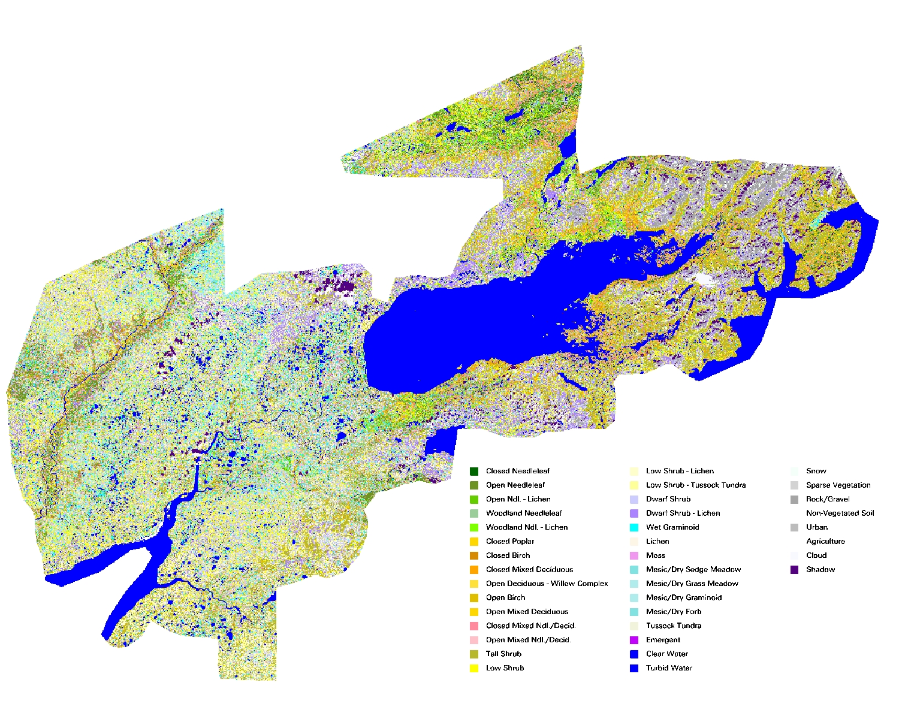

**Figure 6.** Kvichak project area final classified map

vegetation and water in a combination that spectrally resembled needleleaf. These misclassified areas were often narrow strips along water bodies, mostly in the west project area.

As discussed earlier, variation in standing water level even from the time of satellite image acquisition (July, 1999 and 2000) to the time of field data collection (July, 2001) was evident. This discrepancy usually resulted in wet type sites (wet graminoid, tussock tundra, emergent vegetation) being misclassified as dry grass/graminoid and dwarf/low shrub types. Therefore, the editing associated with this type of confusion focused on best representing conditions as they were at the time of satellite image capture.

A final case of spectral classification confusion involved the misclassification of tall shrub and low shrub pixels in the steep mountain valleys as closed deciduous types. The mix of the alder and willow tall shrubs that were distorted by heavy snow

**Table 4.** Acreage of earth cover classes within the project area.

|  |  |  |  |
| --- | --- | --- | --- |
| CLASS NUMBER | CLASS NAME | ACRES | PERCENT  COVER |
| 1 | Closed Needleleaf | 17,001 | 0.26% |
| 2 | Open Needleleaf | 304,527 | 4.69% |
| 3 | Open Ndl. - Lichen | 48,450 | 0.75% |
| 4 | Woodland Needleleaf | 164,007 | 2.53% |
| 5 | Woodland Ndl. - Lichen | 138,019 | 2.13% |
| 10 | Closed Deciduous – Poplar | 6,337 | 0.10% |
| 11 | Closed Deciduous – Birch | 70,840 | 1.09% |
| 12 | Closed Mixed Deciduous | 98,731 | 1.52% |
| 13 | Open Deciduous – Willow | 0 | 0.00% |
| 14 | Open Deciduous – Birch | 68,373 | 1.05% |
| 15 | Open Mixed Deciduous | 97,403 | 1.50% |
| 16 | Closed Mixed Ndl./Decid. | 91,388 | 1.41% |
| 17 | Open Mixed Ndl./Decid. | 242,831 | 3.74% |
| 20 | Tall Shrub | 542,102 | 8.35% |
| 21 | Low Shrub | 625,079 | 9.63% |
| 22 | Low Shrub - Lichen | 467,074 | 7.20% |
| 23 | Low Shrub - Tussock Tundra | 86,666 | 1.34% |
| 24 | Dwarf Shrub | 698,483 | 10.76% |
| 25 | Dwarf Shrub - Lichen | 341,063 | 5.25% |
| 32 | Wet Graminoid | 210,732 | 3.25% |
| 33 | Wet Forb | 0 | 0.00% |
| 34 | Wet Sedge | 0 | 0.00% |
| 36 | Lichen | 60,535 | 0.93% |
| 37 | Moss | 29,503 | 0.45% |
| 41 | Mesic / Dry Sedge Meadow | 20,233 | 0.31% |
| 42 | Mesic / Dry Grass Meadow | 121,113 | 1.87% |
| 43 | Mesic / Dry Graminoid | 205,059 | 3.16% |
| 44 | Mesic / Dry Forb | 0 | 0.00% |
| 50 | Tussock Tundra | 189,679 | 2.92% |
| 51 | Tussock Tundra – Lichen | 0 | 0.00% |
| 60 | Aquatic Bed | 0 | 0.00% |
| 61 | Emergent Vegetation | 7,753 | 0.12% |
| 70 | Clear Water | 1,160,901 | 17.88% |
| 71 | Turbid Water | 2,430 | 0.04% |
| 72 | Snow | 12,016 | 0.19% |
| 80 | Sparse Vegetation | 41,127 | 0.63% |
| 81 | Rock/Gravel | 144,935 | 2.23% |
| 82 | Non-vegetated soil | 28,283 | 0.44% |
| 90 | Urban | 1,882 | 0.03% |
| 92/93 | Cloud / Shadow | 146,987 | 2.98% |
| **Total** |  | **6,491,542** | **100%** |

apparently mimicked the spectral signatures of closed deciduous. This confusion was corrected via manual editing utilizing photo-interpretation and review of specific field notes and photos. Fortunately, the areas exhibiting this confusion were confined to the steep mountain valleys in the northeast part of the project area.

The classification of the east project area was challenging due to a lack of training sites for a large area southeast of King Salmon. Field reconnaissance was planned for this area, but inclement weather prevented travel by helicopter. Thus the initial analysis of the training sites and spectral variability in the image exhibited many classes that did not have a close spectral relationship with any training site. To adequately label these classes required close examination of cluster groupings, adjacent classes, field and training site data, and aerial photos. Often an iterative process was used and classes were relabeled based on a newer interpretation of the available information.

## Accuracy Assessment

Some earth cover classes were not adequately represented in the field data available for training and accuracy assessment, primarily because of their scarcity within the project area, e.g., moss, open mixed needleleaf deciduous, closed birch, closed poplar. In the past, classes with an inadequate sample size were collapsed into the next hierarchical cover type for accuracy assessment of the classification. This grouping often resulted in only 8-10 accuracy assessment classes vs. the 30+ classes present in the classification. In addition, this approach grouped classes based solely on their specific mapping class labels versus grouping individual sites based on their ecological composition or function. By grouping classes in this manner, one loses all ability to evaluate and measure the relationship between regions of the map that classify nicely into the “heart” of a mapping class and those regions that occur on the classification and ecological boundaries between the discrete mapping classes. For example, a vegetation caller may have interpreted a site to contain 10% tree cover and 90% low shrubs. This site would be classified as a woodland conifer site. If this site is used to evaluate a site classified with a group of pixels indicating a presence of 5% tree cover and 95% low shrubs, the site would have been evaluated as incorrectly classified. Since the literature generally accepts the fact that even the most experienced visual estimates of earth cover consider a range of variation in interpretation of +/-10% to be acceptable, this particular accuracy assessment site containing 10% tree cover should also be considered acceptably classified as low shrub and tallied as such. Evaluating the earth cover classification in this manner provides the end user with a more realistic measure of reliability of the classified map as it relates to the actual continuum of vegetation composition as compared to simply lumping mapping classes for evaluation based on their discrete class name.

A more appropriate and informative representation of the reliability/accuracy of the earth cover classification is found in the error matrix provided in Appendix D. In this matrix, no lumping of mapping classes has occurred. Therefore, the user can evaluate the performance and interrelationships of *all* mapping classes represented in the final earth cover map. The error matrix presents values for user’s accuracy, producer’s accuracy, and the overall accuracy for +/- 0% and +/-5% variation in interpretation within the reference data. In the error matrix, numbers along the main diagonal of the matrix indicate an exact match between the reference data site and the map. A tally of these numbers indicates the overall accuracy of the map at the +/- 0% variation in interpretation level. If two numbers occupy a non-diagonal cell, the left number indicates an acceptable match between the reference data site and the map assuming a +/- 5% variation in reference data interpretation. The number on the right indicates the number of sites that are not acceptable matches. A tally of the numbers within the diagonal along with the acceptable numbers in the off-diagonal cells (left number(s)) indicates the overall accuracy of the map at the +/- 5% variation in interpretation level.

A number of important analyses can be made regarding the relationship of the mapped data with the actual vegetation distributions throughout the study area using this method of accuracy assessment. Since the off-diagonal acceptable matches are presented, an indication of the number of field sites that represent vegetation compositions on the boundary of two or more mapping classes is given. The acceptance or unacceptance of each accuracy assessment site with an off-diagonal map class provides insight into the vegetation composition of that reference site. For instance, in the matrix in Appendix D (Total), of the seven reference sites characterized as dwarf shrub-lichen, two sites were an acceptable match with dwarf shrub-other and one site was an unacceptable match with sparse vegetation. The remainder of the sites (4) was diagonal matches with dwarf shrub-lichen. The off-diagonal matches indicate that two of those sites were just on the border between dwarf-shrub-lichen and dwarf shrub (15-20% lichen cover). Similarly, since the number of misclassified sites is still indicated in the matrix, a user can determine in which classes the map is least reliable and with which mapping classes the unreliable classes are confused. If lumping of classes is still desired, this can easily be accomplished through application of the techniques utilized in previous projects. Although the matrix of lumped classes is not presented in this report, the classification accuracy of the grouped classes of open needleleaf, woodland needleleaf, deciduous, mixed needleleaf/deciduous, tall shrub, low shrub, dwarf shrub, forb/graminoid, and barren was computed to be 79.7%.

Overall Accuracy Assessment

The difference in classification accuracy between the +/- 0% variation in interpretation level (70%) and the +/- 5% variation in interpretation level (80%) indicates that a substantial number of the reference data sites were characterized as being right on the boundary of two or more mapping classes. As stated earlier, it is generally accepted that variation in interpretation of +/- 10% is common and accepted for human interpreters, either from aerial photography or on the ground. When this natural and accepted variation is measured and accounted for (as in the case of the error matrix in Appendix D), a more reliable and informative measure of accuracy and reliability is presented.

The results presented in Table 4 reflect the tremendous diversity in landcover types within the project area. Only one terrestrial land class accounts for more that 10% of the total project area (Dwarf shrub – 10.76%). Combining physiognomically similar classes shows that around 43% of the terrestrial land cover is in the dwarf/low shrub classes (23% low shrub, 20% dwarf). Terrestrial land cover is defined as the total landcover minus water and cloud/shadow acreage. Other classes and class groups that are present in relatively high percentages include tall shrub (10%), open needleleaf (6%), woodland needleleaf types (6%), and mixed needleaf deciduous types (7%). Together these classes account for over 70% of the project area.

The accuracy figures for the dwarf/low shrub classes are substantially higher at the +/- 5% level, indicating that many of the sites were very close in structure and composition. This is evident when looking at the field data; many of the sites are near the .25m shrub height class break and/or the 20% lichen cover class break. Users accuracies (+/- 5%) for these classes range from 83-100%, indicating that the map reliably presents these classes. Producer’s accuracies are somewhat lower (50-86%), indicating that some sites were incorrectly omitted from these classes. Two of these omitted sites were classed as wet graminoid and they most likely contained more water on the image date than during the field reconnaissance, thus they were identified as shrub sites but spectrally were classed as wet graminoid. This tendency to over map wet graminoid is of potential interest to the end user. Three other sites were placed in classes very similar to there reference classes, indicating the difficulty in distinguishing the subtle differences between the dwarf/low shrub tundra types. This is somewhat understandable when the patchy, heterogeneous nature of these sites is considered, as well as the compositional variation.

The tall shrub class was mapped with good accuracy (91% user’s accuracy, 100% producer’s accuracy), indicating that this class showed little confusion with other classes and that manual editing and modeling efforts to separate this class from some of the closed deciduous types were largely successful, with the exception of one site which was classed as closed mixed deciduous.

Open needleaf was 6% of the total terrestrial landcover and was mapped with reasonable accuracies (75% user’s and producer’s accuracies). One closed birch site was classified as open needleleaf, indicating some confusion in the break between 75% majority needleleaf or deciduous. Further evidence of this is that another open needleleaf site was incorrectly classified as open mixed deciduous. Both of these sites were very heterogeneous mixes of mature needleleaf and deciduous trees and tall shrubs.

Woodland needleaf types (Woodland needleleaf and woodland needleaf lichen) also account for 6% of the total terrestrial landcover. Accuracy for woodland needleleaf lichen was 100%, indicating an outstanding correspondence between the map and ground for this class. The absence of any accuracy assessment sites for woodland needleleaf is worthy of mention, especially since woodland needleleaf is approximately 3% of the total terrestrial landcover. This is a good example of the larger problem of too few training sites. Seven woodland needleaf sites were visited during field reconnaissance. Two were in the west project area, and four were in the east project area. Because the west and east project areas were separate classification efforts, no woodland needleleaf sites were set aside for accuracy assessment because to do so would severely limit the number of sites available for classification in both the east and west project areas. Qualitative Analysis of digitized field observations and data from the 1992 classification indicates that woodland needleaf was mapped with good accuracy.

The open mixed needleleaf deciduous class shows low accuracies (50% users and producers accuracies), but these results are based on a very low number of accuracy assessment sites – 2. Nevertheless, the error matrix results point out the difficulty in distinguishing the mature forested stands in the project area, many of which contain both needleleaf and deciduous trees. One open mixed needleleaf site was classified as closed birch; this site was classified with 18% open mixed needleleaf deciduous and 25% open needleleaf.

Lastly, the error matrix also shows some confusion between dwarf shrub classes and sparse vegetation. One dwarf shrub lichen site was erroneously classed as sparse vegetation, and a sparse vegetation site was classed as dwarf shrub. Both of these sites were at relatively high elevation rocky ridge crests; the confusion is not surprising as foliose lichens covering the rocks may spectrally mimic dwarf shrub and lichen.

In summary, based on the quantitative accuracy assessment, the earth cover classification map produced for the Kvichak is reliable. Over 70% of the accuracy assessment sites matched the full detailed 32 mapping classes directly; even when taking no variation in interpretation and no class lumping into account. When as little as +/- 5% variation in interpretation was accounted for, nearly eight out of ten (79.7%) of the reference sites were found to correspond correctly with the classified map.

Discussion

As was stated earlier, the Kvichak Project Area is very diverse mix of landcover types. Only one class contained over 10% of the project area, three if the cloud/ shadow and water classes are subtracted from the acreage total. The majority of the landcover classes were between 1 and 5% of the total area mapped. There were a very low number of accuracy assessment sites available to estimate the accuracy of these landcover classes; only one class had 10 sites (Tall shrub) and many had as few as two or three. Because of this, the reported accuracy assessment percentages must be viewed cautiously as one or two misclassified (or correctly classified) sites can have a great impact on the resulting percentage. Only 64 sites were used to assess an area of 5,328,211 acres comprised of 30+ landcover classes. This problem is directly related to the overall low number of training sites available for the classification (296 sites). While this number of sites may seem adequate for a project area of this size, these sites were divided for separate classifications for the east and west project areas (165 sites for the west project area and 131 for the east project area). When selecting accuracy assessment sites from the available field sites for each project area, the 15 site minimum rule discussed earlier was often ignored in order to have at least a handful of sites for accuracy assessment.

While the accuracy assessment performed in this project was not a robust test of the classification, it gives the user some confidence while using the classification. It provided enough detail for the end user to determine where discrepancies in the classification may cause a problem while using the data. It is also important to note the variations in the dates of the imagery, aerial photographs, and field data. For this project, the imagery was acquired on September 1999 and September 2000. The aerial photographs spanned a seven year period from 1978-84, and the field data was collected in July 2001. Differences due to environmental changes from the different sources may have affected the accuracy assessment. As discussed earlier, the significant differences in standing water on many of the wetter sites between the image date and the field collection date contributed to inconsistencies in correctly identifying sites. Depending on the standing water present at any given time, each of these class labels may have been appropriate.

A major assumption of quantitative accuracy assessments is that the label from the reference information represents the “true” label of the site and that all differences between the remotely sensed map classification and the reference data are due to classification and/or delineation error (Congalton and Green 1993). Unfortunately, error matrices can be inadequate indicators of map error because they are often confused by non-map error differences. Some of the non-map errors that can cause confusion are: (1) registration differences between the reference data and the remotely sensed map classification, (2) digitizing errors, (3) data entry errors, (4) changes in land cover between the date of the remotely sensed data and the date of the reference data, (5) mistakes in interpretation of reference data, and perhaps most significant (6) variation in classification and delineation of the reference data due to inconsistencies in human interpretation of vegetation. The error matrix developed and presented in this report attempts to capture, measure, and account for likely the most significant of these sources of inconsistency and error in the development of the reference data set: variation in human interpretation. The results presented and discussed in this report provide the end user with valuable information regarding the accuracy and reliability of the earth cover data mapped for the Kvichak project area. Separate error matrices for the east and west project areas are provided to give the end user more detailed information about these areas.

## Final Products

The project final product included a digital classification, map, and database of 30 earth cover classes within the Kvichak project area as well as a map of wildlife sighting locations observed during the collection of field data. The digital classification map was delivered in Arc Info Grid and ERDAS Imagine format. The unclassified Landsat TM images used to create the cover map were also delivered. The field site database, a species list and earth cover acreage tables were stored as digital tables in Microsoft Excel and Access format. The wildlife sightings map was delivered as Arc Info shapefile point and polygon coverages. Digital photos of the field sites are stored as jpeg’s

.

# Summary

The Bureau of Land Management (BLM) – Alaska and Ducks Unlimited, Inc. (DU) have been cooperatively mapping wetlands and associated uplands in Alaska using remote sensing and GIS technologies since 1988. This project continued with the mapping effort for the Kvichak projectusing Landsat TM satellite scenes, Path 71, Rows 18, and 19, acquired 09/99; and Path 72, Rows 18 and 19, acquired 09/00. The project area was classified into 30 earth cover categories with an overall accuracy of 79.7% at the +/- 5% level of variation in interpretation. The digital database and map of the classification were the primary products of this project along with hard copy maps of the classification, digital Arc Info shapefile point and polygon coverages of wildlife sightings locations observed during the collection of field data, and a complete field database including digital site photos.

# Literature Cited

Chuvieco, E., and R. G. Congalton. 1988. Using cluster analysis to improve the selection for training statistics in classifying remotely sensed data. Photogrammetric Engineering and Remote Sensing 54:1275-1281.

Congalton, R., and K. Green. 1993. A practical look at the sources of confusion in error matrix generation. Photogrammetric Engineering & Remote Sensing 59:641-644.

Congalton, R. G., K. Green, and J. Teply. 1993. Mapping Old Growth Forest on National Forest and Park Lands in the Pacific Northwest from Remotely Sensed Data. Photogrammetric Engineering and Remote Sensing 59:529-535.

Congalton, R. G. 1991. A review of assessing the accuracy of classifications of remotely sensed data. Remote Sensing of Environment 37:35-46.

Ducks Unlimited Inc., 1998. Earth Cover Classification System –Draft. Unpublished Report. Rancho Cordova, California, USA.

Gopal, S., and C. Woodcock. 1992. Accuracy assessment of the Stanislaus vegetation map using fuzzy sets. Pages 378-394 in Remote Sensing and Natural Resource Management: Proceedings of the Fourth Forest Service Remote Sensing Applications Conference. American Society for Photogrammetry and Remote Sensing, City, State, USA.

Kempka, R. G., R. D. Macleod, J. Payne, F. A. Reid, D. A. Yokel, and G. R. Balogh. 1995. National Petroleum Reserve Alaska Landcover Inventory: Exploring Arctic Coastal Plain Using Remote Sensing. Pages 788-798 in Ninth Annual Symposium on Geographic Information Systems in Natural Resources Management, GIS World Inc., editor. GIS 95 Symposium Proceedings, Vancouver, British Columbia, Canada.

Kempka, R. G., B. S. Maurizi, F. A. Reid, R. C. Altop, and J.W. Denton. 1994. Standardizing reference data collection for satellite land cover mapping in Alaska. Pages 419-426 in Eighth Annual Symposium on Geographic Information Systems in Forestry, Environmental, and Natural Resources Management, GIS World Inc., editor. GIS 94 Symposium Proceedings Vancouver, British Columbia, Canada.

Kempka, R. G., F. A. Reid, and R. C. Altop. 1993. Developing large regional databases for waterfowl habitat in Alaska using satellite inventory techniques: a case study of the Black River. Pages 1-1 in Seventh Annual Symposium on Geographic Information Systems in Forestry, Environment, and Natural Resources Management, GIS World Inc., editor. GIS 93 Symposium Proceedings Vancouver, British Columbia, Canada.

Krebs, P. 1980. ASVT Project Phase I, Denali Study Area, Alaska. Draft Technical Report. U.S. Department of Interior, Bureau of Land Management, Anchorage, Alaska, USA.

Landis, J., and G. Koch. 1977. The measurement of observer agreement for categorical data. Biometrics 33:159-174.

Lillesand, T., and R. Kiefer. 1994. Remote Sensing and Image Interpretation. Wiley and Sons, Inc., New York, USA.

Ritter, R. A., G. T. Koeln, and C. Altop. 1989. Use of Landsat Thematic Mapper Data for Waterfowl Habitat Inventory in Alaska.

Story, M., and R. G. Congalton. 1986. Accuracy Assessment: A User’s Perspective. Photogrammetric Engineering and Remote Sensing 16:529-535.

Tortora, R. 1978. A note on sample size estimation for multinomial populations. The American Statistician 43:1135-1137.

Viereck, L. A., Dryrness, C. T., Batten, and A. R. Wenzlick. 1992. The Alaska Vegetation Classification*.* General Technical Report PNW-GTR-286. U.S. Department of Agriculture, Forest Service, Pacific Northwest Research Station, Portland, Oregon, USA.

# Appendices

## Appendix A. Alaska Earth Cover Classification Class Descriptions

1. **Forest**

Needleleaf and Deciduous Trees-

The needleleaf species generally found were white spruce (*Picea glauca*) and black spruce (*P. mariana*). White spruce tended to occur on warmer sites with better drainage, while black spruce dominated poorly drained sites, and was more common in the interior of Alaska. The needleleaf classes included both white and black spruce.

The deciduous tree species generally found were paper birch (*Betula papyfera*), aspen (*Populus tremuloides*) and cottonwood (*P. balsamifera* and *P. trichocarpa*). Black cottonwoods (*P. trichocarpa*) were generally found only in river valleys and on alluvial flats. Under some conditions willow (*Salix* spp.) and alder *(Alnus rubra)* formed a significant part of the tree canopy. Deciduous stands were found in major river valleys, on alluvial flats, surrounding lakes, or most commonly, on the steep slopes of small hills. Mixed deciduous/coniferous stands were present in the same areas as pure deciduous stands. While needleleaf stands were extremely extensive, deciduous and mixed deciduous/coniferous stands were generally limited in size. The only exception to this rule was near major rivers, where relatively extensive stands of pure deciduous trees occur on floodplains and in ancient oxbows.

**1.1 Closed Needleleaf**

At least 60% of the cover was trees, and >75% of the trees were needleleaf trees. Closed needleleaf sites were rare because even where stem densities were high, the crown closure remained low. Generally, closed needleleaf sites were found only along major rivers.

**1.2 Open Needleleaf**

From 25-59% of the cover was trees, and >75% of the trees were needleleaf. This class was very common throughout the interior of Alaska. A wide variety of understory plant groups were present, including low and tall shrubs, forbs, grasses, sedges, horsetails, mosses and lichens.

**1.21 Open Needleleaf Lichen**

From 25-59% of the cover was trees, >75% of the trees were needleleaf, and > 20% of the understory was lichen.

* 1. **Woodland Needleleaf**

From 10-24% of the cover was trees, and >75% of the trees were needleleaf. Woodland understory was extremely varied and included most of the shrub, herbaceous, or graminoid types present in the study area.

**1.31 Woodland Needleleaf Lichen**

From 10-24% of the cover was trees, >75% of the trees were needleleaf, and > 20% of the understory was lichen. The lichen often occurred in small round patches between trees. Within the study area, this class was generally found along ridgetops or on riparian benches.

**1.4 Closed Deciduous (Mixed Deciduous Species 1.45)**

At least 60% of the cover was trees, and >75% of the trees were deciduous. Occurred in stands of limited size, generally on the floodplains of major rivers, but occasionally on hillsides, riparian gravel bars, or bordering small lakes. This class included Paper Birch, Aspen, or Cottonwood.

**1.41 Closed Birch**

At least 60% of the cover was trees, >75% of the trees were deciduous, and >75% of the deciduous trees were Paper Birch (*Betula Papyfera).* This class was very rare.

**1.42 Closed Aspen**

At least 60% of the cover was trees, >75% of the trees were deciduous, and >75% of the deciduous trees were Aspen*.* Stands of pure aspen occurred, but were generally no larger than a few acres. They were found on steep slopes, with particular soil conditions, and on river floodplains.

**1.43 Closed Poplar**

At least 60% of the cover was trees, >75% of the trees were deciduous, and >75% of the deciduous trees were Cottonwood*.* Stands of pure cottonwood were occasionally found on riparian gravel bars.

* 1. **Open Deciduous (Mixed Deciduous Species 1.54)**

From 25-59% of the cover was trees, and >75% of the trees were deciduous. There was generally a needleleaf component to this class though it was less than 25%. This was a relatively uncommon class.

**1.51 Open Birch**

From 25-59% of the cover was trees, >75% of the trees were deciduous, and >75% of the deciduous trees were Paper Birch*.* This class was very rare. No examples of this class were found in the study area.

**1.52 Open Aspen**

From 25-59% of the cover was trees, >75% of the trees were deciduous, and >75% of the deciduous trees were Aspen*.*

**1.53 Open Cottonwood**

From 25-59% of the cover was trees, >75% of the trees were deciduous, and >75% of the deciduous trees were Cottonwood*.*

* 1. **Closed Mixed Needleleaf/Deciduous**

At least 60% of the cover was trees, but neither needleleaf nor deciduous trees made up >75% of the tree cover. This class was uncommon and found mainly along the meanders of major rivers.

**1.7** **Open Mixed Needleleaf/Deciduous**

From 25-59% of the cover was trees, but neither needleleaf nor deciduous trees made up >75% of the tree cover. This class occurred in regenerating burns, on hill slopes, or bordering lakes.

1. **Shrub**

The tall and low shrub classes were dominated by willow species, dwarf birch (*Betula nana* and *Betula glandulosa*) and *Vaccinium* species*,* with alder being somewhat less common. However, the proportions of willow to birch and the relative heights of the shrub species varied widely, which created difficulties in determining whether a site was made up of tall or low shrub. As a result, the height of the shrub species making up the largest proportion of the site dictated whether the site was called a low or tall shrub. The shrub heights were averaged within a genus, as in the case of a site with both tall and low willow shrubs. Dwarf shrub was usually composed of dwarf ericaceous shrubs and *Dryas* species, but often included a variety of forbs and graminoids. The species composition of this class varied widely from site to site and included rare plant species. It is nearly always found on hill tops or mountain plateaus, and may have included some rock.

**2.1 Tall Shrub**

Shrubs made up 40-100% of the cover and shrub height was >1.3 meters. This class generally had a major willow component that was mixed with dwarf birch and/or alder, but could also have been dominated by nearly pure stands of alder. It was found most often in wet drainages, at the head of streams, or on slopes.

**2.21 Willow/Alder Low Shrub**

Shrubs made up 40-100% of the cover, shrub height was .25-1.3 meters, and >75% of the shrub cover was willow and/or alder.

**2.22 Other Low Shrub/Tussock Tundra**

Shrubs made up 40-100% of the cover, shrub height was .25-1.3 meters, and >35% of the cover was made up of tussock forming cotton grass *(Eriophorum vaginatum*). This class was found in extensive patches in flat, poorly drained areas. It was generally made up of cotton grass, ericaceous shrubs, willow and/or alder shrubs, other graminoids, and an occasional black spruce.

**2.23 Other Low Shrub/Lichen**

Shrubs made up 40-100% of the cover, shrub height was .25-1.3 meters, and >20% of the cover was made up of lichen. This class was found at mid-high elevations. The shrub species in this class were nearly always dwarf birch.

**2.24 Other Low Shrub**

Shrubs made up 40-100% of the cover, shrub height was .25-1.3 meters. This was the most common low shrub class. It was generally composed of dwarf birch, willow species, *Vaccinium* species, and ledum species.

**2.31 Dwarf Shrub/Lichen**

Shrubs made up 40-100% of the cover, shrub height was <.25 meters, and >20% of the cover was made up of lichen. This class was generally made up of dwarf ericaceous shrubs and *Dryas* species, but often included a variety of forbs and graminoids. It was nearly always found at higher elevations on hilltops, mountain slopes and plateaus. This class may be more open than the Other Dwarf Shrub class.

**2.31 Other Dwarf Shrub**

Shrubs made up 40-100% of the cover, the shrub height is <.25 meters. This class was generally made up of dwarf ericaceous shrubs and *Dryas* species, but often included a variety of forbs and graminoids, and some rock. It was nearly always found at higher elevations on hilltops, mountain slopes, and plateaus.

1. **Herbaceous**

The classes in this category included bryoids, forbs, and graminoids. Bryoids and forbs were present as a component of most of the other classes but rarely appeared in pure stands. Graminoids such as *Carex* spp., *Eriophorum* spp., or bluejoint grass (*Calamagrostis canadensis*) may have dominated a community.

**3.11 Lichen**

Composed of >40% herbaceous species, <25% water, and > 60% lichen species.

**3.12 Moss**

Composed of >40% herbaceous species, <25% water, and >60% moss species.

**3.21 Wet Graminoid**

Composed of >40% herbaceous species, <25% water, and where >60% of the herbaceous cover was graminoid, and >20% of the graminoid cover was made up of *Carex aquatilis*. This class represented wet or seasonally flooded sites. It was often present in stands too small to be mapped at the current scale.

**3.31 Tussock Tundra**

Composed of >40% herbaceous species, <25% water, where >50% of the herbaceous cover was graminoid, and >35% of the graminoid cover was made up of tussock forming cotton grass. Tussock tundra often included ericaceous shrubs, willow and/or alder shrubs, forbs, bryoids, and other graminoids, and was usually found at lower elevations in flat, poorly drained areas.

**3.311 Tussock Tundra/Lichen**

Composed of >40% herbaceous species, <25% water, where >50% of the herbaceous cover was graminoid, and >20% of the cover was lichen, and >35% of the graminoid cover was made up of tussock forming cotton grass. Tussock tundra often included ericaceous shrubs, willow and/or alder shrubs, forbs and other graminoids, and was usually found at lower elevations in flat, poorly drained areas. This class included a major component of lichen.

**3.34 Mesic/Dry Graminoid**

Composed of >40% herbaceous species, <5% water, with >50% graminoids excluding tussock forming cotton grass and *Carex aquatilis*. This class was not common and was found generally only at high elevations.

**3.35 Mesic/Dry Forb**

Composed of >40% herbaceous species, <5% water, with <50% graminiods. Regenerating burn areas dominated by fireweed *(Epilobium angustifolium)* fell into the mesic/dry forb category. However, forb communities without significant graminoid or shrub components were generally rare in the interior of Alaska.

1. **Aquatic Vegetation**

The aquatic vegetation was divided into Aquatic Bed and Emergent classes. The Aquatic Bed class was dominated by plants with leaves that float on the water surface, generally pond lilies (*Nuphar polysepalum*). The Emergent Vegetation class was composed of species that were partially submerged in the water, and included freshwater herbs such as Horsetails (*Equisetum* spp.), Marestail (*Hippuris* spp.), and Buckbean (*Menyanthes trifoliata*).

**4.1 Aquatic Bed**

Aquatic vegetation made up >20% of the cover, and >20% of the vegetation was composed of plants with floating leaves. This class was generally dominated by pond lilies.

4.2 Emergent Vegetation

Aquatic vegetation made up >20% of the cover, and >20% of the vegetation was composed of plants other than pond lilies. Generally included freshwater herbs such as Horsetails, Marestail, or Buckbean.

* 1. **Clear Water**

Composed of >80% clear water.

* 1. **Turbid Water**

Composed of >80% turbid water.

**6.0 Barren**

This class included sparsely vegetated sites, e.g., abandoned gravel pits or riparian gravel bars, along with non-vegetated sites, e.g., barren mountaintops or glacial till.

**6.1 Sparse Vegetation**

At least 50% of the area was barren, but vegetation made up >20% of the cover. This class was often found on riparian gravel bars, on rocky or very steep slopes and in abandoned gravel pits. The plant species were generally herbs, graminoids and bryoids.

**6.2 Rock/Gravel**

At least 50% of the area was barren, >50% of the cover was composed of rock and/or gravel, and vegetation made up less than 20% of the cover. This class was most often made up of mountaintops or glaciers.

**6.3 Non-vegetated Soil**

At least 50% of the area was barren, >50% of the cover was composed of mud, silt or sand, and vegetation made up less than 20% of the cover. This type was generally along shorelines or rivers.

1. **Urban**

At least 50% of the area was urban. This class was only found in the study area in the within the village of Ruby.

**8.0** **Agriculture**

At least 50% of the area was agriculture. This class was not found in the study area.

* 1. **Cloud/Shadow**

At least 50% of the cover was cloud or shadow.

* 1. Cloud

At least 50% of the cover was made up of clouds.

* 1. Cloud Shadow

At least 50% of the cover was made up of clouds shadows.

* 1. **Terrain Shadow**

At least 50% of the cover was made up of terrain shadows.

10.0 Other

Sites that did not fall into any other category were assigned to Other. For example, sites containing 25%-80% water, <25% shrub and <20% aquatic vegetation were classed as Other. Sites classed as Other may have also included extensive areas of vegetative litter, such as downed wood.

## Appendix B. Earth cover classification decision tree.

yes

yes

yes

yes

yes

yes

yes

no

yes

yes

yes

yes

yes

no

1.1

1.21

1.2

1.41

1.42

1.43

1.44

1.51

1.52

1.53

1.54

1.6

1.7

1.31

1.3

no

no

≥ 75% needleleaf **AND** height > 1 m

≥ 20% lichen

Trees 10-24%

29-59% closed canopy

≥ 60% closed canopy

no

no

no

no

no

no

≥ 75% single species

25-59% closed canopy

Closed Needleaf

Open Needleaf Lichen

Open Needleaf

Closed Birch

Closed Aspen

Closed Poplar

Closed Mixed Deciduous

Open Birch

Open Aspen

Open Poplar

Open Mixed Deciduous

Closed Mixed Needle/Decid

Open Mixed Needle/Decid

Woodland Needleleaf Lichen

Woodland Needleaf

≥ 75% single species

≥ 60% closed canopy

≥ 75% deciduous

Trees 25-100%

≥ 20% lichen

≥ 60% closed canopy

25-59% closed canopy

≥ 75% needleleaf

yes

2.1

2.21

2.22

2.23

2.24

2.31

2.32

3.11

3.12

3.21

3.22

3.311

3.312

3.32

3.33

3.34

3.35

no

no

no

yes

yes

yes

yes

yes

yes

yes

yes

yes

yes

no

no

no

no

no

yes

yes

yes

yes

yes

yes

yes

yes

≥ 50% grass

no

no

no

no

no

no

no

≥ 40% herbaceous **AND**

**≤ 25%** water

≥ 50% sedge

≥ 50% grass

and tussock

≥ 35% tussock

≥ 50% graminoid

(Sedge, Grass, Tussock)

≥ 20% lichen

≥ 50% graminoid (sedge, grass)

≥ 35% tussock

5-25% water **OR**

> 20% Carex aquatilis

≥ 50% lichen

≥ 50% bryoid

Tall

Low Shrub Willow/Alder

Low Shrub Tussock Tundra

Low Shrub Lichen

Low Shrub Other

Dwarf Shrub Lichen

Dwarf Shrub

Lichen

Moss

Wet Graminoid

Wet Forb

Tussock Tundra Lichen

Tussock Tundra

Mesic/Dry Sedge Meadow

Mesic/Dry Grass Meadow

Mesic/Dry Graminoid

Mesic/Dry Forb

≥ 20% lichen

≥ 20% lichen

≥ 35% tussock

≥ 75% willow / alder

most common shrub is < 0.25 m tall

most common shrub is 0.25- 1.3 m tall

most common shrub is ≥ 1.3 m tall

Shrubs 25-100%

no

yes

4.1

4.2

5.3

5.4

6.1

6.2

6.3

7.0

8.0

8.1

8.2

9.1

9.2

10.0

Aquatic Bed

Emergent Vegetation

Clear Water

Turbid Water

Sparse Vegetation

Rock / Gravel

Non-Vegetated Soil

Urban

Agriculture

Snow

Ice

Cloud

Shadow

Other

yes

≥ 50% Shadow

≥ 50% Cloud

≥ 50% Ice

≥ 50% Snow

≥ 50% Agriculture

≥ 50% Urban

≥ 50% rock/gravel

≥ 20% vegetation

≥ 50% Barren Ground

≥ 80% Water

≥ 20% aquatic bed

≥ 20% Aquatic Vegetation

no

yes

yes

yes

yes

yes

yes

yes

yes

yes

yes

yes

no

no

clear water

no

no

no

no

yes

## Appendix C. Plant species and cover type list.

|  |  |  |  |  |  |  |
| --- | --- | --- | --- | --- | --- | --- |
| **Site Tally** |  | **Symbol** |  | **Species** |  | **Common Name** |
| 237 |  | LITT |  | LITTER |  | LITTER |
| 160 |  | LIXX |  | LICHEN |  | LICHEN |
| 157 |  | VAUL |  | VACCINIUM ULIGINOSUM |  | BLUEBERRY,BOG |
| 150 |  | MOXX |  | MOSS |  | MOSS |
| 140 |  | LEPA11 |  | LEDUM PALUSTRE |  | LABRADOR TEA |
| 136 |  | CAXX |  | CAREX SPP |  | SEDGE SPP |
| 134 |  | SAX_ |  | SALIX SPP |  | WILLOW |
| 115 |  | CACA4 |  | CALAMAGROSTIS CANADENSIS |  | REEDGRASS,BLUE-JOINT |
| 99 |  | BEGL |  | BETULA GLANDULOSA |  | BIRCH,RESIN |
| 82 |  | EMNI |  | EMPETRUM NIGRUM |  | CROWBERRY,BLACK |
| 80 |  | BENA |  | BETULA NANA |  | BIRCH,DWARF |
| 70 |  | FEXX |  | FERN SPP |  | FERN SPP |
| 70 |  | PIGL |  | PICEA GLAUCA |  | SPRUCE,WHITE |
| 57 |  | BEPA |  | BETULA PAPYRIFERA |  | BIRCH,PAPER |
| 55 |  | SADW |  | SALIX DW. |  | WILLOW, DWARF |
| 55 |  | SPBE |  | SPIREA BEAUVERDIANA |  | SPIREA |
| 49 |  | EPAN2 |  | EPILOBIUM ANGUSTIFOLIUM |  | FIREWEED |
| 46 |  | DEAD1 |  | STANDING DEAD |  | STANDING DEAD |
| 45 |  | BARE |  | BARE GROUND |  | BARE GROUND |
| 44 |  | ALCR6 |  | ALNUS CRISPA |  | ALDER,GREEN |
| 41 |  | ERXX |  | ERIOPHORUM SPP |  | COTTON-GRASS |
| 41 |  | PICEA |  | PICEA SPP. |  | SPRUCE, MIXED WHITE AND BLACK |
| 40 |  | ERVA4 |  | ERIOPHORUM VAGINATUM |  | COTTON-GRASS,TUSSOCK |
| 39 |  | VAVI |  | VACCINIUM VITIS-IDAEA |  | CRANBERRY,LOWBUSH |
| 35 |  | CWATER |  | CLEAR WATER |  | CLEAR WATER |
| 34 |  | ALNU9 |  | ALNUS SPP |  | ALDER SPP |
| 33 |  | ANPO |  | ANDROMEDA POLIFOLIA |  | ROSEMARY,BOG |
| 33 |  | EQXX |  | EQUISETUM SPP |  | HORSETAILS SPP |
| 33 |  | RUCH |  | RUBUS CHAMAEMORUS |  | CLOUDBERRY |
| 30 |  | LOPR |  | LOISELURIA PROCUMBENS |  | AZALEA, ALPINE |
| 30 |  | ROCK |  | ROCK |  | ROCK |
| 27 |  | POPA14 |  | POTENTILLA PALUSTRIS |  | CINQUEFOIL,MARSH |
| 25 |  | MYGA |  | MYRICA GALE |  | SWEETGALE |
| 23 |  | CAAQ |  | CAREX AQUATILIS |  | SEDGE,WATER |
| 18 |  | ECHO2 |  | ECHINOPANAX HORRIDUM |  | DEVIL'S CLUB |
| 18 |  | POBA2 |  | POPULUS BALSAMIFERA |  | POPLAR,BALSAM |
| 18 |  | VEVI |  | VERATRUM VIRIDE |  | FALSE-HELLEBORE,AMERICAN |
| 16 |  | GRASS |  | GRASS |  | GRASS |
| 16 |  | SATRE |  | SALIX TREE |  | WILLOW TREE |
| 15 |  | LEGR |  | LEDUM GROENLANDICUM |  | LABRADOR-TEA,GREENLAND |
| 13 |  | HELA4 |  | HERACLEUM LANATUM |  | COW-PARSNIP |
| 12 |  | CHCA2 |  | CHAMAEDAPHNE CALYCULATA |  | LEATHERLEAF |
| 12 |  | COCA13 |  | CORNUS CANADENSIS |  | BUNCHBERRY,CANADA |
| 11 |  | DRXX |  | DRYAS SPP |  | MOUNTAIN-AVENS |
| 10 |  | ARXX |  | ARNICA SPP |  | ARNICA SPP |
| 9 |  | GRAV |  | GRAVEL |  | GRAVEL |
| 9 |  | METR3 |  | MENYANTHES TRIFOLIATA |  | BUCKBEAN |
| 8 |  | ANNA |  | ANEMONE NARCISSIFLORA |  | ANEMONE,NARCISSUS |
| 7 |  | ALTRE |  | ALNUS SPP TREE |  | ALDER, TREE |
| 7 |  | ARRU |  | ARCTOSTAPHYLOS RUBRA |  | BEARBERRY,RED |
| 6 |  | BEPAK |  | BETULA PAPYRIFERA VAR. KENAICA |  | BIRCH,KENAI |
| 6 |  | GEPR4 |  | GERANIUM PRATENSE |  | CRANE'S-BILL,MEADOW |
| 6 |  | MUDX |  | MUD |  | MUD |
| 6 |  | PIMA |  | PICEA MARIANA |  | SPRUCE,BLACK |
| 5 |  | ARUV |  | ARCTOSTAPHYLOS UVA-URSI |  | KINNEKINNICK |
| 5 |  | MIAR3 |  | MINUARTIA ARCTICA |  | STITCHWORT, ARCTIC |
| 5 |  | SOSI2 |  | SORBUS SITCHENSIS |  | MOUNTAIN ASH,WESTERN |
| 4 |  | LEDE5 |  | LEDUM DECUMBENS |  | LABRADOR-TEA,NARROW-LEAF |
| 4 |  | SPRO |  | SPIRANTHES ROMANZOFFIANA |  | LADIES'-TRESSES,HOODED |
| 3 |  | ARCTO3 |  | ARCTOSTAPHYLOS SPP |  | BEARBERRY |
| 3 |  | CASP5 |  | CAREX SPECTABILIS |  | SEDGE,SHOWY |
| 3 |  | CATE11 |  | CASSIOPE TETRAGONA |  | BELL-HEATHER,ARCTIC |
| 3 |  | DIAPE |  | DIAPENSIA LAPPONICA |  | DIAPENSIA |
| 3 |  | EQFL |  | EQUISETUM FLUVIATILE |  | HORSETAIL,WATER |
| 3 |  | LUPIN |  | LUPINUS SPP |  | LUPINE,SPP |
| 3 |  | PELA |  | PEDICULARIS LABRADORICA |  | LOUSEWORT,LABRADOR |
| 3 |  | POFR4 |  | POTENTILLA FRUTICOSA |  | CINQUEFOIL,SHRUBBY |
| 3 |  | POTR15 |  | POPULUS TRICHOCARPA |  | BLACK COTTONWOOD |
| 3 |  | RIBES |  | RIBES SPP |  | CURRANT,SPP |
| 3 |  | RUBUS |  | RUBUS SPP. |  | RUBUS SPP. |
| 3 |  | SAST11 |  | SANGUISORBA STIPULATA |  | BURNET |
| 3 |  | SHCA |  | SHEPHERDIA CANADENSIS |  | SOAPBERRY |
| 3 |  | VAOX |  | VACCINIUM OXYCOCCOS |  | CRANBERRY,SMALL |
| 3 |  | VIED |  | VIBURNUM EDULE |  | CRANBERRY,HIGHBUSH |
| 2 |  | ANLU |  | ANGELICA LUCIDA |  | ANGELICA,SEAWATCH |
| 2 |  | ARTEM |  | ARTEMISIA SPP |  | SAGE, SPP |
| 2 |  | CAMPA |  | CAMPANULA SPP |  | CAMPANULA SPP |
| 2 |  | CIMA |  | CICUTA MACKENZIANA |  | WATER-HEMLOCK,MACKENZIE |
| 2 |  | DROB |  | DROSERA X OBOVATA |  | SUNDEW |
| 2 |  | ELBE3 |  | ELYNA BELLARDII |  | ALPINESEDGE,BELLARD |
| 2 |  | ERSP8 |  | ERIOPHORUM SPISSUM |  | HARE'S-TAIL |
| 2 |  | IRSE |  | IRIS SETOSA |  | IRIS,BEACH-HEAD |
| 2 |  | LAPA4 |  | LATHYRUS PALUSTRIS |  | PEAVINE,VETCHLING |
| 2 |  | LUNO |  | LUPINUS NOOTKATENSIS |  | LUPINE,NOOTKA |
| 2 |  | MINUA |  | MINUARTIA SPP. |  | STITCHWORT,SPP |
| 2 |  | PEDIC |  | PEDICULARIS SPP |  | LOUSEWORT,SPP |
| 2 |  | PEFR5 |  | PETASITES FRIGIDUS |  | COLTSFOOT,ARCTIC SWEET |
| 2 |  | POAC |  | POLEMONIUM ACUTIFLORUM |  | JACOB'S-LADDER,STICKY TALL |
| 2 |  | PUNU |  | PUCCINELLIA NUTKAENSIS |  | GRASS,NOOTKA ALKALI |
| 2 |  | RUMEX |  | RUMEX SPP |  | DOCK,SPP |
| 2 |  | SASP2 |  | SALIX SPHENOPHYLLA |  | WILLOW,WEDGE-LEAF |
| 1 |  | ANMO9 |  | ANTENNARIA MONOCEPHALA |  | PUSSYTOE |
| 1 |  | ARAL2 |  | ARCTOSTAPHYLOS ALPINA |  | MANZANITA,ALPINE |
| 1 |  | BEER2 |  | BECKMANNIA ERUCIFORMIS |  | GRASS,BECKMANN'S |
| 1 |  | BEOC2 |  | BETULA OCCIDENTALIS |  | BIRCH,SPRING |
| 1 |  | CAED |  | CAKILE EDENTULA |  | SEAROCKET,AMERICAN |
| 1 |  | DRIN4 |  | DRYAS INTEGRIFOLIA |  | MOUNTAIN-AVENS,ENTIRE-LEAF |
| 1 |  | EPAN4 |  | EPILOBIUM ANAGALLIDIFOLIUM |  | WILLOW-HERB,PIMPERNEL |
| 1 |  | EPXX |  | EPILOBIUM SPP |  | FIREWEED SPP |
| 1 |  | ERAN6 |  | ERIOPHORUM ANGUSTIFOLIUM |  | COTTON-GRASS,NARROW-LEAF |
| 1 |  | GEER2 |  | GERANIUM ERIANTHUM |  | GERANIUM,WOOLY |
| 1 |  | GRXX |  | GRAMINOID SPP |  | GRAMINOID SPP |
| 1 |  | LEDE |  | LEPIDIUM DENSIFLORUM |  | PEPPER-GRASS,DENSE-FLOWER |
| 1 |  | LEVI3 |  | LEPIDIUM VIRGINICUM |  | PEPPER-GRASS,POOR-MAN'S |
| 1 |  | LICO5 |  | LISTERA CONVALLARIOIDES |  | TWAYBLADE,BROAD-LEAF |
| 1 |  | LICO6 |  | LISTERA CORDATA |  | TWAYBLADE,HEART-LEAF |
| 1 |  | LITT2 |  | LITTER STANDING |  | LITTER STANDING |
| 1 |  | LYCOP2 |  | LYCOPODIUM SPP |  | CLUBMOSS,SPP |
| 1 |  | MIOB2 |  | MINUARTIA OBTUSILOBA |  | STITCHWORT,ALPINE |
| 1 |  | MIRU3 |  | MINUARTIA RUBELLA |  | STITCHWORT,BOREAL |
| 1 |  | MOPA2 |  | MONTIA PARVIFOLIA |  | MINER'S-LETTUCE,LITTLE-LEAF |
| 1 |  | NUPHA |  | NUPHAR SPP |  | PONDLILLY SPP |
| 1 |  | NUPO |  | NUPHAR POLYSEPALUM |  | WATER LILY |
| 1 |  | OXNIN |  | OXYTROPIS NIGRESCENS |  | OXYTROPE,BLACKISH |
| 1 |  | POAN5 |  | POTENTILLA ANSERINA |  | SILVERWEED |
| 1 |  | POBI5 |  | POLYGONUM BISTORTA |  | BISTORT,MEADOW |
| 1 |  | POLYG4 |  | POLYGONUM SPP. |  | BISTORT |
| 1 |  | POTR10 |  | POPULUS TREMULOIDES |  | ASPEN,QUAKING |
| 1 |  | RHLA2 |  | RHODODENDRON LAPPONICUM |  | AZALEA,LAPLAND |
| 1 |  | SACA14 |  | SANGUISORBA CANADENSIS |  | BURNET,CANADA |
| 1 |  | SAND |  | SAND |  | SAND |
| 1 |  | SASI2 |  | SALIX SITCHENSIS |  | WILLOW,SITKA |
| 1 |  | SOSC2 |  | SORBUS SCOPULINA |  | MOUNTAIN-ASH,GREENE'S |
| 1 |  | TRMA4 |  | TRIGLOCHIN MARITIMUM |  | ARROW-GRASS,SEASIDE |
| 1 |  | TUWA |  | TURBID WATER |  | TURBID WATER |

## Appendix D. Kvichak Accuracy Assessment Error Matrices





