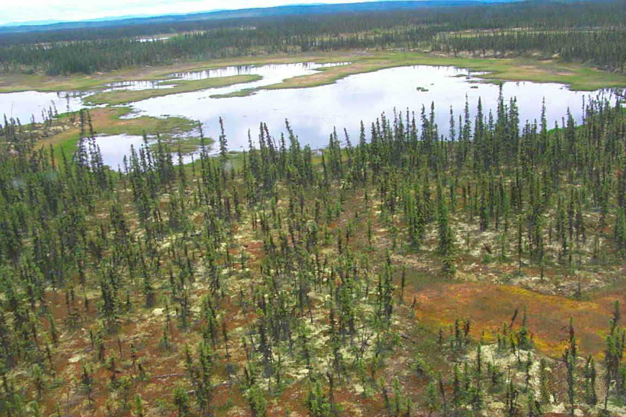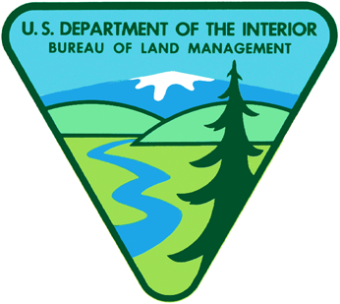

**U.S. Department of the Interior**

U.S. Fish and Wildlife Service

Koyukuk National Wildlife Refuge

**Ducks Unlimited, Inc.**

**BLM-Alaska Technical Report 30**

BLM/AK/ST-02/009+6500+931

2002

**Melozitna River and**

**Koyukuk NWR**

**Earth Cover Classification**

U.S. Department of the Interior

Bureau of Land Management

**Mission Statement**

The Bureau of Land Management (BLM) sustains the health, diversity and productivity of the public lands for the use and enjoyment of present and future generations.

**Partners**

The Department of the Interior’s Bureau of Land Management and U.S. Fish and Wildlife Service, and Ducks Unlimited, Inc. completed this project under a cooperative agreement.

**Cover**

The cover photo shows a portion of the Koyukuk National Wildlife Refuge. It depicts the remoteness of the area and the need to use helicopters for data collection.

**Technical Reports**

Technical Reports issued by the Bureau of Land Management‑Alaska present the results of research, studies, investigations, literature searches, testing, or similar endeavors on a variety of scientific and technical subjects. The results presented are final, or are a summation and analysis of data at an intermediate point in a long‑term research project, and have received objective review by peers in the author’s field.

The reports are available while supplies last from BLM External Affairs, 222 West 7th Avenue, #13, Anchorage, Alaska 99513 (907) 271-3318 and from the Juneau Minerals Information Center, 100 Savikko Road, Mayflower Island, Douglas, AK 99824, (907) 364‑1553. Copies are also available for inspection at the Alaska Resource Library and Information Service (Anchorage), the United States Department of the Interior Resources Library in Washington, D. C., various libraries of the University of Alaska, the BLM National Business Center Library (Denver) and other selected locations.

A complete bibliography of all BLM‑Alaska scientific reports can be found on the Internet at:

http://www.ak.blm.gov/affairs/sci_rpts.html.

Related publications are also listed at: [**http://juneau.ak.blm.gov**](http://juneau.ak.blm.gov).

Melozitna River and Koyukuk NWR

Earth Cover Classification

Technical Report

August 2002

U. S. Department of the Interior

Bureau of Land Management

Alaska State Office

222 W. 7th Ave., #13

Anchorage, AK 99513

U.S. Department of the Interior

U.S. Fish and Wildlife Service

Koyukuk/Nowitna National Wildlife Refuge Complex

P.O. Box 287

Galena, AK

Ducks Unlimited, Inc.

3074 Gold Canal Drive

Rancho Cordova,CA 95670

# Acknowledgements

This project was funded under a cooperative agreement between the United States Department of the Interior’s Fish and Wildlife Service (FWS) and Bureau of Land Management (BLM), and Ducks Unlimited, Inc (DU). This project was administered by Mike Spindler (FWS), Guy Hughes (FWS), John Payne (BLM), and Beate Sterrenberg (Ducks Unlimited).

Special thanks are extended to those who worked in the field: Jeff Campbell (Spatial Solutions), Scott Guyer (BLM), Guy Hughes, Collin Cogley (BLM), and multiple bio-techs from the Galena office of the FWS and the BLM Alaska State Office. Thanks to Louis Drapeau from Evergreen Helicopters, for safe air service. Thanks also to Bob McAlpin from Alaska Fire Service for help in coordinating helicopter contracting, Jeff Campbell for image processing, Mark Pearson (GoeNorth, Inc.) for programming the DUFF field database; and Jing Huang (DU) for programming the accuracy assessment program.

# Table of Contents

Acknowledgements iii

Table of Contents v

List of Figures vii

List of Tables ix

Abstract xi

Introduction 1

Project Objective 1

Project Area 2

Data Acquisition 3

Methods 5

Classification Scheme v

Image preprocessing v

Field Verification 7

Field Data Analysis 9

Classification 9

Accuracy Assessment 13

Results 17

Field Verification 17

Classification 17

Accuracy Assessment 24

Final Products 29

Summary 31

Literature Cited 33

Appendices 35

Appendix A. Alaska Earth Cover Classification Class Descriptions 35

Appendix B. Earth cover classification decision tree. 41

Appendix C. Plant species and cover type list. 45

Appendix D. Melozitna River/Koyukuk NWR Accuracy Assessment Error Matrices 49

# List of Figures

**Figure 1.** Koyukuk NWR and Lower Melozitna Drainage project location. 2

**Figure 2.** Satellite imagery used for the Melozitna River and Koyukuk NWR Earth Cover Mapping Project. 3

**Figure 4.** The customized database and user interface for field data entry (DUFF). 10

**Figure 5.** The image processing flow diagram. 11

**Figure 6.** Koyukuk NWR / Lower Melozitna Drainage final classified map. 21

**Figure 7.** Aerial view of mis-classified Open Mixed Needleleaf/Deciduous stand. 27

**Figure 8.** Aerial view of mis-classified Open Mixed Needleleaf/Deciduous stand. 27

# List of Tables

**Table 1.** Classification scheme developed at the BLM Earth Cover Workshop. 6

**Table 2.** Field sites per mapped class**.** 18

**Table 3.** List of field data collection participants. 18

**Table 4.** Acreage of earth cover classes within the project area. 22

# Abstract

The Bureau of Land Management (BLM) – Alaska and Ducks Unlimited, Inc. (DU) have been cooperatively mapping wetlands and associated uplands in Alaska using remote sensing and GIS technologies since 1988. The goal of this project was to continue the effort by mapping the Koyukuk National Wildlife Refuge and lower Melozitna River Drainage and associated uplands. Portions of four Landsat TM satellite scenes (Paths 75, Rows 14 and 15 (acquired June 30, 1999) and Path 76, Rows 14 and 15 (acquired June 23, 2000) were used to classify the project area into 43 earth cover categories. An unsupervised clustering technique was used to determine the location of field sites and a custom field data collection form and digital database were used to record field information. A helicopter was utilized to gain access to field sites throughout the project area. Global positioning system (GPS) technology was used both to navigate to pre-selected sites and record locations of new sites selected in the field. Data were collected on 452 field sites during a 10-day field season from 6/19/01 through 6/29/01. Approximately 30% (134) of these field sites were set aside for accuracy assessment. A modified supervised/unsupervised classification technique was performed to classify the satellite imagery. The classification scheme for the earth cover inventory was based on Viereck et al. (1992)and revised through a series of meetings coordinated by the BLM – Alaska and DU. The overall accuracy of the mapping categories was 85.8% at the +/-5% level of variation in interpretation of the accuracy assessment reference sites.

# Introduction

The Bureau of Land Management (BLM) – Alaska and Ducks Unlimited, Inc. (DU) began cooperatively mapping wetlands and associated uplands in Alaska using remote sensing and GIS technologies in 1988 (Ritter et al. 1989). Early mapping projects focused exclusively on wetlands (Ritter et al. 1989) but it was apparent that mapping the entire landscape was more cost effective and ultimately more useful to land managers. The BLM is creating a satellite-based, earth cover inventory of all BLM managed lands in Alaska. Many other agencies in Alaska (e.g., National Park Service, U.S. Fish and Wildlife Service, U.S. Forest Service, Alaska Department of Natural Resources, Alaska Department of Fish and Game) are also using similar techniques, and cooperating on these mapping projects. This earth cover mapping effort provides an inventory of Alaska’s land base that can be used for regional management of land and wildlife. Earth cover databases allow researchers, biologists, and managers to define and map crucial areas for wildlife; perform analysis of related habitats; detect changes in the landscape; plot movement patterns for large ungulates; generate risk assessments for proposed projects; and provide baseline data to which wildlife and sociological data can be related.

Landsat Enhanced Thematic Mapper (ETM) satellite imagery was chosen as the primary source for the BLM/DU earth cover mapping effort. Satellite imagery offered a number of advantages for region-wide projects. TM data was cost effective, processed using automated mapping techniques, and collected on a cyclical basis, providing a standardized data source for future database updates or change detection studies (Kempka et al. 1993). In addition, TM imagery included a mid-infrared band, which was sensitive to both vegetation and soil moisture content and was useful in identifying earth cover types. When combined with other GIS data sets, (e.g., elevation, slope, aspect, shaded relief, and hydrology), Landsat TM data produced highly accurate classifications with a moderately detailed classification scheme.

The Melozitna River and Koyukuk NWR Earth Cover Mapping project area contained diverse landscapes and was deemed important for its wildlife and recreational values. The project area extended from the Yukon River in the south, to Caribou Mountain in the north, to the Melozitna River in the east, and west to the Koyukuk River and Nulato Hills. The project area was essentially un-roaded and supported limited recreational use with the exception of fishing along the Yukon River and an occasional boating/canoeing trip on the Melozitna and Koyukuk Rivers. The project area included an abundant moose and tundra swan population and prime caribou migration routes and lichen forage areas; especially near the village of Huslia. The earth cover data will aid in the critical process of resource planning in this valuable and diverse area.

## Project Objective

The objective of this project was to develop a baseline earth cover inventory using Landsat TM imagery for the BLM’s Melozitna River lands, the Koyukuk NWR, and associated areas. More specifically, this project purchased, classified, field verified, and produced high quality, high resolution digital and hard copy resource base maps. The result of this project was an integrated GIS database that can be used for improved natural resources planning.

## Project Area

The project area (Figure 1) for the Melozitna River and Koyukuk NWR Mapping Project consisted of 4.5 million acres centered roughly on the area framed by a triangle formed between the villages of Galena, Ruby, and Huslia. The project area falls in the center of the Kateel River and Melozitna 1:250,000 scale quadrangles. The Koyukuk River runs along the northern and western boundary of the study area. It included portions of the following USGS 1:250 scale quadrangles: Ruby, Melozitna, Nulato, Kateel River, Nulato, and Shungnak. The village of Galena fell just inside the southern boundary of the project along the Yukon River. The village of Huslia is located in the northwest quadrant of the study area.

While this project area encompassed a wide variety of environments ranging from glaciated mountains to lowland black spruce muskeg, much of the study area (45%+) included habitats composed of some form of black and/or white spruce cover.

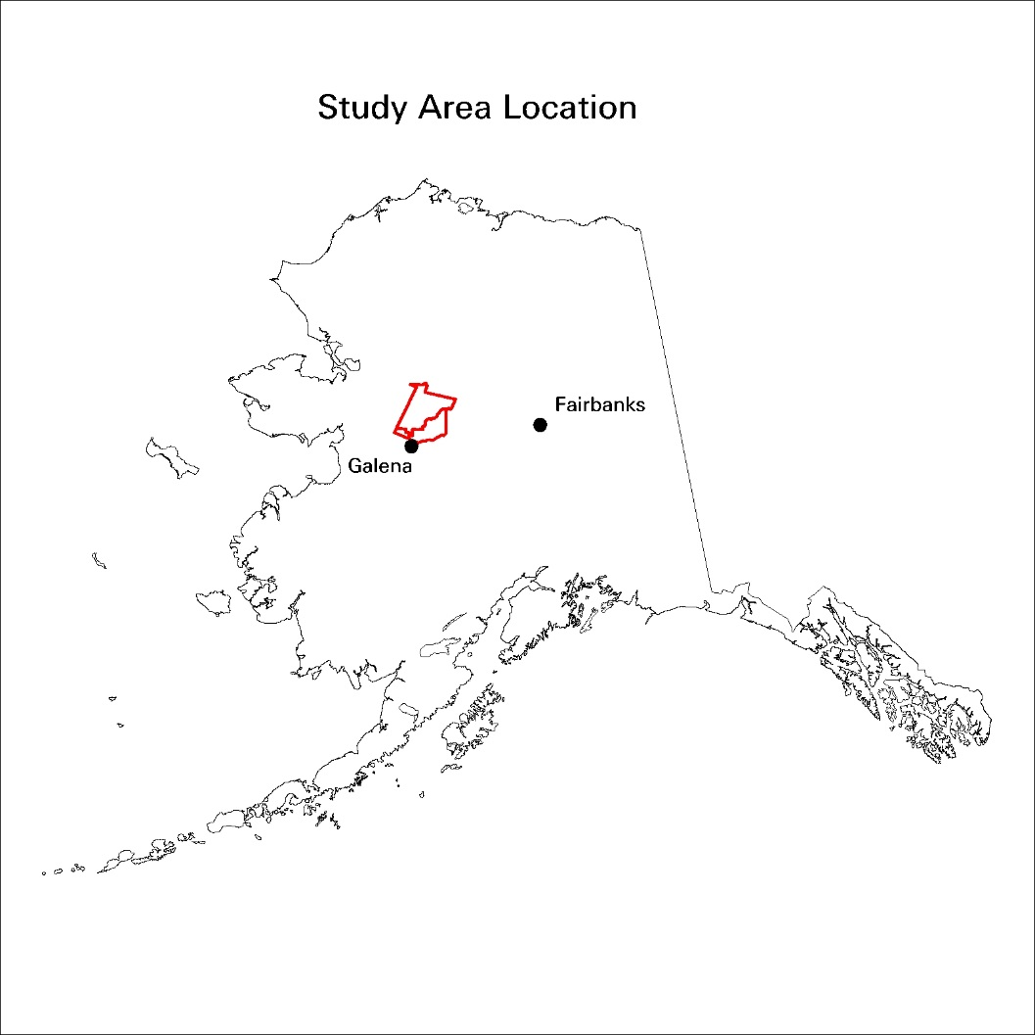

**Figure 1.** Koyukuk NWR and Lower Melozitna Drainage project location.

Large regions of tall and low shrub and low shrub tundra accounted for nearly one-quarter of the study area. Minimal non-forested uplands and associated habitats were present within the study area and were found only along the extreme southeastern and northern edge of the mapping area. The presence of lichen throughout many of the mapped forested and non-forested habitats was substantial. The wide extent of lichen throughout this study area create important caribou habitat. While moose abounded throughout most of the project area, evidence of frequent bear use was also noted, in addition to several black bear sightings. Innumerable small lakes and ponds supported the pond lilies and other aquatic vegetation that make up an important summer food source for breeding tundra swans. Most all wildfires that had burned over the study area were indicated on the 1999 - 2000 satellite imagery.

## Data Acquisition

Four Landsat-7 Enhanced Thematic Mapper scenes were purchased to cover the project area (Figure 2). Path 75, rows 14 and 15,

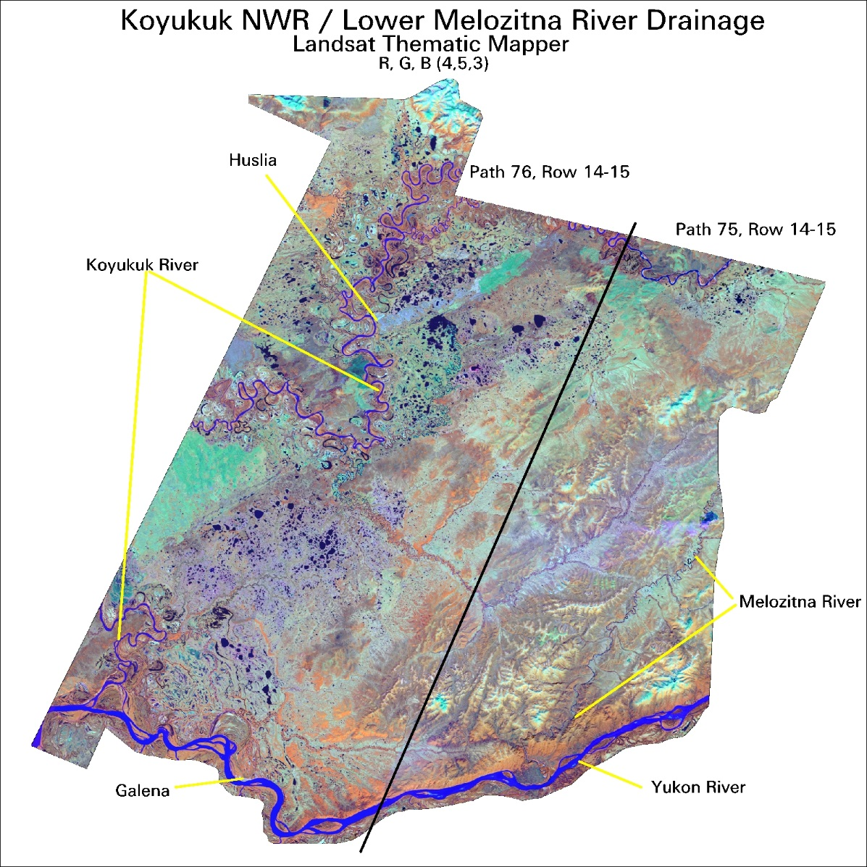

**Figure 2.** Satellite imagery used for the Melozitna River and Koyukuk NWR Earth Cover Mapping Project.

acquired June 30, 1999 covered the eastern half of the project area. Path 76, rows 14 and 15, acquired June 23, 2000 covered the western half of the project area. The scenes were purchased from EROS Data Center in Albers Equal Area projection and were terrain corrected by ImageLinks, Inc., Melbourne, FL. The images contained no significant cloud cover, however, a slight trail of light smoke can be seen coming from a fire just outside the eastern study area boundary. Due to the relatively low mean elevation of the study area and the mid-summer date of the imagery, very little snow or ice covered any portion of the study area.

Field data were collected on 452 field sites during a 10-day field season from 6/19/01 through 6/29/01. The ancillary data used in this project included: 1:60,000 aerial photographs (color infrared transparencies from 1980-82, 1984, and 1986-87 and USGS1:250,000 scale Digital Elevation Models (DEM).

# Methods

## Classification Scheme

The classification system categorized the features to be mapped. The system was derived from the anticipated uses of the map information and the features of the earth that could be discerned by TM data. The classification system had two critical components: (1) a set of labels (e.g., forest, shrub, water); and (2) a set of rules, or a system for assigning labels. The set of rules for assigning labels was mutually exclusive and totally exhaustive (Congalton 1991). Any given area fell into only one category and every area was included in the classification.

Until recently, the BLM/DU classification systems were project specific. As projects expanded in size and as other cooperators began mapping and sharing data across Alaska, the necessity for a standardized classification system became apparent. At the BLM Earth Cover Workshop in Anchorage on 3-6 March 1997, a classification system based on the existing Alaska Vegetation Classification (Viereck et al. 1992) was designed to address this need. The goal of this meeting was to (1) develop an earth cover classification system for the state of Alaska that can be used in large regional mapping efforts, and (2) build consensus for the system among multiple land management agencies. The classification system has been slightly improved since the last meeting.

The classification scheme (Table 1) consisted of 10 major categories and 24 subcategories. A classification decision tree and written description (Appendices A and B) was developed in order to clarify the classification. Though based largely on Level III of the Viereck et al. (1992) classification, some classes have been modified, added or omitted for these mapping projects: e.g., rock, water, ice, cloud and shadow classes were added. Other classes that could not reliably be discerned from satellite imagery had to be collapsed, such as open and closed low shrub classes, or dryas, ericaceous, willow, and dwarf shrub classes. Because of the importance of lichen for site characterization and wildlife, and because the presence of lichen can be detected by satellite imagery, shrub and forested classes with and without a component of lichen were distinguished. A few classes from Level IV of the Viereck et al. (1992) classification were also mapped because of their identifiable satellite signature and their importance for wildlife management. These Level IV classes included tussock tundra, low shrub tussock tundra and low shrub willow/alder.

## Image preprocessing

Each image was examined for quality and consistency. Each band was examined visually and statistically by reviewing histograms. Combinations of bands were displayed to check for band-to-band registration and for clouds, shadows, and haze. Positional accuracy was checked by comparing the image to available ancillary data such as adjacent imagery, hydrography, and DEM’s.

**Table 1.** Classification scheme developed at the BLM Earth Cover Workshop.

|  |  |  |
| --- | --- | --- |
| Level II | Level III | Level IV |
| 1.0 Forest | 1.1 Closed Needleleaf |  |
|  | 1.2 Open Needleleaf | 1.21Open Needleleaf Lichen |
|  | 1.3 Woodland Needleleaf | 1.31 Woodland Needleleaf Lichen |
|  |  |  |
|  | 1.4 Closed Deciduous | 1.41 Closed Paper Birch |
|  |  | 1.42 Closed Aspen |
|  |  | 1.43 Closed Balsam Poplar/Cottonwood |
|  |  | 1.44 Closed Mixed Deciduous |
|  | 1.5 Open Deciduous | 1.51 Open Paper Birch |
|  |  | 1.52 Open Aspen |
|  |  | 1.53 Open Balsam Poplar/Cottonwood |
|  |  | 1.54 Open Mixed Deciduous |
|  |  |  |
|  | 1.6 Closed Mixed Needleleaf/Deciduous |  |
|  | 1.7 Open Mixed Needleleaf/Deciduous |  |
|  |  |  |
| 2.0 Shrub | 2.1 Tall Shrub |  |
|  | 2.2 Low Shrub | 2.21 Low Shrub Willow/Alder |
|  |  | 2.22 Low Shrub Tussock Tundra |
|  |  | 2.23 Low Shrub Lichen |
|  |  | 2.24 Low Shrub Other |
|  |  |  |
|  | 2.3 Dwarf Shrub | 2.31 Dwarf Shrub Lichen |
|  |  | 2.32 Dwarf Shrub Other |
|  |  |  |
| 3.0 Herbaceous | 3.1 Bryoid | 3.11 Lichen |
|  |  | 3.12 Moss |
|  |  |  |
|  | 3.2 Wet Herbaceous | 3.21Wet Graminoid |
|  |  | 3.22 Wet Forb |
|  |  |  |
|  | 3.3 Mesic/Dry Herbaceous | 3.31 Tussock Tundra |
|  |  | 3.32 Mesic/Dry Sedge Meadow |
|  |  | 3.33 Mesic/Dry Grass Meadow |
|  |  | 3.34 Mesic/Dry Graminoid |
|  |  | 3.35 Mesic/Dry Forb |
|  |  |  |
| 4.0 Aquatic Vegetation | 4.1 Aquatic Bed |  |
|  | 4.2 Emergent Vegetation |  |
|  |  |  |
| 5.0 Water | 5.1 Snow |  |
|  | 5.2 Ice |  |
|  | 5.3 Clear Water |  |
|  | 5.4 Turbid Water |  |
|  |  |  |
| 6.0 Barren | 6.1 Sparsely Vegetated |  |
|  | 6.2 Rock/Gravel |  |
|  | 6.3 Mud/Silt/Sand |  |
| 7.0 Urban |  |  |
|  |  |  |
| 8.0 Agriculture |  |  |
|  |  |  |
| 9.0 Cloud/Shadow | 9.1 Cloud |  |
|  | 9.2 Shadow |  |
| 10.0 Other |  |  |

In order to optimize helicopter efficiency, field sites were identified and plotted on field maps before fieldwork began. Sufficient samples for each mapped class were selected to span the variation of spectral responses within that class throughout the entire image. For example, a shrub class in the southern part of an image may have a different spectral response than the same shrub class in the northern part of that image. Many factors contribute to such variation, including aspect, terrain shadow, or small differences in soil moisture. In addition, each earth cover type encompassed a variety of subtypes; e.g., the open needleleaf class included forested areas with 25%-60% crown closure, trees of varying height, and a diverse understory composition.

An unsupervised classification was used to identify spectrally unique areas within the study area. The image analyst individually selected training sites from these spectrally unique areas. Whenever possible, training sites were grouped in clusters to reduce the amount of travel time between sites. The image analyst also to placed training sites near landmarks that were easily recognizable in the field, such as lakes or streams. A tally of the estimated number of field sites per class was kept until all of the target map classes were adequately sampled throughout the project area. The coordinates of the center points of the field sites were then uploaded into a Y-code Rockwell Precision Lightweight GPL receiver (PLGR) for navigational purposes. Training sites were overlain with the satellite imagery and plotted at 1 inch = 1 mile scale. These field maps were used for recording field notes, placing additional field sample sites, and navigating to field sites.

## Field Verification

The purpose of field data collection was to assess, measure, and document the on-the-ground vegetation variation within the project area. This variation was correlated with the spectral variation in the satellite imagery during the image classification process. Low-level helicopter surveys were a very effective method of field data collection since a much broader area was covered with an orthogonal view from above, similar to a satellite sensor. In addition, aerial surveys were often the only alternative in Alaska due to the large amount of roadless areas.

To obtain a reliable and consistent field sample, a custom field data collection form (Kempka et al. 1994) was developed and used to record field information (Figure 3). A five- person helicopter crew performed the field assessment. Each crew consisted of a pilot, biologist, recorder, navigator, and alternate. The navigator operated the GPS equipment and interpreted the satellite image derived field maps to guide the biologist to the pre-defined field site. It was valuable for the image processor to gain first-hand knowledge of the project area, so therefore the image processor had the navigator role. The biologist identified plant species, estimated the percent cover of each cover type, determines the overall earth cover class, and photographed the site. The recorder wrote species percentages and other data on the field form and generally assisted the biologist. The alternate was responsible for crew check-ins, data entry, and substitution in case of sickness. The majority of sites were observed without landing the helicopter. Ground verification was performed when identification of dominant vegetation was uncertain.

**Figure 3. Custom field data collection form.**

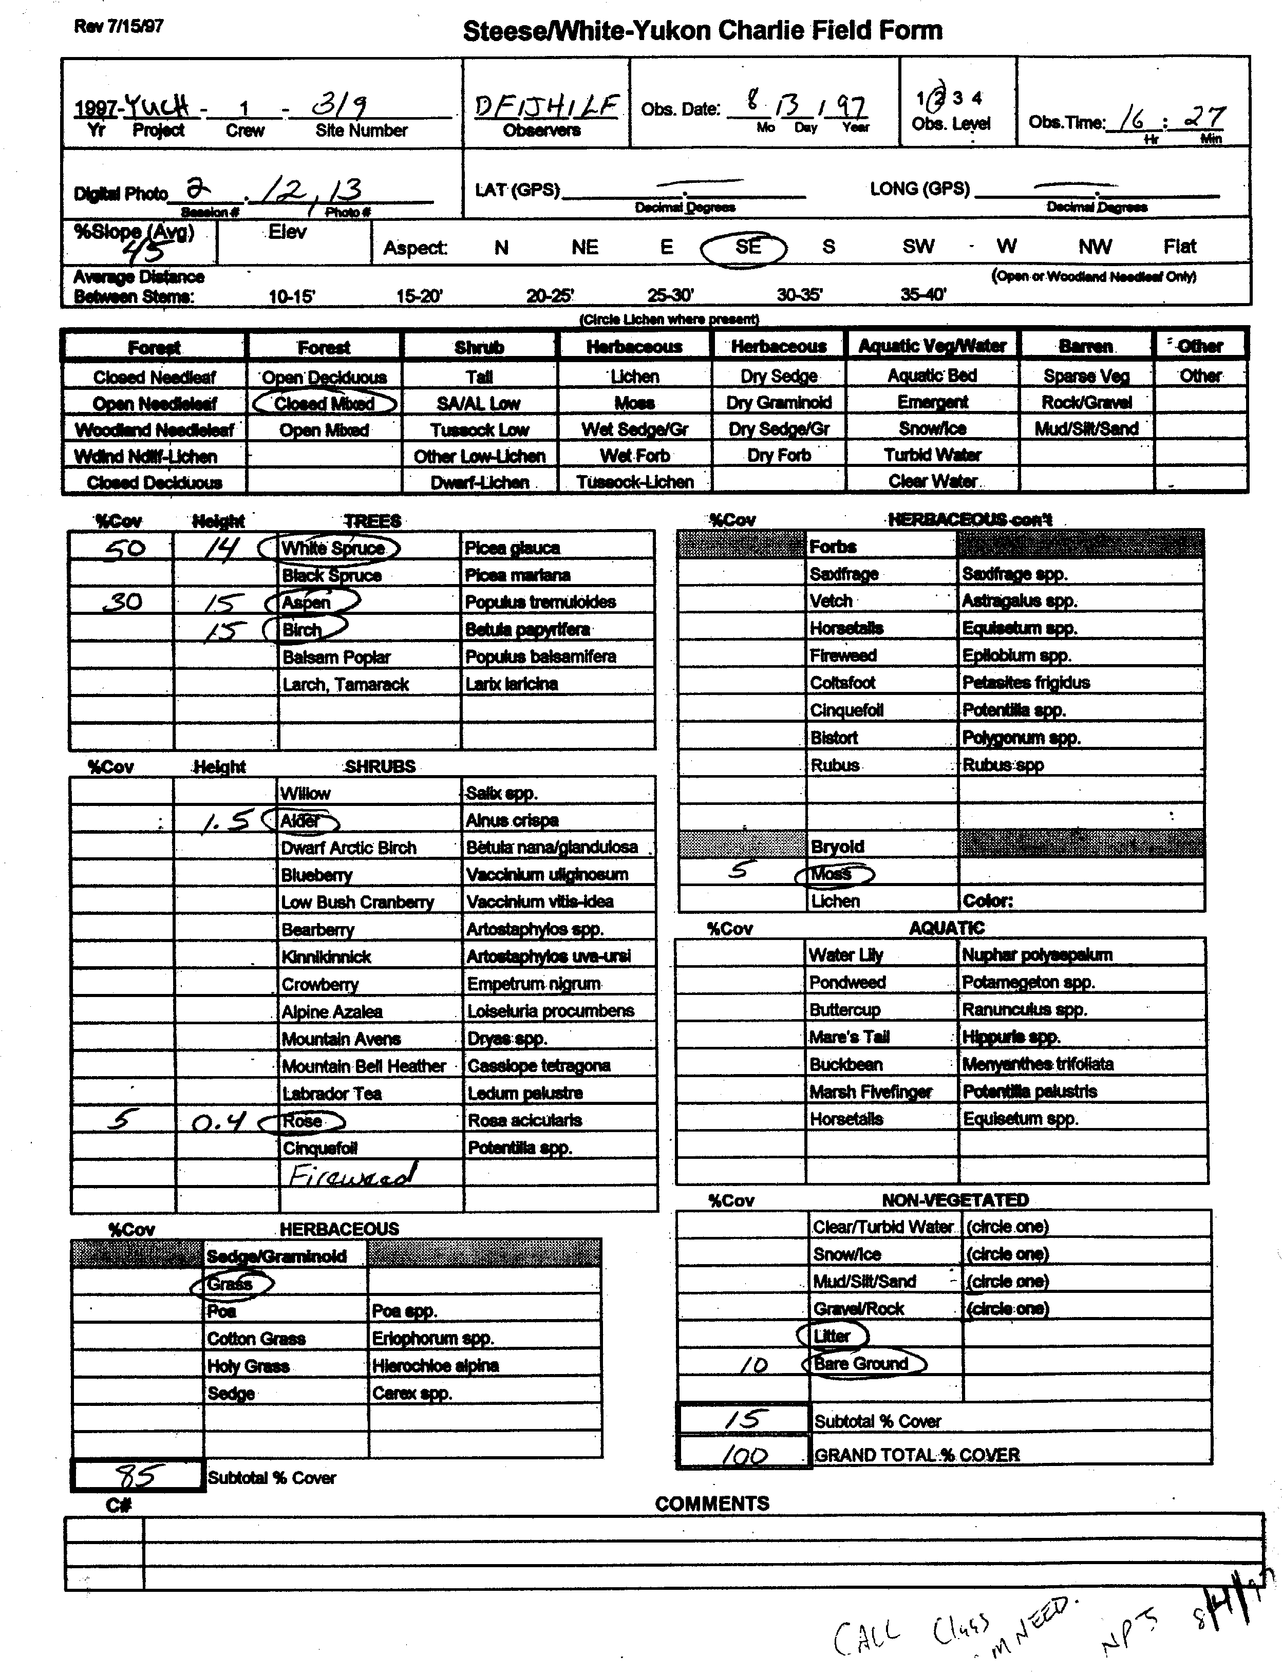

**TIEK**

**XXX**

**Sample Field Form**

These DU/BLM procedures for collecting field data have evolved into a very efficient and effective means of data collection. The navigator used a GPS to locate the site and verified the location on the field map. As the helicopter approached the site at about 300 meters above ground level the navigator described the site and the biologist took a picture with a digital camera. The pilot then descended to approximately 5-10 meters above the vegetation and laterally moved across the site while the biologist called out the vegetation to the recorder. The biologist took another picture with the digital camera for a close-up view of the site. The pilot then ascended to approximately 100 meters so that the biologist could estimate the percentages of each species to the recorder. The navigator then directed the pilot to the next site. On average, it took approximately 4-6 minutes to collect all of the information for one site.

## Field Data Analysis

The collected field information was entered into a digital database using a custom data entry application (DUFF), designed jointly by the BLM and DU and programmed by GeoNorth. The relational database was powered by SQL Anywhere while the user interface was programmed in Visual Basic. The user interface was organized similarly to the field form to facilitate data entry (Figure 4). The application utilized pull down menus to minimize keystrokes and checked for data integrity to minimize data entry errors. The database program also calculated an overall class name for each site based on the recorded species and its cover percentage. Digital images from each site were stored in the database and accessible from within the user interface. The number of field sites per earth cover class was tracked daily to ensure that adequate samples were being obtained within each class.

## Classification

Every image is unique and presents special problems in the classification process. The approach used in this project (Figure 5) has been proven successful over many years. The image processor was actively involved in the field data collection and had first hand knowledge of every training site. The image processor’s site-specific experience and knowledge in combination with high quality ancillary data overcame image problems to produce a high quality, useful product.

Erdas Imagine (vers. 8.5) was used to perform the classification as well as to manage the field site polygons. Various word processing and data analysis software packages were also used during the image classification including MS Word, Excel and Access.

Generation of New Bands

The Landsat TM imagery contained 7 bands of data: 3 visible bands, 1 near-infrared band, 2 mid-infrared bands, and 1 thermal band. One new band was generated for this project. This new band was created using a band-4/band-3 ratio, a band ratio that typically reduces the effect of shadows in the image and enhances the differences between vegetation types (Kempka et al. 1995, Congalton et al. 1993). This 4/3 ratio band replaced thermal band (band 6) to retain a 7-band image for classification.

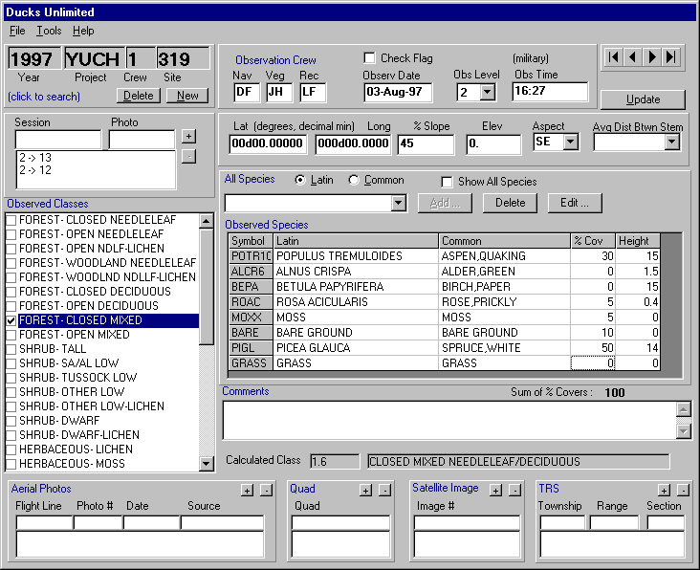

**GULK**

XXX

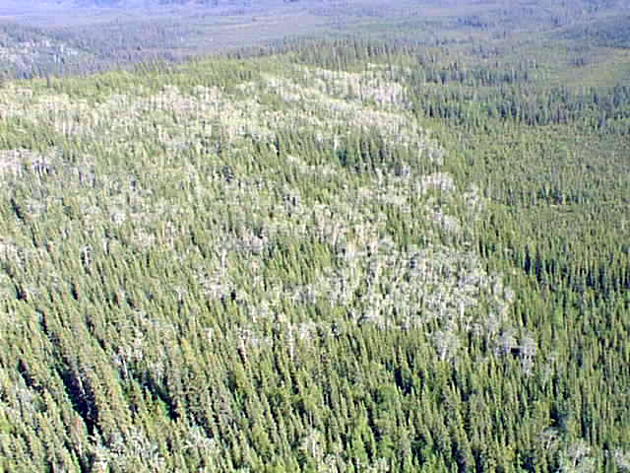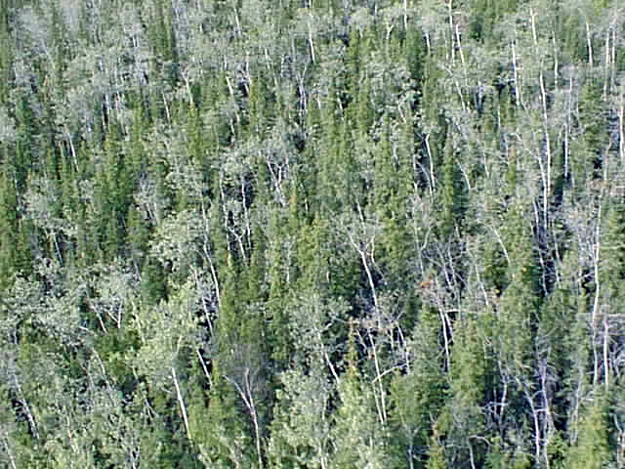 **Sample Field Site – Closed Mixed Needleleaf/Deciduous**

**High site photo Low site photo**

**DUFF INTERFACE**

**Figure 4.** The customized database and user interface for field data entry (DUFF).



**Figure 5.** The image processing flow diagram.

Removal of Clouds and Shadows

Although the entire Koyukuk NWR/Lower Melozitna River Drainage study area can be captured on a single scene/date of Landsat TM imagery, the only available scene of imagery, of relatively recent vintage, that captured the entire study area contained significant cloud cover. Therefore, a decision was made to utilize a composite of two dates/scenes of TM imagery to create a base image data set that was essentially cloud-free. The relatively small amount of haze and smoke from an active fire burning just to the east of the study area were removed from the image before field sites were selected. This process eliminated any confusion between clouds, cloud shadows, and other vegetation types. They were removed using an unsupervised classification and manual on-screen editing. Clouds were separated from shadows and classes were recoded to their respective class number. The cloud/shadow layer is then combined with the rest of the classified image during the last step in the classification process.

Seeding Process

Spectral signatures for the field sites to be used as training areas were extracted from the imagery using a “seeding” process in Erdas Imagine. A pixel within each training area was chosen as a “seed” and adjoining pixels were evaluated for inclusion in each training site using a threshold value based on a spectral euclidean distance. The standard deviations of the seeded areas were kept close to or below 3 and all seeded areas were required to be over 15 pixels (approximately 3.75 acres) in size. Along with the field training areas, additional “seeds” were generated for clear water, turbid water, and snow classes. These classes were easily recognized on the imagery and aerial photography. The output of the seeding process in Imagine was a signature file that contains all of the statistics for the training areas. The signature file was then used in the modified supervised/unsupervised classification.

Generation of Unsupervised Signatures

An unsupervised classification was generated using the six raw bands and the 4/3 ratio. One hundred and fifty signatures were derived from the unsupervised classification using the ISODATA program in Imagine. The output of this process was a signature file similar to that of the seeding process but containing the 150 unsupervised signatures. A maximum likelihood classification of the 150 unsupervised signatures was generated using the supervised classification program in Imagine.

Modified Supervised/Unsupervised Classification

A modified supervised/unsupervised classification approach (Chuvieco and Congalton 1988) was used for the classification. This approach used a statistical program to group the spectrally unique signatures from the unsupervised classification with the signatures of the supervised training areas. In this way, the spectrally unique areas were labeled according to the supervised training areas. This classification approach provided three major benefits: (1) it aided in the labeling of the unsupervised classes by grouping them with known supervised training sites; (2) it helped to identify classes that possessed no spectral uniqueness (i.e., training sites that were spectrally inseparable); and (3) it identified areas of spectral reflectance present in the imagery that had not been represented by a training site. This approach was an iterative process because all of the supervised signatures do not cluster perfectly with the unsupervised signatures the first time. The unsupervised signatures that matched well with the supervised signatures were inspected, labeled with the appropriate class label, and removed from the classification process. The remaining confused clusters were grouped into general categories (e.g., forest, shrub, non-vegetation) and re-run through the process. This process was repeated until all of the spectral classes were adequately matched and labeled, or until the remaining confused classes were spectrally inseparable. Throughout this iterative process, interim checks of classification accuracy were performed by intersecting the classified image with a coverage of the training sites to determine if the training sites were being accurately labeled by the classification. Areas with incorrectly classified training sites were run through further iterations of the supervised/unsupervised classification and further refined. The iterative process of interim accuracy assessments and refining classifications was terminated when the accuracy assessments indicated no improvements between one iteration and the next.

### Editing and Modeling

Models that incorporated ancillary data sets such as elevation, slope, aspect, shaded relief, etc. helped to separate confused classes. For instance, terrain shadow/water confusion was easily corrected by creating a model using a shaded relief layer derived from DEMs.

For this project, the final steps of the classification process were to model the confused classes remaining after the iterative supervised/unsupervised classification process and to make final edits in areas that still had classification errors. Editing of classification errors was a process of comparing the classified image to the raw satellite image, aerial photography, and notes on field maps to identify errors remaining in the classification. These errors were then corrected by manually changing the class value for the pixels that were classified in error to their correct class value.

## Accuracy Assessment

There were two primary motivations for accuracy assessment: (1) to understand the errors in the map (so they can be corrected), and (2) to provide an overall assessment of the reliability of the map (Gopal and Woodcock, 1992). Factors affecting accuracy included the number and location of test samples and the sampling scheme employed. Congalton (1991) suggested that 50 samples be selected for each map category as a rule of thumb. This value has been empirically derived over many projects. A second method of determining sample size includes using the multinomial distribution and specifying a given confidence in the estimate (Tortora 1978). The results of this calculation tend to favorably agree with Congalton’s rule of thumb. Once a sample size is determined, it must be allocated among the categories in the map. A strictly proportional allocation is possible. However, the smaller categories in areal extent will have only a few samples that may severely hamper future analysis. The other extreme is to force a given number of samples from each category. Depending on the extent of each category, this approach can significantly bias the results. Finally, a sampling scheme must be selected. A purely random approach has excellent statistical properties, but is practically difficult and expensive to apply. A purely systematic approach is easy to apply, but could result in sampling from only limited areas of the map.

### Alaska Perspective

Obtaining adequate reference data for performing an accuracy assessment can be extremely expensive in remote areas. Aircraft is the only means of transportation throughout most of Alaska. Aerial photographs are available for most of Alaska, but most are at a scale that makes it difficult if not impossible to distinguish some vegetation classes. Ideally, fieldwork would be performed during one summer, the classification would be performed during the winter, and the reference data would be collected the next summer. This procedure would allow a stratified random sample of the classification and ensure adequate sampling of all the classes. Unfortunately, this methodology is not typically feasible due to the cost of obtaining the field data in Alaska.

In this project, the fieldwork for obtaining the training sites for classifying the imagery and the reference data for the accuracy assessment was accomplished at the same time. Special care was taken during the preprocessing stage and in the field to make sure adequate samples were obtained. However, funding limitations did not allow for the number of samples suggested for each class (n=50) for the accuracy assessment. Some earth cover classes were naturally limited in size and distribution, so that a statistically valid accuracy assessment sample could not be obtained without additional field time. For classes with low sample sizes few, if any, field sites were withheld for the accuracy assessment. This does not indicate that the classification for these types is inaccurate but rather that no statistically valid conclusions can be made about the accuracy of these classes. However, withholding even a small percentage of sites for the accuracy assessment provided some confidence in the classification and guided the image processor and end user in identifying areas of confusion in the classification.

Selection of Accuracy Assessment Sites

Approximately 30% of the collected field sites were set aside for use in the assessment of map accuracy while the remaining sites were utilized in the classification process. Unfortunately, given time and budget constraints it was not always possible to obtain enough sites per class to perform both the classification and a statistically valid accuracy assessment. A minimum of 15 sites in an individual class (5 for accuracy assessment, 10 for image processing training sites) was required before any attempt was made to assess the accuracy of that class. Classes with less than 15 field sites were still classified. However, much fewer, if any, field sites were utilized for accuracy assessment for these classes. Accuracy assessment sites were selected randomly across the project area to reduce bias.

### Some Considerations

While the accuracy assessment performed in this project is by no means a robust test of the classification, it does give the user some confidence in using the classification. It also provides enough detail for the end user to determine where discrepancies in the classification may cause a problem while using the data. It is also important to note the variations in the dates of the imagery, aerial photographs, and field data. For this project, the imagery was from June, 1999/2000; the aerial photographs spanned a seven year period from 1980 through 1987,

the field data was collected in July 2001. Differences due to environmental changes from the different sources may have had a major impact on the accuracy assessment.

A major assumption of quantitative accuracy assessments is that the label from the reference information represents the “true” label of the site and that all differences between the remotely sensed map classification and the reference data are due to classification and/or delineation error (Congalton and Green 1993). Unfortunately, error matrices can be inadequate indicators of map error because they are often confused by non-map error differences. Some of the non-map errors that can cause confusion are: registration differences between the reference data and the remotely sensed map classification, digitizing errors, data entry errors, changes in land cover between the date of the remotely sensed data and the date of the reference data, mistakes in interpretation of reference data, and variation in classification and delineation of the reference data due to inconsistencies in human interpretation of vegetation.

In an effort to account for some of the variation in human interpretation in the accuracy assessment process, overall classification accuracies were also generated assuming a +/- 5% variation in estimation of vegetation compositions for each of the accuracy assessment sites. In other words, if a variation in interpretation of +/- 5% would have resulted in the generation of a different reference site label, this new label was also considered an acceptable mapping label for the reference site.

Error Matrix

The standard method for assessing the accuracy of a map was to build an error matrix, also known as a confusion matrix, or contingency table. The error matrix compares the reference data (field site or photo interpreted site) with the classification. The matrix was designed as a square array of numbers set out in rows and columns that expressed the number of sites assigned to a particular category in the reference data relative to the number of sites assigned to a particular category in the classification. The columns represented the reference data while the rows indicated the classification (Lillesand and Kiefer, 1994). An error matrix was an effective way to represent accuracy in that the individual accuracy of each category was plainly described along with both the errors of inclusion (commission errors) and errors of exclusion (omission errors) present in the classification. A commission error occurred when an area was included in a category it did not belong. An omission error was excluding that area from the category in which it did belong. Every error was an omission from the correct category and a commission to a wrong category. Note that the error matrix and accuracy assessment was based on the assumption that the reference data was 100% correct. This assumption was not always true.

In addition to clearly showing errors of omission and commission, the error matrix was used to compute overall accuracy, producer’s accuracy, and user’s accuracy (Story and Congalton 1986). Overall accuracy was allocated as the sum of the major diagonal (i.e., the correctly classified samples) divided by the total number of samples in the error matrix. This value is the most commonly reported accuracy assessment statistic. Producer’s and user’s accuracies are ways of representing individual category accuracy instead of just the overall classification accuracy.

# 

# Results

## Field Verification

Data were collected on 452 field sites during a 10-day field season from 7/19/01 through 7/29/01. Approximately 30% (134) of these field sites were set aside for accuracy assessment. The proportions of sites per class (Table 2) largely reflects the proportion of corresponding earth cover types within the project area, though proportionally more sites were collected for classes that exhibited greater variation in growth form and/or spectral response on the satellite imagery.

An A-Star helicopter was used to gain access to the field sites. For consistency in data collection, one crewmember acted as the “vegetation caller” and performed the vegetation identification and percentage estimates for all sites (Table 3). A single field “camp” location was utilized throughout the project. The BLM Alaska Fire Service barracks and airfield in the village of Galena served as the staging area for the field crew, helicopter, field equipment, and all planning activities. The primary fuel depot was based at the Galena Airstrip. A remote fuel site was also established at the airstrip in the village of Huslia (two 500 gallon bladders). Flight following was conducted via helicopter radio with the Alaska Fire Service dispatcher in Galena. Alternative flight following was also conducted via radio through the USF&WS station in Galena.

## Classification

The three most extensive vegetated classes within the final classification were: Open Needleleaf (944,335 acres or 20.9% of total area), Woodland Needleleaf (786,441 acres or 17.4% or total area), Low Shrub – Other (582,128 acres or 12.9% of total area). While the total of these three cover types accounted for just over 50% of the study area’s vegetation, only one other single vegetation type comprised more than 5% of the total earth cover (Low Shrub - Tussock Tundra @ 286,280 acres or 6.3% of total area). The vast majority of the remainder of the study area’s earth cover was comprised of various mosaics of: 1) regenerating fire scars containing low shrub, birch, bare ground, and occasional forbs; 2) wet lowlands of standing water, sedges, low shrubs and emergent vegetation; 3) open and woodland needleleaf and open mixed needleleaf/deciduous forests; and 4) mostly isolated dry uplands comprised of dwarf shrub, lichen, sparse vegetation, and bare rock. The bulk of the non-forest vegetation compositions were composed of several Tall- and Low Shrub classes including Low Shrub – Other, Low Shrub – Tussock Tundra, and Tall Shrub. Non-woody vegetation accounted for less than 6% of the earth cover in the study area. Most of the non-woody vegetation was contained in the Wet Sedge/Graminoid classes that were found surrounding much of the low lying, poorly drained areas surrounding the numerous small ponds and lakes throughout the study area. Forested stands of open and woodland spruce interspersed were far less contiguous than those found on the Nowitna NWR/Galena MOA study area lying immediately south of the Melozitna/Koyukuk study area. Open and woodland spruce stands were interspersed with areas of drier low shrub/low shrub –

**Table 2.** Field sites per mapped class**.**

|  |  |  |
| --- | --- | --- |
| Class Name | Total Field  Sites per Class | Sites Witheld for  Accuracy Assesement |
| CLOSED NEEDLELEAF | 5 | 1 |
| OPEN NEEDLELEAF | 63 | 21 |
| OPEN NEEDLELEAF – LICHEN | 22 | 7 |
| WOODLAND NEEDLELEAF | 24 | 7 |
| WOODLAND NEEDLELEAF – LICHEN | 17 | 5 |
| CLOSED DECIDUOUS | 42 | 14 |
| OPEN DECIDUOUS | 9 | 1 |
| CLOSED MIXED NEEDLELEAF / DECIDUOUS | 4 | 0 |
| OPEN MIXED NEEDLELEAF / DECIDUOUS | 21 | 5 |
| TALL SHRUB | 43 | 13 |
| LOW SHRUB – OTHER | 43 | 13 |
| LOW SHRUB – LICHEN | 2 | 0 |
| LOW SHRUB – ALDER/WILLOW | 3 | 0 |
| LOW SHRUB – TUSSOCK TUNDRA | 24 | 8 |
| DWARF SHRUB – OTHER | 21 | 7 |
| DWARF SHRUB – LICHEN | 20 | 6 |
| WET SEDGE / GRAMINOID | 9 | 5 |
| WET FORB | 3 | 0 |
| MESIC/DRY SEDGE MEADOW | 6 | 0 |
| MESIC/DRY GRASS MEADOW | 6 | 1 |
| MESIC / DRY GRAMINOID | 3 | 0 |
| MESIC / DRY FORB | 1 | 0 |
| TUSSOCK TUNDRA | 0 | 0 |
| TUSSOCK TUNDRA – LICHEN | 5 | 3 |
| EMERGENT VEGETATION | 2 | 0 |
| AQUATIC BED | 3 | 0 |
| CLEAR WATER | 0 | 3 |
| TURBID WATER | 0 | 3 |
| SPARSE VEGETATION | 6 | 2 |
| ROCK GRAVEL | 6 | 2 |
| NON-VEGETATED SOIL | 4 | 0 |
| LICHEN | 15 | 4 |
| MOSS | 11 | 3 |
| OTHER | 9 | 0 |
| **TOTAL** | **452** | **134** |

**Table 3.** List of field data collection participants.

|  |  |  |
| --- | --- | --- |
| Participant | Role | Agency |
| Guy Hughes | Biologist/Vegetation Expert | US Fish & Wildlife Service |
| Collin Cogley | Recorder/Alternate | BLM Fairbanks Field Office |
| Various Bio-technicians | Recorder/Alternate | USF&WS, BLM |
| Jeff Campbell | Navigator/Image Processor | DU – Spatial Solutions, Inc. |

tussock tundra and wet sedge/graminoid wetlands. Uplands were characterized by rolling hills covered with a mix of closed birch, open needleleaf, and closed mixed needleleaf/deciduous forest types. Only a few isolated areas presented uplands that exhibited extensive non-forest types including dwarf shrub, lichen, sparse vegetation and some dry graminoid cover types.

Large contiguous stands of open needleleaf - lichen and woodland needleleaf – lichen were present throughout the study area. Due to the distinct spectral reflectance of the combination of a sparse needleleaf overstory and an often dense lichen understory, these areas were routinely mapped accurately and consistently. The exception to these consistent classification conditions were found in the areas of very low spruce canopy cover (resulting in a lichen class).

Stands of closed canopy deciduous trees were found on steep, well drained south-facing slopes throughout the study area. These stands were composed primarily of Birch; although occasional stands of Aspen were present. Unfortunately, no consistent, few reliable spectral signature could be derived for these often scattered and smaller stands of Aspen. Closed canopy needleleaf stands also appeared to be constrained by soil conditions and were found only near major river drainages or on the very top of flat ridges. Open deciduous stands were rare, occurring mainly in areas that had been recently burned or otherwise disturbed. The aquatic bed cover type, composed primarily of floating pond lilies, was a relatively common type within the numerous small pond and lakes, especially in the northern extent of the project area just south of the Yukon River.

Differentiating between wet and dry graminoid/forb proved to be difficult as the moisture and water level conditions visible on the 1999 and 2000 satellite imagery and those observed in the field in 2001 in many of the forb/graminoid types appeared highly variable. Unfortunately, the class label for a given training site polygon is very sensitive to the presence of as little as 5% water. For instance, an area on the satellite imagery that appeared to be completely free from the presence of standing water or any other forms of moisture. However, during the field data reconnaissance, many of these areas were found to contain 20-30% standing water (and many others completely flooded) that had not yet completely dried-up for the summer. This very small amount of water present on the training site often resulted in a “wet” label for the polygon when the satellite image clearly portrayed the area as being completely dry. As a result, there was initial confusion between forb/graminoid regions being classified as dry when there was obvious presence of standing water visible in the satellite imagery.

Rock and sparse vegetation cover types were found mostly at the highest elevations, along stream and riverbanks and sandbars. No significant, regions snow and ice were found within the study area. The image data contained only no significant cloud cover along the southeastern edge of the study area. However, a slight trail of light smoke can be seen coming from a fire just outside the eastern study area boundary. The combination of the active burn and its resulting smoke trail impacted and/or obscured a little over 10,000 acres. The active burn itself fell outside the actual project area boundary. However, a prevailing east-to-west wind at the time of the image acquisition caused the smoke plume to drift into the study area.

The distribution of the mapped earth cover types is characterized in Table 4 and Figure 6.

Modeling

Modeling was performed using a shaded relief image and an elevation zone image derived from USGS DEM at 1:250,000 scale. The shaded relief image was created in Erdas Imagine using the solar azimuth and solar elevation listed in the header file for the TM image. The DEM was often used to help separate spectrally confused classes like terrain shadow and deep water. Elevation images were also used to model cover types that were slope, aspect or elevation limited. While these slope, aspect, and/or elevation limitations did provide good consistent measures for correcting misclassifications throughout the study area, they are not always to be trusted to represent actual vegetation occurrence 100% of the time. Therefore, careful manual confirmation of model results were performed and anomalies corrected following the execution of each spatial model.

Modeling was primarily used to identify misclassified areas. Since water, wet graminoid, closed canopy forest and shadow have similar spectral signatures these classes were often confused. Water obviously did not occur on a slope, but terrain shadows did, so a slope based model was used to search out shadowed areas that had been misclassified as water or wet graminoid. Tussock tundra signatures were confused with dwarf shrub, but unlike dwarf shrub, tussock tundra will not occur at higher elevations or on steep slopes. Closed and open canopy needleleaf was found only at lower elevations within the project area, so modeling was also used to check for terrain shadow at higher elevations that had been misclassified as forest or where terrain slope.

It is important to note that the modeling process was used primarily to identify *potentially* misclassified cover types throughout the study area. In order to maximize the reliability and classification accuracy in this mapping effort, manual review and editing techniques were utilized to correct the misclassified pixels to their appropriate mapping classification.

Editing

Editing was performed on all classes to various extents depending on how well the iterative classification process worked for each. The edits were verified with field sites, field photographs, aerial photography and field notes wherever possible. Some editing centered on ecological differences across the project area. For example, a single signature classified low shrub – tussock tundra in the lowlands near the upper reaches of the Koyukuk River and dwarf shrub - lichen on the higher elevation regions in the southeast regions of the study area. Editing in this case consisted of correctly labeling and separating classes along ecological boundaries. Because the project area was relatively diverse, this kind of editing was often necessary; especially in the transitional areas from treeline into the dwarf shrub/sparse vegetation zones. Another kind of editing was needed to classify areas that fell in the middle of the gradient between one class and another, e.g., between woodland needleleaf and shrub. A woodland area of 10-15% trees was easily confused with tall shrub areas of 5-10%

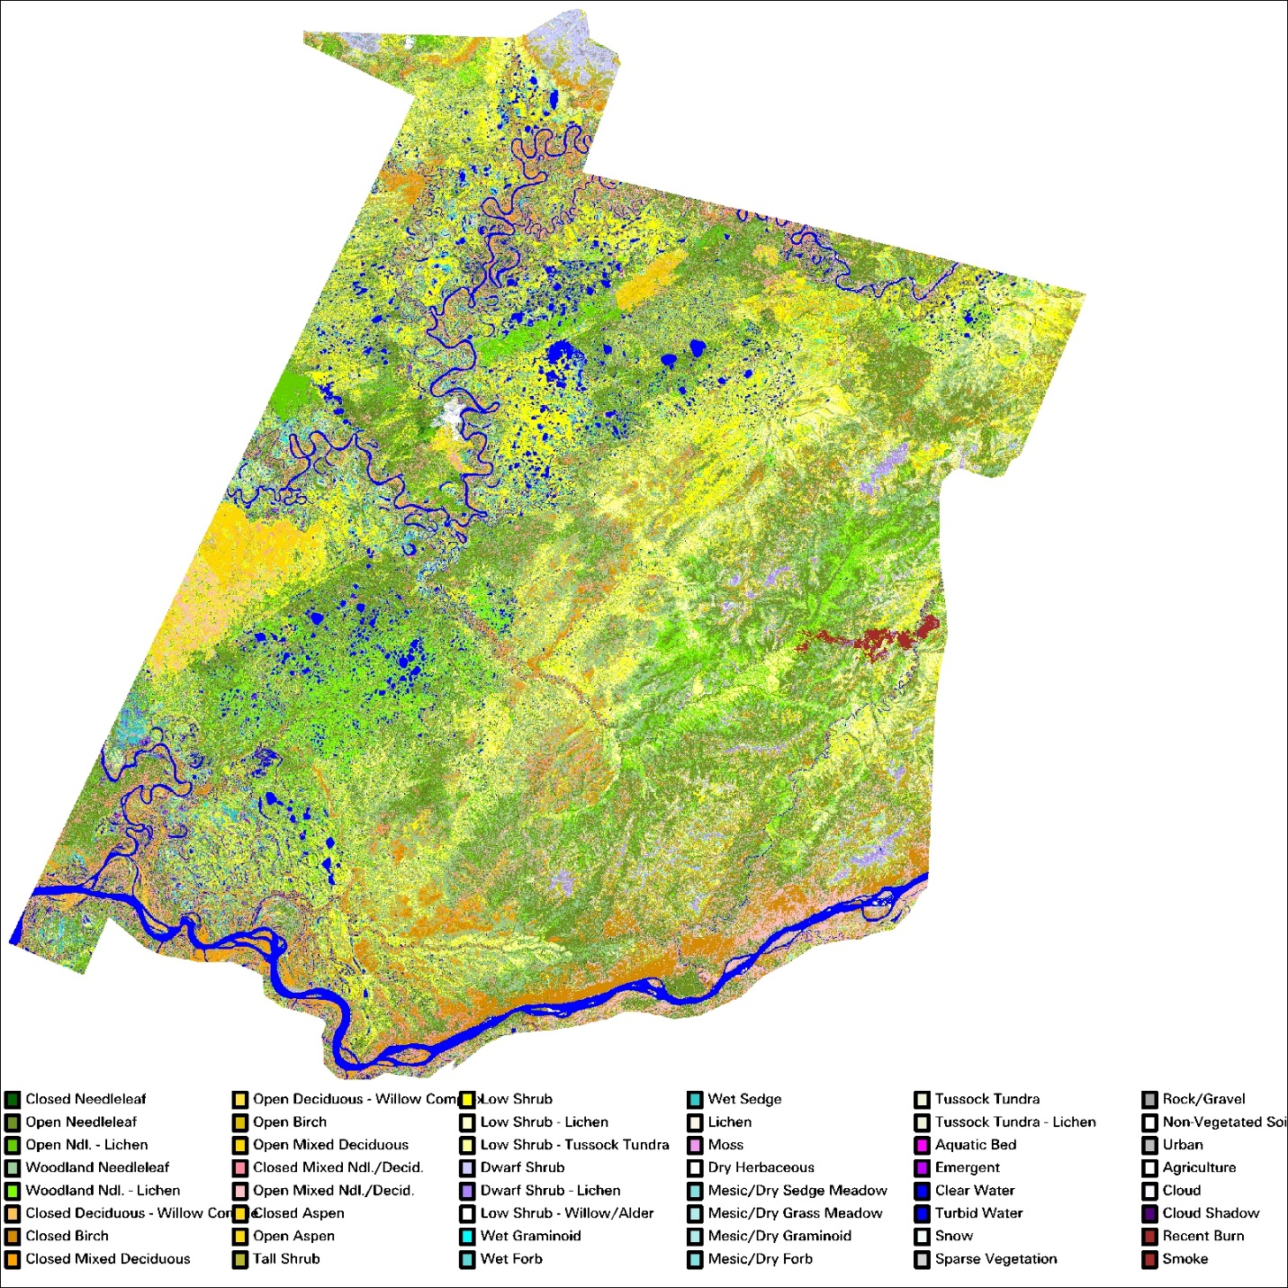

**Figure 6.** Koyukuk NWR / Lower Melozitna Drainage final classified map.

trees. This case was evident throughout the study area as bands of low and tall shrub transitioned from stands of woodland needleleaf. The most prevalent example of the confusion within the gradient between classes was found between open- and woodland needleleaf. As evidenced by the field training sites, the majority of the open and woodland needleleaf classes exhibited a tree crown cover between 20% and 30%. Similarly, low shrub areas at a height of .3 meters were confused with dwarf shrub areas with a height of .2 meters. In fact, in many cases, the biologist observer characterized a site as low shrub – other while the DUFF program calculated the site as dwarf shrub – other. Most of these cases exhibited 25-40% shrubs all presenting a

**Table 4.** Acreage of earth cover classes within the project area.

|  |  |  |  |
| --- | --- | --- | --- |
| CLASS NUMBER | CLASS NAME | ACRES | PERCENT  COVER |
| 1 | Closed Needleleaf | 22,112 | 0.49% |
| 2 | Open Needleleaf | 944,335 | 20.90% |
| 3 | Open Ndl. - Lichen | 141,234 | 3.13% |
| 4 | Woodland Needleleaf | 786,441 | 17.41% |
| 5 | Woodland Ndl. - Lichen | 209,075 | 4.63% |
| 10 | Closed Deciduous – Willow Complex | 11,706 | 0.26% |
| 11 | Closed Deciduous – Birch | 168,163 | 3.72% |
| 12 | Closed Mixed Deciduous | 110,412 | 2.44% |
| 13 | Open Deciduous – Willow Complex | 9,469 | 0.21% |
| 14 | Open Deciduous – Birch | 17,052 | 0.38% |
| 15 | Open Mixed Deciduous | 39,503 | 0.87% |
| 16 | Closed Mixed Ndl./Decid. | 78,208 | 1.73% |
| 17 | Open Mixed Ndl./Decid. | 216,536 | 4.79% |
| 18 | Closed Aspen | 1,032 | 0.02% |
| 19 | Open Aspen | 6,183 | 0.14% |
| 20 | Tall Shrub | 207,144 | 4.58% |
| 21 | Low Shrub | 582,128 | 12.88% |
| 22 | Low Shrub - Lichen | 20,530 | 0.45% |
| 23 | Low Shrub - Tussock Tundra | 286,280 | 6.34% |
| 24 | Dwarf Shrub | 44,276 | 0.98% |
| 25 | Dwarf Shrub - Lichen | 32,513 | 0.72% |
| 32 | Low Shrub – Willow/Alder | 27,794 | 0.62% |
| 33 | Wet Graminoid | 28,599 | 0.63% |
| 34 | Wet Sedge | 89,146 | 1.97% |
| 36 | Lichen | 11,646 | 0.26% |
| 37 | Moss | 11,849 | 0.26% |
| 41 | Mesic / Dry Sedge Meadow | 9,411 | 0.21% |
| 42 | Mesic / Dry Grass Meadow | 2,679 | 0.06% |
| 43 | Mesic / Dry Graminoid | 27,472 | 0.61% |
| 44 | Mesic / Dry Forb | 2,585 | 0.06% |
| 50 | Tussock Tundra | 25,062 | 0.55% |
| 51 | Tussock Tundra – Lichen | 14,370 | 0.32% |
| 60 | Aquatic Bed | 3,775 | 0.08% |
| 61 | Emergent Vegetation | 41,982 | 0.93% |
| 70 | Clear Water | 163,328 | 3.61% |
| 71 | Turbid Water | 91,115 | 2.02% |
| 72 | Snow | 827 | 0.02% |
| 80 | Sparse Vegetation | 3,169 | 0.07% |
| 81 | Rock/Gravel | 7,088 | 0.16% |
| 82 | Non-Vegetated Soil | 8,227 | 0.18% |
| 90 | Urban | 1,022 | 0.02% |
| 92/93 | Cloud / Cloud Shadow | 2,255 | 0.05% |
| 94 | Recent Burn | 1,264 | 0.03% |
| 95 | Smoke | 9,395 | 0.21% |
| **Total** |  | **4,518,393** | **100%** |

height of .2 to .3 meters. These transitional areas and signatures had to be examined and a classification decision made based on the available data and field notes. In the majority of these cases, the biologist’s characterization of the site was selected as the most appropriate site label for the signature.

A similar challenge arose in the discrimination between low-lying, very wet sites that were characterized by the field biologist as wet sedge, but often were recorded as containing exactly 25% dwarf shrubs at .2-meters in height. In these cases, the site/signature fell on the boundary of three classes: wet sedge, dwarf shrub – other, and low shrub – other. Again, the biologist’s characterization (observed class) was generally accepted as the most appropriate site label. In order to provide accuracy and consistency to the final earth cover classification map, manual editing was required to correct the confusion resulting from this phenomenon.

In some cases, a single pixel fell across two cover types, as when a pixel fell across the edge between a lake and the forested land surrounding it. These half-water, half-land signatures were often confused with areas of wet sedge/graminoid and open/closed needleleaf. Editing was done to separate legitimate wet sedge/graminoid and open needleleaf pixels based on aerial photography, field notes and topography.

Due to the variety and amount of vegetation cover present, the most difficult landcover types to consistently distinguish spectrally and thematically were found with the “recent” burn areas. Even the field training sites located in these areas were filled with a high degree of variability that described landcover types ranging from low shrub-other to open birch to tall shrub to sparse vegetation. In fact, many sites were calculated to be open birch with more than 40% 1-meter tall birch trees that the vegetation caller characterized as the tall shrub class. A review of the field data sheets for many of these burn area training sites shows that these highly variable locations may be described by two or more landcover type classes with only a 5-10% change in vegetation estimation or height. The primary confusion is centered on the presence of young birch regeneration that often function as tall shrub *and* open deciduous. While the final classification of these burn areas did result in a consistent and reliable characterization of the area, much landcover class variation is found throughout the burns that are associated with only slight changes in the actual vegetation composition. Much manual editing and spatial modeling techniques were used specifically within regenerating burn areas to assure a reliable, consistent characterization of these unusual regions of the study area.

A final case of spectral classification confusion involved the misclassification of closed birch and tall shrub. The spectral reflectance of these two earth cover types is very similar; especially when one considers the variety of slope and aspect combinations that these two types occupy. This confusion was corrected via manual editing utilizing photo-interpretation and review of specific field notes and photos. Fortunately, the areas exhibiting this vegetation composite were limited to only a few regions of the study area where typically tall shrub and closed birch communities transitioned from forested needleleaf regions to the high-elevation regions at tree-line.

Finally, at the request of U.S. Fish & Wildlife project participants, an attempt was made to further stratify the mixed deciduous classes into closed- and open deciduous classes that discriminated the willow dominated communities from other mixed deciduous types. This effort was focused on the younger willow communities found along the riparian corridors of the Yukon, Melozitna, and Koyukuk Rivers. These willow communities were spectrally quite distinct from the older, more established closed birch forests that occupied portions of the riparian corridor usually just inland from the willow communities and river’s edge. Therefore, a consistent and reliable stratification of willow dominated forests from other mixed deciduous forests was achieved. The total acreage of the willow-complex classes is presented in Table 4.

## Accuracy Assessment

Some earth cover classes were not adequately represented in the field data available for training and accuracy assessment, primarily because of their scarcity within the project area, e.g., closed needleleaf, closed mixed needleleaf/deciduous, open deciduous, aquatic bed. In the past, classes with an inadequate sample size were collapsed into the next hierarchical cover type for accuracy assessment of the classification. This grouping often resulted in only 8-10 accuracy assessment classes vs. the 30+ classes present in the classification. In addition, this approach grouped classes based solely on their specific mapping class labels versus grouping individual sites based on their ecological composition or function. By grouping classes in this manner, one loses all ability to evaluate and measure the relationship between regions of the map that classify nicely into the “heart” of a mapping class and those regions that occur on the classification and ecological boundaries between the discrete mapping classes. For example, a vegetation caller may have interpreted a site to contain 10% tree cover and 90% low shrubs. This site would be classified as a woodland conifer site. If this site is used to evaluate a site classified with a group of pixels indicating a presence of 5% tree cover and 95% low shrubs, the site would have been evaluated as incorrectly classified. Since the literature generally accepts the fact that even the most experienced visual estimates of earth cover consider a range of variation in interpretation of +/-10% to be acceptable, this particular accuracy assessment site containing 10% tree cover should also be considered acceptably classified as low shrub and tallied as such. Evaluating the earth cover classification in this manner provides the end user with a more realistic measure of reliability of the classified map as it relates to the actual continuum of vegetation composition as compared to simply lumping mapping classes for evaluation based on their discrete class name.

A more appropriate and informative representation of the reliability/accuracy of the earth cover classification is found in the error matrix provided in Appendix D. In this matrix, no lumping of mapping classes has occurred. Therefore, the user can evaluate the performance and interrelationships of *all* mapping classes represented in the final earth cover map. The error matrix presents values for user’s accuracy, producer’s accuracy, and the overall accuracy for +/- 0% and +/-5% variation in interpretation within the reference data. In the error matrix, numbers along the main diagonal of the matrix indicate an exact match between the reference data site and the map. A tally of these numbers indicates the overall accuracy of the map at the +/- 0% variation in interpretation level. If two numbers occupy a non-diagonal cell, the left number indicates an acceptable match between the reference data site and the map assuming a +/- 5% variation in reference data interpretation. The number on the right indicates the number of sites that are not acceptable matches. A tally of the numbers within the diagonal along with the acceptable numbers in the off-diagonal cells (left number(s)) indicates the overall accuracy of the map at the +/- 5% variation in interpretation level.

A number of important analyses can be made regarding the relationship of the mapped data with the actual vegetation distributions throughout the study area using this method of accuracy assessment. Since the off-diagonal acceptable matches are presented, an indication of the number of field sites that represent vegetation compositions on the boundary of two or more mapping classes is given. The acceptance or unacceptance of each accuracy assessment site with an off-diagonal map class provides insight into the vegetation composition of that reference site. For instance, in the combined Path 75/76 matrix in Appendix D, of the eleven reference sites characterized as closed birch, one site was an acceptable match with closed deciduous, and one was an unacceptable match with closed deciduous. The remainder of the sites (9) were diagonal matches with open needleleaf. The off-diagonal matches indicate that at least one of those sites was just on the border between closed birch and closed deciduous (70 - 75% of tree canopy cover in birch). Also, since the number of misclassified sites is still indicated in the matrix, a user can determine in which classes the map is least reliable and with which mapping classes the unreliable classes are confused. If lumping of classes is still desired, this can easily be accomplished through application of the techniques utilized in previous projects. Although the matrix of lumped classes is not presented in this report, the classification accuracy of the grouped classes of Open Needleleaf, Woodland Needleleaf, Deciduous, Mixed Needleleaf/Deciduous, Tall Shrub, Low Shrub, Dwarf Shrub, Forb/Graminoid, and Barren was computed to be 78.2% with no allowance for variation in interpretation.

Overall Accuracy Assessment

The difference in classification accuracy between the +/- 0% variation in interpretation level (76%) and the +/- 5% variation in interpretation level (86%) indicates that a great number of the reference data sites were characterized as being right on the boundary of two or more mapping classes. As stated earlier, it is generally accepted that variation in interpretation of +/- 10% is common and accepted for human interpreters, either from aerial photography or on the ground. When this natural and accepted variation is measured and accounted for (as in the case of the error matrix in Appendix D at the +/-5% variation level), a more reliable and informative measure of accuracy and reliability is presented.

The accuracy measures of the needleleaf classes were acceptable with absolutely no lumping or variation of interpretation allowed (open needleleaf = 90%, open needleleaf – lichen = 57%, woodland needleleaf = 86%, woodland needleleaf – lichen = 100%). Allowing +/- 5% variation in interpretation in the reference data, much greater accuracy is demonstrated (open

needleleaf = 100%, open needleleaf – lichen = 100%, woodland needleleaf = 86%, woodland needleleaf – lichen = 100%). The User’s Accuracies for the same classes are comparable. These measures are extremely encouraging since nearly half of the study area is mapped as one of these forested needleleaf classes. When an area is classified as one of the forested needleleaf classes, the user can have extreme confidence in the accuracy of that classification. Of the 7 needleleaf reference sites, 6 were considered acceptable matches at the +/- 5% variation in interpretation level. This indicates that the majority of the reference sites that were direct matches with the map sites were right on the boundary between two different mapping classes; one of which the map presented for the site. The vast majority of the forty-one needleleaf reference sites, however, were found to be a match with no variation in interpretation.

No significant trends of error were found in the combined path 75/76 error matrix. The errors that were present seemed to occur more-or-less equally to all mapping classes without one or two classes accounting for the majority of the error. The one potential exception may be the dwarf shrub – other class. Although a total of only seven reference sites were available for evaluation this class, only two of the reference sites were found to be misclassified at the +/-5% variation level. However, only two of the reference sites were found to be direct matches at the +/-0% variation level. One of the remaining three off-diagonal acceptable matches and both of the off-diagonal misses were associated with graminoid mapping classes such as wet sedge and tussock tundra. This was indicative of much of the confusion associated with the wet dwarf shrub areas of the study area. Many of these sites were often heavily dominated by 50 – 70% sedge species with generally only 20 – 35% dwarf shrub species. In many of these cases it was quite difficult to spectrally discriminate between those 55% sedge/35% dwarf shrub sites and those areas comprised of 65% sedge/20% dwarf shrub. To complicate matters in this project, the amount of visible water apparent in the satellite imagery within and surrounding these dwarf shrub/wet sedge regions was often quite different that what was observed on the ground during the 2001 field season. In most cases, field observations noted significantly more water (20 – 40% more in some cases) that was evident in the imagery. This circumstance made for an even more difficult characterization of the presence/absence of the shrub component.

Similar results are found throughout the error matrix. When accounting for those reference sites that characterize vegetation communities at the boundary of two or more mapping classes, consistently high accuracy measures are found for both the user’s and producer’s accuracy. Most every measure of both the user’s and producer’s accuracy at the +/- 5% level of variation of interpretation in the reference data for classes containing more than four reference sites exceeded 83%, with the vast majority of these sites exceeding 90% accuracy. The one obvious exception to this trend, in addition to the previously discussed dwarf shrub – other class, was in the open mixed class. Even with only a total of five accuracy assessment sites, this class appears to represent some confusion with classes on either end of its range: pure needleleaf vs. pure deciduous. No simple explanation is evident for this result. Both the off-diagonal reference sites for the open mixed needleleaf/deciduous class were not the typical open mixed stands that comprise the majority of the class as it is mapped in the final earth cover classification. Figures 7 and 8 present aerial views of these sites.

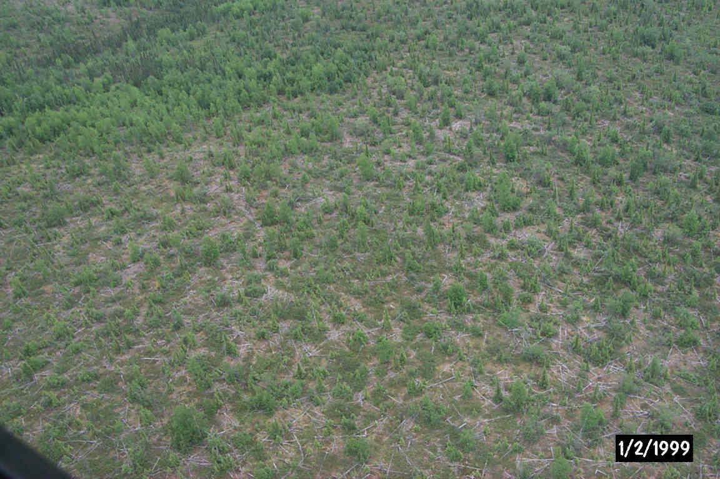

**Figure 7.** Aerial view of mis-classified Open Mixed Needleleaf/Deciduous stand.

This stand was classified as “Woodland Needleleaf” (date on photo incorrect).

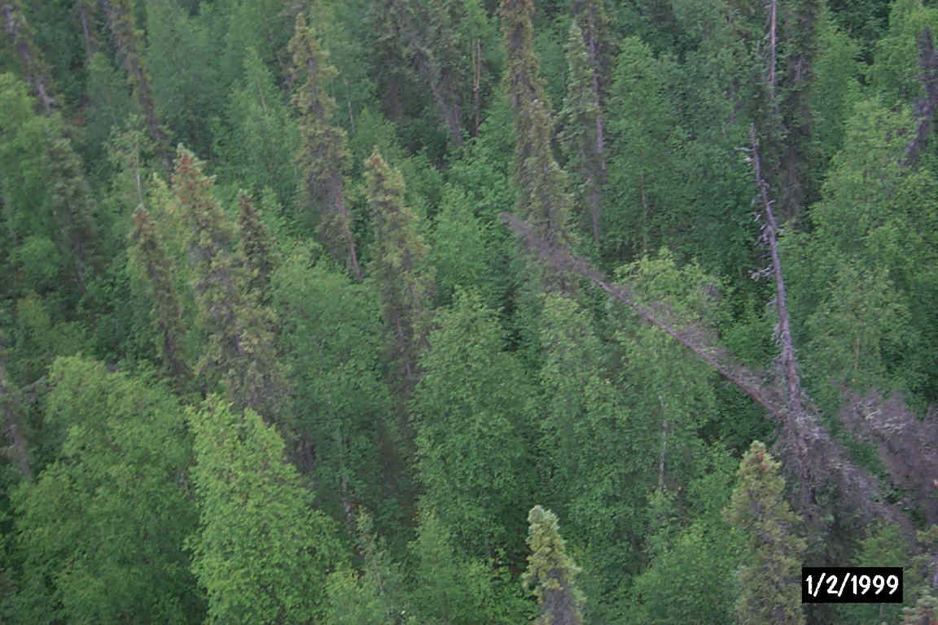

**Figure 8.** Aerial view of mis-classified Open Mixed Needleleaf/Deciduous stand.

This stand was classified as “Closed Deciduous” (date on photo incorrect).

Despite the strong correlation between the reference data and the classified map data, one trend of potential interest to an end user is evidenced in the error matrix. From a user’s perspective, the closed deciduous class presents a slight tendency toward being over classified. While 2 out of the 3 closed deciduous reference sites were found to be classified correctly at the +/- 5% variation level, a total of four non-closed deciduous reference sites were found to be classified as closed deciduous. Although one of these four sites were found to be correctly classified at the +/- 5% variation level, this statistic does tend to potentially indicate that several vegetation types are being mapped disproportionately as closed deciduous. However, the three mapping classes found to be confused with the closed deciduous class in the error matrix all present evidence for their misclassification. For example, one of the misclassified reference sites was confused with the closed birch class, itself a “closed deciduous” site. Another reference site mapped as closed deciduous was characterized as a tall shrub site. This confusion is not surprising since the spectral overlap of closed deciduous classes and tall shrub (often just a meter in height short of being a closed deciduous site) is often great. The third and final reference site found to be inappropriately classified as closed deciduous is the open mixed needleleaf/deciduous site shown in Figure 8 above. Although the closed deciduous mapping class presents some tendency toward being over-represented in the final earth cover map, the entire mapping class only occupies less than 2 ½ % of the total project area.

In summary, based on the quantitative accuracy assessment, the earth cover classification map produced for the Koyukuk NWR/Lower Melozitna River Drainage is very reliable. Nearly 76% of the accuracy assessment sites matched the full detailed 33 mapping classes directly; even when taking no variation in interpretation and no class lumping into account. When as little as +/- 5% variation in interpretation was accounted for, nearly nine out of ten (85.8%) of the reference sites were found to correspond correctly with the classified map.

Discussion

While the accuracy assessment performed in this project was not a robust test of the classification, it gives the user some confidence while using the classification. It provided enough detail for the end user to determine where discrepancies in the classification may cause a problem while using the data. It is also important to note the variations in the dates of the imagery, aerial photographs, and field data. For this project, the imagery was acquired on June 30, 1999 and June 23, 2000. The aerial photographs spanned a seven-year period from 1980-87, and the field data was collected in July 2001. Differences due to environmental changes from the different sources may have affected the accuracy assessment. As discussed earlier, the significant differences in standing water in many older oxbows and other wetter sites between the image date and the field collection date contributed to inconsistencies in correctly identifying sites as wet or dry graminoid/forb, emergent, or dwarf shrub. Depending on the standing water present at any given time, each of these class labels may have been appropriate.

The other primary area of confusion revealed in the analysis of accuracy pertains to the recently burned areas. As previously discussed, these regions of the study area are actively regenerating. The consistent presence of low shrubs, tall shrubs, ½ to 2-meter tall birch and spruce trees of varying densities throughout many of these burned areas result in a consistent mix of woodland needleleaf, open birch, open mixed, low shrub, and tall shrub classes, each of which is often separated by only a few canopy cover percentage points estimated by a single interpreter. Such a scenario is fraught with potential spectral and thematic overlap and confusion even though the basic form and function of the regenerating vegetation is fairly consistent.

A major assumption of quantitative accuracy assessments is that the label from the reference information represents the “true” label of the site and that all differences between the remotely sensed map classification and the reference data are due to classification and/or delineation error (Congalton and Green 1993). Unfortunately, error matrices can be inadequate indicators of map error because they are often confused by non-map error differences. Some of the non-map errors that can cause confusion are: (1) registration differences between the reference data and the remotely sensed map classification, (2) digitizing errors, (3) data entry errors, (4) changes in land cover between the date of the remotely sensed data and the date of the reference data, (5) mistakes in interpretation of reference data, and perhaps most significant (6) variation in classification and delineation of the reference data due to inconsistencies in human interpretation of vegetation. The error matrix developed and presented in this report attempts to capture, measure, and account for likely the most significant of these sources of inconsistency and error in the development of the reference data set: variation in human interpretation. The results presented and discussed in this report provide the end user with valuable information regarding the accuracy and reliability of the earth cover data mapped for the Koyukuk NWR/Lower Melozitna River Drainage.

## Final Products

The project final product included a digital classification, map, and database of 44 earth cover classes within the Koyukuk NWR/Lower Melozitna River Drainage project area as well as a map of wildlife sighting locations observed during the collection of field data. The digital classification map was delivered in ArcInfo Grid and Erdas Imagine format. The unclassified Landsat TM images used to create the cover map were also delivered. The field site database, a species list and earth cover acreage tables were stored as digital tables in Microsoft Excel and Access format. The wildlife sightings map was delivered as an ArcInfo point coverage. Digital photos of the field sites are stored as jpeg’s. All of the delivered datasets were loaded into Arcview projects for display purposes.

# Summary

The Bureau of Land Management (BLM) – Alaska and Ducks Unlimited, Inc. (DU) have been cooperatively mapping wetlands and associated uplands in Alaska using remote sensing and GIS technologies since 1988. This project continued with the mapping effort for the Koyukuk NWR/Lower Melozitna River Drainage projectusing Landsat TM satellite scenes, Path 75, Rows 14 and 15 acquired 30 June 1999 and Path 76, Rows 14 and 15 acquired on 23 June 2000. The project area was classified into 42 earth cover categories with an overall accuracy of 85.8% at the +/- 5% level of variation in interpretation. The digital database and map of the classification were the primary products of this project along with hard copy maps of the classification, a digital ArcInfo point coverage of wildlife sighting locations observed during the collection of field data, a complete field database including digital site photos, and an ArcView project.

# Literature Cited

Chuvieco, E., and R. G. Congalton. 1988. Using cluster analysis to improve the selection for training statistics in classifying remotely sensed data. Photogrammetric Engineering and Remote Sensing 54:1275-1281.

Congalton, R., and K. Green. 1993. A practical look at the sources of confusion in error matrix generation. Photogrammetric Engineering & Remote Sensing 59:641-644.

Congalton, R. G., K. Green, and J. Teply. 1993. Mapping Old Growth Forest on National Forest and Park Lands in the Pacific Northwest from Remotely Sensed Data. Photogrammetric Engineering and Remote Sensing 59:529-535.

Congalton, R. G. 1991. A review of assessing the accuracy of classifications of remotely sensed data. Remote Sensing of Environment 37:35-46.

Gopal, S., and C. Woodcock. 1992. Accuracy assessment of the Stanislaus vegetation map using fuzzy sets. Pages 378-394 in Remote Sensing and Natural Resource Management: Proceedings of the Fourth Forest Service Remote Sensing Applications Conference. American Society for Photogrammetry and Remote Sensing, City, State, USA.

Kempka, R. G., R. D. Macleod, J. Payne, F. A. Reid, D. A. Yokel, and G. R. Balogh. 1995. National Petroleum Reserve Alaska Landcover Inventory: Exploring Arctic Coastal Plain Using Remote Sensing. Pages 788-798 in Ninth Annual Symposium on Geographic Information Systems in Natural Resources Management, GIS World Inc., editor. GIS 95 Symposium Proceedings, Vancouver, British Columbia, Canada.

Kempka, R. G., B. S. Maurizi, F. A. Reid, R. C. Altop, and J.W. Denton. 1994. Standardizing reference data collection for satellite land cover mapping in Alaska. Pages 419-426 in Eighth Annual Symposium on Geographic Information Systems in Forestry, Environmental, and Natural Resources Management, GIS World Inc., editor. GIS 94 Symposium Proceedings Vancouver, British Columbia, Canada.

Kempka, R. G., F. A. Reid, and R. C. Altop. 1993. Developing large regional databases for waterfowl habitat in Alaska using satellite inventory techniques: a case study of the Black River. Pages 1-1 in Seventh Annual Symposium on Geographic Information Systems in Forestry, Environment, and Natural Resources Management, GIS World Inc., editor. GIS 93 Symposium Proceedings Vancouver, British Columbia, Canada.

Lillesand, T., and R. Kiefer. 1994. Remote Sensing and Image Interpretation. Wiley and Sons, Inc., New York, USA.

Ritter, R. A., G. T. Koeln, and C. Altop. 1989. Use of Landsat Thematic Mapper Data for Waterfowl Habitat Inventory in Alaska.

Story, M., and R. G. Congalton. 1986. Accuracy Assessment: A User’s Perspective. Photogrammetric Engineering and Remote Sensing 16:529-535.

Tortora, R. 1978. A note on sample size estimation for multinomial populations. The American Statistician 43:1135-1137.

Viereck, L. A., Dryrness, C. T., Batten, and A. R. Wenzlick. 1992. The Alaska Vegetation Classification*.* General Technical Report PNW-GTR-286. U.S. Department of Agriculture, Forest Service, Pacific Northwest Research Station, Portland, Oregon, USA.

# Appendices

## Appendix A. Alaska Earth Cover Classification Class Descriptions

1. **Forest**

Needleleaf and Deciduous Trees-

The needleleaf species generally found were white spruce (*Picea glauca*) and black spruce (*P. mariana*). White spruce tended to occur on warmer sites with better drainage, while black spruce dominated poorly drained sites, and was more common in the interior of Alaska. The needleleaf classes included both white and black spruce.

The deciduous tree species generally found were paper birch (*Betula papyfera*), aspen (*Populus tremuloides*) and cottonwood (*P. balsamifera* and *P. trichocarpa*). Black cottonwoods (*P. trichocarpa*) were generally found only in river valleys and on alluvial flats. Under some conditions willow (*Salix* spp.) and alder *(Alnus rubra)* formed a significant part of the tree canopy. Deciduous stands were found in major river valleys, on alluvial flats, surrounding lakes, or most commonly, on the steep slopes of small hills. Mixed deciduous/coniferous stands were present in the same areas as pure deciduous stands. While needleleaf stands were extensive, deciduous and mixed deciduous/coniferous stands were generally limited in size. The only exception to this rule was near major rivers, where relatively extensive stands of pure deciduous trees occur on floodplains and in ancient oxbows.

**1.1 Closed Needleleaf**

At least 60% of the cover was trees, and >75% of the trees were needleleaf trees. Closed needleleaf sites were rare because even where stem densities were high, the crown closure remained low. Generally, closed needleleaf sites were found only along major rivers.

**1.2 Open Needleleaf**

From 25-59% of the cover was trees, and >75% of the trees were needleleaf. This class was very common throughout the interior of Alaska. A wide variety of understory plant groups were present, including low and tall shrubs, forbs, grasses, sedges, horsetails, mosses and lichens.

**1.21 Open Needleleaf Lichen**

From 25-59% of the cover was trees, >75% of the trees were needleleaf, and > 20% of the understory was lichen.

* 1. **Woodland Needleleaf**

From 10-24% of the cover was trees, and >75% of the trees were needleleaf. Woodland understory was extremely varied and included most of the shrub, herbaceous, or graminoid types present in the study area.

**1.31 Woodland Needleleaf Lichen**

From 10-24% of the cover was trees, >75% of the trees were needleleaf, and > 20% of the understory was lichen. The lichen often occurred in small round patches between trees. Within the study area, this class was generally found along ridgetops or on riparian benches.

**1.4 Closed Deciduous (Mixed Deciduous Species 1.45)**

At least 60% of the cover was trees, and >75% of the trees were deciduous. Occurred in stands of limited size, generally on the floodplains of major rivers, but occasionally on hillsides, riparian gravel bars, or bordering small lakes. This class included Paper Birch, Aspen, or Cottonwood.

**1.41 Closed Birch**

At least 60% of the cover was trees, >75% of the trees were deciduous, and >75% of the deciduous trees were Paper Birch (*Betula Papyfera).*

**1.42 Closed Aspen**

At least 60% of the cover was trees, >75% of the trees were deciduous, and >75% of the deciduous trees were Aspen*.* Stands of pure aspen occurred, but were generally no larger than a few acres. They were found on steep slopes, with particular soil conditions, and on river floodplains.

**1.43 Closed Poplar**

At least 60% of the cover was trees, >75% of the trees were deciduous, and >75% of the deciduous trees were Cottonwood*.*

**1.44 Closed Deciduous – Willow Complex**

At least 60% of the cover was trees, >75% of the trees were deciduous, and >60% of the deciduous trees were of the Salix genera, tree form*.*

* 1. **Open Deciduous (Mixed Deciduous Species 1.55)**

From 25-59% of the cover was trees, and >75% of the trees were deciduous. There was generally a needleleaf component to this class though it was less than 25%. This was a relatively uncommon class.

**1.51 Open Birch**

From 25-59% of the cover was trees, >75% of the trees were deciduous, and >75% of the deciduous trees were Paper Birch*.* This class was very rare. No examples of this class were found in the study area.

**1.52 Open Aspen**

From 25-59% of the cover was trees, >75% of the trees were deciduous, and >75% of the deciduous trees were Aspen*.*

**1.53 Open Cottonwood**

From 25-59% of the cover was trees, >75% of the trees were deciduous, and >75% of the deciduous trees were Cottonwood*.*

**1.54 Open Deciduous – Willow Complex**

At least 25-59% of the cover was trees, >75% of the trees were deciduous, and >60% of the deciduous trees were of the Salix genera, tree form*.*

* 1. **Closed Mixed Needleleaf/Deciduous**

At least 60% of the cover was trees, but neither needleleaf nor deciduous trees made up >75% of the tree cover. This class was uncommon and found mainly along the meanders of major rivers.

**1.7** **Open Mixed Needleleaf/Deciduous**

From 25-59% of the cover was trees, but neither needleleaf nor deciduous trees made up >75% of the tree cover. This class occurred in regenerating burns, on hill slopes, or bordering lakes.

1. **Shrub**

The tall and low shrub classes were dominated by willow species, dwarf birch (*Betula nana* and *Betula glandulosa*) and *Vaccinium* species*,* with alder being somewhat less common. However, the proportions of willow to birch and the relative heights of the shrub species varied widely, which created difficulties in determining whether a site was made up of tall or low shrub. As a result, the height of the shrub species making up the largest proportion of the site dictated whether the site was called a low or tall shrub. The shrub heights were averaged within a genus, as in the case of a site with both tall and low willow shrubs. Dwarf shrub was usually composed of dwarf ericaceous shrubs and *Dryas* species, but often included a variety of forbs and graminoids. The species composition of this class varied widely from site to site and included rare plant species. It is nearly always found on hill tops or mountain plateaus, and may have included some rock.

**2.1 Tall Shrub**

Shrubs made up 40-100% of the cover and shrub height was >1.3 meters. This class generally had a major willow component that was mixed with dwarf birch and/or alder, but could also have been dominated by nearly pure stands of alder. It was found most often in wet drainages, at the head of streams, or on slopes.

**2.21 Willow/Alder Low Shrub**

Shrubs made up 40-100% of the cover, shrub height was .25-1.3 meters, and >75% of the shrub cover was willow and/or alder.

**2.22 Other Low Shrub/Tussock Tundra**

Shrubs made up 40-100% of the cover, shrub height was .25-1.3 meters, and >35% of the cover was made up of tussock forming cotton grass *(Eriophorum vaginatum*). This class was found in extensive patches in flat, poorly drained areas. It was generally made up of cotton grass, ericaceous shrubs, willow and/or alder shrubs, other graminoids, and an occasional black spruce.

**2.23 Other Low Shrub/Lichen**

Shrubs made up 40-100% of the cover, shrub height was .25-1.3 meters, and >20% of the cover was made up of lichen. This class was found at mid-high elevations. The shrub species in this class were nearly always dwarf birch.

**2.24 Other Low Shrub**

Shrubs made up 40-100% of the cover, shrub height was .25-1.3 meters. This was the most common low shrub class. It was generally composed of dwarf birch, willow species, *Vaccinium* species, and ledum species.

**2.31 Dwarf Shrub/Lichen**

Shrubs made up 40-100% of the cover, shrub height was <.25 meters, and >20% of the cover was made up of lichen. This class was generally made up of dwarf ericaceous shrubs and *Dryas* species, but often included a variety of forbs and graminoids. It was nearly always found at higher elevations on hilltops, mountain slopes and plateaus. This class may be more open than the Other Dwarf Shrub class.

**2.31 Other Dwarf Shrub**

Shrubs made up 40-100% of the cover, the shrub height is <.25 meters. This class was generally made up of dwarf ericaceous shrubs and *Dryas* species, but often included a variety of forbs and graminoids, and some rock. It was nearly always found at higher elevations on hilltops, mountain slopes, and plateaus.

1. **Herbaceous**

The classes in this category included bryoids, forbs, and graminoids. Bryoids and forbs were present as a component of most of the other classes but rarely appeared in pure stands. Graminoids such as *Carex* spp., *Eriophorum* spp., or bluejoint grass (*Calamagrostis canadensis*) may have dominated a community.

**3.11 Lichen**

Composed of >40% herbaceous species, <25% water, and > 60% lichen species.

**3.12 Moss**

Composed of >40% herbaceous species, <25% water, and >60% moss species.

**3.21 Wet Graminoid**

Composed of >40% herbaceous species, <25% water, and where >60% of the herbaceous cover was graminoid, and >20% of the graminoid cover was made up of *Carex aquatilis*. This class represented wet or seasonally flooded sites. It was often present in stands too small to be mapped at the current scale.

**3.31 Tussock Tundra**

Composed of >40% herbaceous species, <25% water, where >50% of the herbaceous cover was graminoid, and >35% of the graminoid cover was made up of tussock forming cotton grass. Tussock tundra often included ericaceous shrubs, willow and/or alder shrubs, forbs, bryoids, and other graminoids, and was usually found at lower elevations in flat, poorly drained areas.

**3.311 Tussock Tundra/Lichen**

Composed of >40% herbaceous species, <25% water, where >50% of the herbaceous cover was graminoid, and >20% of the cover was lichen, and >35% of the graminoid cover was made up of tussock forming cotton grass. Tussock tundra often included ericaceous shrubs, willow and/or alder shrubs, forbs and other graminoids, and was usually found at lower elevations in flat, poorly drained areas. This class included a major component of lichen.

**3.34 Mesic/Dry Graminoid**

Composed of >40% herbaceous species, <5% water, with >50% graminoids excluding tussock forming cotton grass and *Carex aquatilis*. This class was not common and was found generally only at high elevations.

**3.35 Mesic/Dry Forb**

Composed of >40% herbaceous species, <5% water, with <50% graminiods. Regenerating burn areas dominated by fireweed *(Epilobium angustifolium)* fell into the mesic/dry forb category. However, forb communities without significant graminoid or shrub components were generally rare in the interior of Alaska.

1. **Aquatic Vegetation**

The aquatic vegetation was divided into Aquatic Bed and Emergent classes. The Aquatic Bed class was dominated by plants with leaves that float on the water surface, generally pond lilies (*Nuphar polysepalum*). The Emergent Vegetation class was composed of species that were partially submerged in the water, and included freshwater herbs such as Horsetails (*Equisetum* spp.), Marestail (*Hippuris* spp.), and Buckbean (*Menyanthes trifoliata*).

**4.1 Aquatic Bed**

Aquatic vegetation made up >20% of the cover, and >20% of the vegetation was composed of plants with floating leaves. This class was generally dominated by pond lilies.

4.2 Emergent Vegetation

Aquatic vegetation made up >20% of the cover, and >20% of the vegetation was composed of plants other than pond lilies. Generally included freshwater herbs such as Horsetails, Marestail, or Buckbean.

* 1. **Clear Water**

Composed of >80% clear water.

* 1. **Turbid Water**

Composed of >80% turbid water.

**6.0 Barren**

This class included sparsely vegetated sites, e.g., abandoned gravel pits or riparian gravel bars, along with non-vegetated sites, e.g., barren mountaintops or glacial till.

**6.1 Sparse Vegetation**

At least 50% of the area was barren, but vegetation made up >20% of the cover. This class was often found on riparian gravel bars, on rocky or very steep slopes and in abandoned gravel pits. The plant species were generally herbs, graminoids and bryoids.

**6.2 Rock/Gravel**

At least 50% of the area was barren, >50% of the cover was composed of rock and/or gravel, and vegetation made up less than 20% of the cover. This class was most often made up of mountaintops or glaciers.

**6.3 Non-vegetated Soil**

At least 50% of the area was barren, >50% of the cover was composed of mud, silt or sand, and vegetation made up less than 20% of the cover. This type was generally along shorelines or rivers.

1. **Urban**

At least 50% of the area was urban. This class was only found in the study area in the within the village of Ruby.

1. **Agriculture**

At least 50% of the area was agriculture. This class was not found in the study area.

* 1. **Cloud/Shadow**

At least 50% of the cover was cloud or shadow.

* 1. Cloud

At least 50% of the cover was made up of clouds.

* 1. Cloud Shadow

At least 50% of the cover was made up of clouds shadows.

* 1. **Terrain Shadow**

At least 50% of the cover was made up of terrain shadows.

10.0 Other

Sites that did not fall into any other category were assigned to Other. For example, sites containing 25%-80% water, <25% shrub and <20% aquatic vegetation were classed as Other. Sites classed as Other may have also included extensive areas of vegetative litter, such as downed wood.

## Appendix B. Earth cover classification decision tree.

yes

yes

yes

yes

yes

yes

yes

no

yes

yes

yes

yes

yes

no

1.1

1.21

1.2

1.41

1.42

1.43

1.44

1.51

1.52

1.53

1.54

1.6

1.7

1.31

1.3

no

no

≥ 75% needleleaf **AND** height > 1 m

≥ 20% lichen

Trees 10-24%

29-59% closed canopy

≥ 60% closed canopy

no

no

no

no

no

no

≥ 75% single species

25-59% closed canopy

Closed Needleaf

Open Needleaf Lichen

Open Needleaf

Closed Birch

Closed Aspen

Closed Poplar

Closed Mixed Deciduous

Open Birch

Open Aspen

Open Poplar

Open Mixed Deciduous

Closed Mixed Needle/Decid

Open Mixed Needle/Decid

Woodland Needleleaf Lichen

Woodland Needleaf

≥ 75% single species

≥ 60% closed canopy

≥ 75% deciduous

Trees 25-100%

≥ 20% lichen

≥ 60% closed canopy

25-59% closed canopy

≥ 75% needleleaf

yes

2.1

2.21

2.22

2.23

2.24

2.31

2.32

3.11

3.12

3.21

3.22

3.311

3.312

3.32

3.33

3.34

3.35

no

no

no

yes

yes

yes

yes

yes

yes

yes

yes

yes

yes

no

no

no

no

no

yes

yes

yes

yes

yes

yes

yes

yes

≥ 50% grass

no

no

no

no

no

no

no

≥ 40% herbaceous **AND**

**≤ 25%** water

≥ 50% sedge

≥ 50% grass

and tussock

≥ 35% tussock

≥ 50% graminoid

(Sedge, Grass, Tussock)

≥ 20% lichen

≥ 50% graminoid (sedge, grass)

≥ 35% tussock

5-25% water **OR**

> 20% Carex aquatilis

≥ 50% lichen

≥ 50% bryoid

Tall

Low Shrub Willow/Alder

Low Shrub Tussock Tundra

Low Shrub Lichen

Low Shrub Other

Dwarf Shrub Lichen

Dwarf Shrub

Lichen

Moss

Wet Graminoid

Wet Forb

Tussock Tundra Lichen

Tussock Tundra

Mesic/Dry Sedge Meadow

Mesic/Dry Grass Meadow

Mesic/Dry Graminoid

Mesic/Dry Forb

≥ 20% lichen

≥ 20% lichen

≥ 35% tussock

≥ 75% willow / alder

most common shrub is < 0.25 m tall

most common shrub is 0.25- 1.3 m tall

most common shrub is ≥ 1.3 m tall

Shrubs 25-100%

no

yes

4.1

4.2

5.3

5.4

6.1

6.2

6.3

7.0

8.0

8.1

8.2

9.1

9.2

10.0

Aquatic Bed

Emergent Vegetation

Clear Water

Turbid Water

Sparse Vegetation

Rock / Gravel

Non-Vegetated Soil

Urban

Agriculture

Snow

Ice

Cloud

Shadow

Other

yes

≥ 50% Shadow

≥ 50% Cloud

≥ 50% Ice

≥ 50% Snow

≥ 50% Agriculture

≥ 50% Urban

≥ 50% rock/gravel

≥ 20% vegetation

≥ 50% Barren Ground

≥ 80% Water

≥ 20% aquatic bed

≥ 20% Aquatic Vegetation

no

yes

yes

yes

yes

yes

yes

yes

yes

yes

yes

yes

no

no

clear water

no

no

no

no

yes

no

## Appendix C. Plant species and cover type list.

|  |  |  |  |  |  |  |
| --- | --- | --- | --- | --- | --- | --- |
| **Site Tally** |  | **Symbol** |  | **Species** |  | **Common Name** |
| 402 |  | MOXX |  | MOSS |  | MOSS |
| 351 |  | VAUL |  | VACCINIUM ULIGINOSUM |  | BLUEBERRY,BOG |
| 335 |  | LITT |  | LITTER |  | LITTER |
| 321 |  | LEPA |  | LEDUM PALUSTRE |  | LABRADOR TEA |
| 311 |  | LIXX |  | LICHEN |  | LICHEN |
| 284 |  | SAX_ |  | SALIX SPP |  | WILLOW |
| 262 |  | BEGL |  | BETULA GLANDULOSA |  | BIRCH,DWARF ARCTIC |
| 193 |  | CACA4 |  | CALAMAGROSTIS CANADENSIS |  | REEDGRASS,BLUE-JOINT |
| 172 |  | CAXX |  | CAREX SPP |  | SEDGE SPP |
| 148 |  | PIMA |  | PICEA MARIANA |  | SPRUCE,BLACK |
| 129 |  | EMNI |  | EMPETRUM NIGRUM |  | CROWBERRY,BLACK |
| 127 |  | ALCR6 |  | ALNUS CRISPA |  | ALDER,GREEN |
| 125 |  | PIGL |  | PICEA GLAUCA |  | SPRUCE,WHITE |
| 106 |  | EQXX |  | EQUISETUM SPP |  | HORSETAILS SPP |
| 105 |  | BEPA |  | BETULA PAPYRIFERA |  | BIRCH,PAPER |
| 104 |  | PISP |  | PICEA SPP. |  | SPRUCE, MIXED WHITE AND BLACK |
| 96 |  | RUCH |  | RUBUS CHAMAEMORUS |  | CLOUDBERRY |
| 88 |  | EPAN2 |  | EPILOBIUM ANGUSTIFOLIUM |  | FIREWEED |
| 88 |  | ERXX |  | ERIOPHORUM SPP |  | COTTON-GRASS |
| 79 |  | DRXX |  | DRYAS SPP |  | MOUNTAIN-AVENS |
| 79 |  | SPBE |  | SPIRAEA BEAUVERDIANA |  | SPIRAEA,BEAUVERED |
| 65 |  | CLWA |  | CLEAR WATER |  | CLEAR WATER |
| 64 |  | LALA |  | LARIX LARICINA |  | LARCH,AMERICAN |
| 62 |  | BENA |  | BETULA NANA |  | BIRCH,SWAMP |
| 61 |  | SADW |  | SALIX DW. |  | WILLOW, DWARF |
| 59 |  | ROCK |  | ROCK |  | ROCK |
| 57 |  | GRAV |  | GRAVEL |  | GRAVEL |
| 56 |  | POFR |  | POTENTILLA FRTICOSA |  | CINQUEFOIL, BUSH |
| 49 |  | FERN |  | FERN SPP |  | FERN |
| 49 |  | STDE |  | STANDING DEAD |  | STANDING DEAD |
| 44 |  | POBA2 |  | POPULUS BALSAMIFERA |  | POPLAR,BALSAM |
| 39 |  | ERVA4 |  | ERIOPHORUM VAGINATUM |  | COTTON-GRASS,TUSSOCK |
| 36 |  | CAAQ |  | CAREX AQUATILIS |  | SEDGE,WATER |
| 36 |  | COCA13 |  | CORNUS CANADENSIS |  | BUNCHBERRY,CANADA |
| 36 |  | VAVI |  | VACCINIUM VITIS-IDAEA |  | CRANBERRY,MOUNTAIN |
| 33 |  | ROAC |  | ROSA ACICULARIS |  | ROSE,PRICKLY |
| 30 |  | PEFR5 |  | PETASITES FRIGIDUS |  | COLTSFOOT,ARCTIC SWEET |
| 26 |  | POTR10 |  | POPULUS TREMULOIDES |  | ASPEN,QUAKING |
| 24 |  | FESP |  | FESTUCA SPP |  | FESCUE |
| 24 |  | MYGA |  | MYRICA GALE |  | SWEETGALE |
| 23 |  | SESP |  | SENECIO SPP |  | SENECIO |
| 18 |  | VEVI |  | VERATRUM VIRIDE |  | FALSE-HELLEBORE,AMERICAN |
| 17 |  | ARSP |  | ARCTOSTAPHYLOS SPP. |  | BEARBERRY |
| 17 |  | METR3 |  | MENYANTHES TRIFOLIATA |  | BUCKBEAN |
| 16 |  | BARE |  | BARE GROUND |  | BARE GROUND |
| 15 |  | CATE11 |  | CASSIOPE TETRAGONA |  | BELL-HEATHER,ARCTIC |
| 14 |  | GELI2 |  | GEOCAULON LIVIDUM |  | TOADFLAX,NORTHERN RED-FRUIT |
| 14 |  | SAXX |  | SAXIFRAGA SPP |  | SAXIFRAGE SPP |
| 13 |  | ARTSP |  | ARTEMISIA SPP. |  | SAGE, SPP. |
| 13 |  | CHCA2 |  | CHAMAEDAPHNE CALYCULATA |  | LEATHERLEAF |
| 12 |  | ANPO |  | ANDROMEDA POLIFOLIA |  | ROSEMARY,BOG |
| 12 |  | HELA4 |  | HERACLEUM LANATUM |  | COW-PARSNIP |
| 12 |  | MUDX |  | MUD |  | MUD |
| 12 |  | SACA14 |  | SANGUISORBA CANADENSIS |  | BURNET,CANADA |
| 11 |  | ARNS |  | ARNICA SPP. |  | ARNICA |
| 11 |  | ASXX |  | ASTRAGALUS SPP |  | VETCH |
| 11 |  | GEPR4 |  | GERANIUM PRATENSE |  | CRANE'S-BILL,MEADOW |
| 11 |  | LUPS |  | LUPINUS SPP. |  | LUPINE |
| 11 |  | POPA14 |  | POTENTILLA PALUSTRIS |  | CINQUEFOIL,MARSH |
| 10 |  | ACDE2 |  | ACONITUM DELPHINIFOLIUM |  | MONKSHOOD,LARKSPUR-LEAF |
| 10 |  | EQFL |  | EQUISETUM FLUVIATILE |  | HORSETAIL,WATER |
| 8 |  | SERO2 |  | SEDUM ROSEA |  | STONECROP,ROSEROOT |
| 8 |  | SIAC |  | SILENE ACAULIS |  | CAMPION,MOSS |
| 6 |  | DIUN |  | DIAPENSIA |  | DIAPENSIA |
| 6 |  | LYSP |  | LYCOPODIUM SPP. |  | CLUBMOSS |
| 6 |  | PESP |  | PEDICULARIS SPP |  | LOUSEWORT |
| 6 |  | POBI5 |  | POLYGONUM BISTORTA |  | BISTORT,MEADOW |
| 6 |  | SHCA |  | SHEPHERDIA CANADENSIS |  | BUFFALO-BERRY,CANADA |
| 5 |  | ALTRE |  | ALNUS SPP TREE |  | ALDER, TREE |
| 5 |  | GRASS |  | GRASS |  | GRASS |
| 5 |  | JUCO |  | JUNIPERUS COMMUNIS |  | JUNIPER, COMMON MOUNTAIN |
| 5 |  | MEPA |  | MERTENSIA PANICULATA |  | BLUEBELLS,TALL |
| 4 |  | BORI |  | BOYKINIA RICHARSONI |  | BEARPLANT |
| 4 |  | CALA7 |  | CAMPANULA LASIOCARPA |  | BELLFLOWER,COMMON ALASKA |
| 4 |  | POAL5 |  | POLYGONUM ALASKANUM |  | RHUBARB,ALASKA WILD |
| 4 |  | SAND |  | SAND |  | SAND |
| 4 |  | VIED |  | VIBURNUM EDULE |  | SQUASHBERRY |
| 3 |  | AGBO2 |  | AGROSTIS BOREALIS |  | BENTGRASS,NORTHERN |
| 3 |  | ANMO |  | ANTENNARIA MONOCEPHALA |  | PUSSYTOE |
| 3 |  | CIDO |  | CICUTA DOUGLASII |  | WATER-HEMLOCK,WESTERN |
| 3 |  | COSP |  | CORNUS SPP. |  | DOGWOOD SPP. |
| 3 |  | COST4 |  | CORNUS STOLONIFERA |  | DOGWOOD,RED-OSIER |
| 3 |  | GABO2 |  | GALIUM BOREALE |  | BEDSTRAW,NORTHERN |
| 3 |  | LYAL3 |  | LYCOPODIUM ALPINUM |  | CLUBMOSS,ALPINE |
| 3 |  | POAC |  | POLEMONIUM ACUTIFLORUM |  | JACOB'S-LADDER,STICKY TALL |
| 3 |  | RISP |  | RIBES SPP. |  | RASBERRY |
| 3 |  | SAEX2 |  | SAXIFRAGA EXILIS |  | SAXIFRAGE |
| 2 |  | CAMS |  | CAMPANULA SPP. |  | CAMPANULA |
| 2 |  | CAPA5 |  | CALTHA PALUSTRIS |  | MARSH-MARIGOLD,COMMON |
| 2 |  | CASP |  | CASTILLEJA |  | CASTILLEJA |
| 2 |  | DEGL3 |  | DELPHINIUM GLAUCUM |  | LARKSPUR,TOWER |
| 2 |  | FOXX |  | FORB SPP |  | FORB SPP |
| 2 |  | IRSE |  | IRIS SETOSA |  | IRIS,BEACH-HEAD |
| 2 |  | LOPR |  | LOISELURIA PROCUMBENS |  | AZALEA, ALPINE |
| 2 |  | MISP |  | MINUARTIA SPP. |  | MINUARTIA |
| 2 |  | PALA9 |  | PAPAVER LAPPONICUM |  | POPPY,ARCTIC |
| 2 |  | RHLA2 |  | RHODODENDRON LAPPONICUM |  | AZALEA,LAPLAND |
| 2 |  | RUAR6 |  | RUMEX ARCTICUS |  | DOCK,ARCTIC |
| 1 |  | ANPA |  | ANEMONE PARVIFLORA |  | THIMBLE-WEED,SMALL-FLOWER |
| 1 |  | ARUV |  | ARCTOSTAPHYLOS UVA-URSI |  | KINNEKINNICK |
| 1 |  | ASSP |  | ASTER SPP |  | ASTER |
| 1 |  | CAMI12 |  | CASTILLEJA MINIATA |  | INDIAN-PAINTBRUSH,SCARLET |
| 1 |  | CARO2 |  | CAMPANULA ROTUNDIFOLIA |  | BELLFLOWER,SCOTCH |
| 1 |  | EPAN4 |  | EPILOBIUM ANAGALLIDIFOLIUM |  | WILLOW-HERB,PIMPERNEL |
| 1 |  | EQSP |  | EPILIOLIUM SPP |  | FIREWEED |
| 1 |  | HEAL |  | HEDYSARUM ALPINUM |  | SWEETVETCH,ALPINE |
| 1 |  | HESPP |  | HEDYSARUM SPP. |  | SWEETVETCH, SPECIES |
| 1 |  | LIBO3 |  | LINNAEA BOREALIS |  | TWINFLOWER |
| 1 |  | MIAR |  | MINUARTIA ARCTICA |  | STITCHWORT, ARCTIC |
| 1 |  | POLS |  | POLYGONUM SPP. |  | BISTORT |
| 1 |  | POTS |  | POTENTILLA SPP. |  | CINQUEFOIL |
| 1 |  | RITR |  | RIBES TRISTE |  | CURRANT,SWAMP RED |
| 1 |  | RMSP |  | RUMEX SPP |  | DOCK |
| 1 |  | SATRE |  | SALIX TREE |  | WILLOW TREE |
| 1 |  | VAAL |  | VACCINIUM ALASKAENSE |  | BLUEBERRY,ALASKA |
| 1 |  | VISP |  | VIOLA SPP |  | VIOLET |

## Appendix D. Melozitna River/Koyukuk NWR Accuracy Assessment Error Matrices



