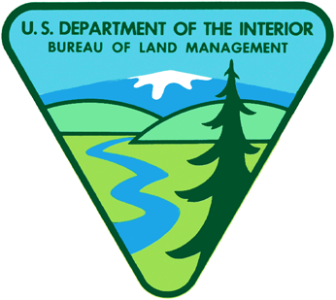

**BLM-Alaska Technical Report 24**

BLM/AK/ST-02/009+6500+931

September 2003

U.S. Department of the Interior

Bureau of Land Management

**U.S. Department of the Interior**

U.S. Fish and Wildlife Service

**Goodnews Bay**

**Earth Cover Classification**

**Ducks Unlimited, Inc.**

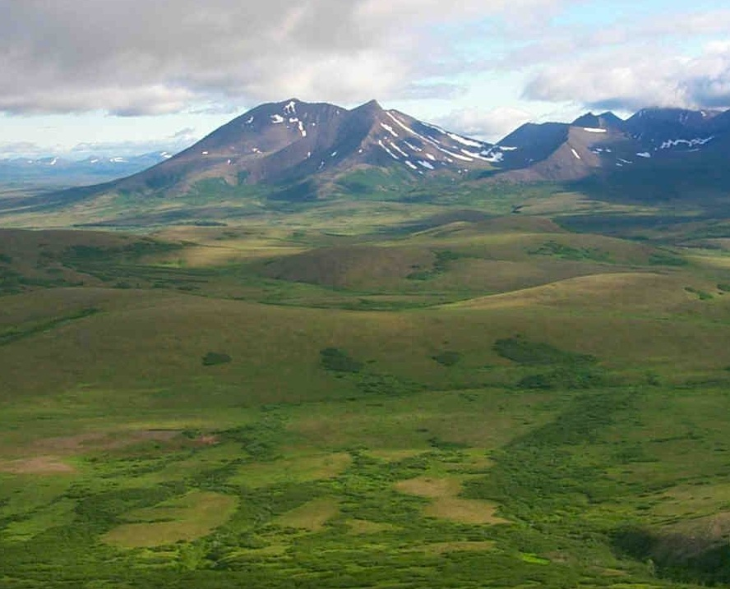

**Mission Statement**

The Bureau of Land Management (BLM) sustains the health, diversity and productivity of the public lands for the use and enjoyment of present and future generations.

**Partners**

The Department of the Interior’s Bureau of Land Management and U.S. Fish and Wildlife Service, and Ducks Unlimited, Inc. completed this project under a cooperative agreement.

**Cover**

The cover photo shows a portion of the project area near Tatlignagpeke Mountain, northwest of Goodnews Bay. It depicts the remoteness of the area and the need to use helicopters for data collection.

**Technical Reports**

Technical Reports issued by the Bureau of Land Management‑Alaska present the results of research, studies, investigations, literature searches, testing, or similar endeavors on a variety of scientific and technical subjects. The results presented are final, or are a summation and analysis of data at an intermediate point in a long‑term research project, and have received objective review by peers in the author’s field.

The reports are available while supplies last from BLM External Affairs, 222 West 7th Avenue, #13, Anchorage, Alaska 99513 (907) 271-3318 and from the Juneau Minerals Information Center, 100 Savikko Road, Mayflower Island, Douglas, AK 99824, (907) 364‑1553. Copies are also available for inspection at the Alaska Resource Library and Information Service (Anchorage), the United States Department of the Interior Resources Library in Washington, D. C., various libraries of the University of Alaska, the BLM National Business Center Library (Denver) and other selected locations.

A complete bibliography of all BLM‑Alaska scientific reports can be found on the Internet at:

http://www.ak.blm.gov/affairs/sci_rpts.html.

Related publications are also listed at:

<http://juneau.ak.blm.gov>.

Goodnews Bay

Earth Cover Classification

Technical Report 24

September 2003

U. S. Department of the Interior

Bureau of Land Management

Alaska State Office

222 W. 7th Ave., #13

Anchorage, AK 99513

U.S. Department of the Interior

U.S. Fish and Wildlife Service

Togiak National Wildlife Refuge

P.O. Box 270

Dillingham, AK 99576

Ducks Unlimited, Inc.

3074 Gold Canal Drive

Rancho Cordova, CA 95670

# Acknowledgements

This project was funded under a cooperative agreement between the United States Department of the Interior’s Bureau of Land Management (BLM) and Fish and Wildlife Service (FWS), and Ducks Unlimited, Inc (DU). This project was administered by John Payne (BLM), Gail Collins (FWS), and Beate Sterrenberg (DU).

Special thanks are extended to those who worked in the field, including Gail Collins, Pat Walsh (FWS), Jeff Denton (BLM), and Dan Fehringer (DU). Thanks to Louis Drapeau and Ron, pilot and mechanic from Evergreen Helicopters, for safe air service. Thanks also to Bob McAlpin from Alaska Fire Service for help coordinating helicopter contracting, Dan Fehringer for image processing, Mark Pearson (GoeNorth, Inc.) for programming the DUFF field database; and Jing Huang (DU) for programming the accuracy assessment program.

# 

# Table of Contents

Acknowledgements iii

Table of Contents v

List of Figures vii

List of Tables ix

Abstract xi

Introduction 1

Project Objective 2

Project Area 2

Data Acquisition 4

Methods 7

Classification Scheme 7

Image preprocessing 7

Field Verification 9

Field Data Analysis 10

Classification 13

Accuracy Assessment 16

Results 21

Field Verification 21

Classification 23

Accuracy Assessment 26

Discussion 27

Final Products 29

Conclusions 31

Literature Cited 33

APPENDICES 35

Appendix A. Alaska Earth Cover Classification Class Descriptions. 37

Appendix B. Alaska earth cover classification decision tree. 43

Appendix C. Plant species and frequency. 47

Appendix D. Error Matrix for Accuracy Assessment Sites. 49

Appendix E. Error Matrix for Training Sites. 51

Appendix F. Combined Error Matrix - Training and Accuracy Assessment Sites. 53

Appendix G. Goodnews Bay Earth Cover Mapping Classified Image Metadata. 55

Appendix G. Goodnews Bay Earth Cover Mapping Field Sites Metadata 61

Appendix H. Attribute Descriptions for Field Site Coverage and Dbase Files. 67

Appendix I. Contact Information 71

# List of Figures

**Figure 1.** Goodnews Bay Earth Cover Mapping project location. 3

**Figure 2.** Land Status within the Goodnews Bay project area. 4

**Figure 3.** Satellite images used for fieldwork. 5

**Figure 4.** Example custom field data collection form. 11

**Figure 5.** Ducks Unlimited Field Form (DUFF) Software, the customized database and user interface for field data entry. 12

**Figure 6.** The Image processing flow diagram. 15

**Figure 7.** Distribution of field sites for the Goodnews Bay mapping project. 21

**Figure 8.** Goodnews Bay earth cover map. 23

# List of Tables

**Table 1.** Acreage of project area summed by land status. 3

**Table 2.** Classification scheme developed at the BLM Earth Cover Workshop 8

**Table 3.** Field sites per class for Goodnews Bay project. 22

**Table 4.** Summary of Accuracy Assessment and Training Sites, by class. 22

**Table 5.** Acreage of earth cover classes within the project area. 24

**Table 6**. 10 most common species observed in dwarf shrub, dwarf shrub lichen, mesic/dry graminoid and lichen field sites (n=65). 28

# 

# Abstract

The Bureau of Land Management (BLM) – Alaska and Ducks Unlimited, Inc. (DU) have been cooperatively mapping wetlands and associated uplands in Alaska using remote sensing and GIS technologies since 1988. The BLM’s plans to continue this mapping effort on their Goodnews Bay lands coincided with the Togiak National Wildlife Refuge’s (NWR) goal of producing earth cover data for their lands. Because the refuge surrounds the Goodnews Bay block of land, combining field data collection efforts resulted in the reduction of overall costs associated with the earth cover mapping projects. In addition to the cooperative field data collection, both agencies used standardized classification schemes and image processing procedures throughout the mapping process. This project mapped the BLM’s Goodnews Bay lands, as well as all surrounding State and Native lands that fall between the BLM lands and the Refuge boundary. The Togiak NWR is concurrently being mapped by Refuge personnel and will be mosaiced with this classification upon completion to provide a seamless earth cover database for the entire region. Landsat TM satellite images (Path 76, Rows 18 and 19, acquired 9 September 1999) were used to classify the project area into 17 earth cover categories. Cloud covered areas from the 1999 image were filled in using additional Landsat TM images (Path 76, Rows 18 and 19, acquired 27 September 2000). An unsupervised clustering technique was used to determine the location of field sites and a custom field data collection form and digital database were used to record field information. Helicopters were utilized to gain access to field sites throughout the project area. Global positioning system (GPS) technology was used both to navigate to pre-selected sites and to record the locations of new sites selected in the field. The project area is approximately 0.7 million acres. A total of 139 field sites were visited during 3 days of fieldwork. Approximately 20% (29) of these field sites were set aside for accuracy assessment. A modified supervised/unsupervised classification technique was performed to classify the satellite imagery. The classification scheme for the earth cover inventory was based on Viereck et al. (1992)and revised through a series of meetings coordinated by the BLM – Alaska and DU. The overall accuracy of major mapping categories was over 80% at the +/-5% level of variation.

# Introduction

In Alaska, most ground-based inventories of vegetation have been limited by accessibility to the area, or logistically restricted to a single large or several smaller watersheds. Aerial photography is available for much of Alaska, but is highly variable in scale and typically outdated which generally limits its usefulness for determining earth cover over large regional areas. In the last two decades, space-borne remote sensors (Landsat, SPOT, ERS-1, and others) have emerged as the best platforms for developing regional earth cover databases. Access to these large databases allow researchers, biologists, and managers to define and map crucial areas for wildlife, perform analysis of related habitats, plot movement patterns for large ungulates, generate risk assessments for proposed projects, and provide baseline data to which wildlife and sociological data can be related.

A satellite inventory of earth cover serves many purposes. It provides baseline acreage statistics and corresponding maps for areas that currently lack or have outdated information for decision-making. It is very useful for planning Environmental Impact Statements (EIS), Comprehensive Management Plans (CMP), and other regional studies that are mandated by the Federal Government. It can be integrated with other digital data sets into a GIS to produce maps, overlays, and further analysis. It also helps researchers identify areas most important to specific species of interest and can guide biologically driven decisions on land use practices (Kempka et al. 1993). Knowledge of the size, shape, distribution and extent of earth cover types, when linked to species habitat and human activities, vastly improves our decision-making capabilities. The greater the area encompassed by earth cover information, in association with other digital base layers, the more regional, landscape-level assessment can be made and the more reliable our land management decisions will become.

The Bureau of Land Management (BLM) – Alaska and Ducks Unlimited, Inc. (DU) began cooperatively mapping wetlands and associated uplands in Alaska using remote sensing and GIS technologies in 1988 (Ritter et al. 1989). The initial mapping projects that were undertaken focused on mapping only the wetland types such as deep marsh, shallow marsh, and aquatic classes (Ritter et al. 1989). It soon became apparent that mapping the entire landscape was more cost effective and useful to both managers and habitat studies. Over the years, many refinements have been made to both the techniques of collecting field information and classifying the imagery. The BLM is currently in the process of mapping all of their lands in Alaska using this methodology. Many other agencies in Alaska (i.e. National Park Service, U.S. Fish and Wildlife Service, U.S. Forest Service, Alaska Department of Natural Resources, Alaska Department of Fish and Game) are also using similar techniques for mapping and wildlife analysis. This project represents a cooperative effort between the, the BLM, the USFWS Togiak NWR, and DU to map BLM land near Goodnews Bay, as well as State and Native land between the BLM land and the surrounding Togiak NWR. The Togiak NWR is concurrently being mapped by Refuge personnel using the same methods and will be mosaiced with this classification upon completion to provide a seamless earth cover database for the entire region. This earth cover mapping effort provides an inventory of Alaska’s land base that can be used for regional management of land and wildlife. Earth cover databases allow researchers, biologists, and managers to define and map crucial areas for wildlife; perform analysis of related habitats; detect changes in the landscape; plot movement patterns for large ungulates; generate risk assessments for proposed projects; estimate fire fuel loadings; and provide baseline data to which wildlife and sociological data can be related.

Landsat Thematic Mapper (TM) satellite imagery was chosen as the primary source for the BLM/DU earth cover mapping effort and was the only imagery used for this project area. Satellite imagery offers a number of advantages for region-wide projects. TM data is cost effective, processed using automated mapping techniques, and collected on a cyclical basis, providing a standardized data source for future database updates or change detection studies (Kempka et al. 1993). In addition, TM imagery includes a mid-infrared band, which is sensitive to both vegetation and soil moisture content and is useful in identifying earth cover types. When combined with other GIS data sets, (e.g., elevation, slope, aspect, shaded relief, and hydrology), Landsat TM data produces highly accurate classifications with a moderately detailed classification scheme.

## Project Objective

The objective of this project was to develop a baseline earth cover inventory using Landsat TM imagery for the Goodnews Bay BLM lands and associated areas. More specifically, this project purchased, classified, field verified, and produced high quality, high resolution digital and hard copy resource base maps. The result of this project was an integrated GIS database that can be used for improved natural resources planning.

## Project Area

The project area (Figure 1) consisted of approximately 680,000 acres and included lands owned or managed by the BLM, the FWS and native corporations (Figure 2). Approximately 345,000 acres of the project area (Table 1) falls under BLM management (State Selected, Native Selected and BLM land). The initial project area was defined by the Togiak NWR boundary and included all lands in the Goodnews Bay block not managed by the Refuge. A two-mile buffer into the refuge was added to this area to provide overlap with the Togiak NWR earth cover mapping effort. This overlap area will aid in edgematching with the Togiak NWR earth cover maps upon their completion. The project area contained portions of the Goodnews Bay and Hagemeister Island USGS 1:250,000 scale quadrangles.

The project area was roadless except for the minor road system immediately within the village of Goodnews Bay. The project area encompassed a variety of environments ranging from alpine mountains to coastal plains, and was characterized by large expanses of dwarf shrub cover types with tall shrub or tree-sized willow and alder found in riparian areas and on lower hill-slopes. Caribou, moose, and grizzly bear were all commonly observed throughout the study area, but in limited numbers. The Goodnews River, flowing through the center of the project area, supports a commercial salmon run as well as an exclusive sport-fishing lodge and is of local economic and social importance.

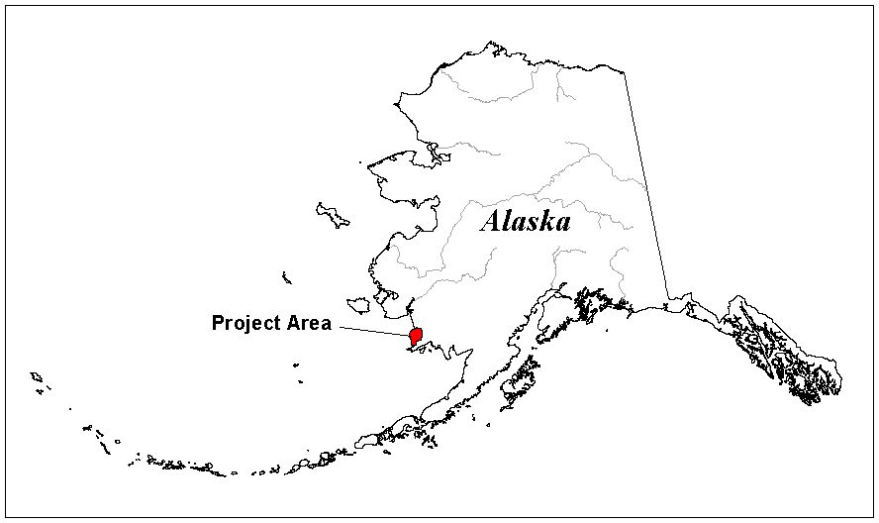

Figure 1. Goodnews Bay Earth Cover Mapping project location.

**Table 1.** Acreage of project area summed by land status.

|  |  |
| --- | --- |
| General Status | Acres |
| Bureau of Land Management | 165,013 |
| U.S. Fish and Wildlife Service | 113,164 |
| State Selected | 77,664 |
| Native Patent or IC | 222,250 |
| Native Selected | 102,071 |
| Total | 680,162 |
| Source: BLM General Status layer March 06, 2002 |  |

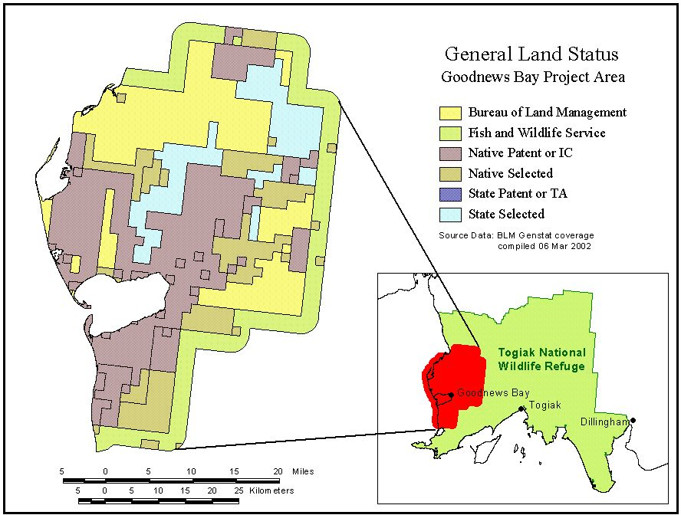

Figure 2. Land Status within the Goodnews Bay project area.

## Data Acquisition

Four Landsat 7 ETM+ satellite images were used in this mapping effort. Images from path 76, rows 18 and 19, acquired 27 September 2000 were provided by the BLM. The images were purchased through and terrain-corrected by ImageLinks of Melbourne, FL. The images were georeferenced to the BLM’s standard Albers Conic Equal Area projection with standard Alaska projection parameters (55N, 65N, -154W, 50N) and North American Datum 1927 (NAD27). These images were chosen because they were the most cloud-free images available for the project area and represented the most current data available for the project area. Unfortunately, the early autumn acquisition date of the images resulted in the presence of extensive leaf senescence and defoliation in deciduous plant species throughout the images. These two images were used for training site delineation and for fieldwork. Upon return from fieldwork the Togiak NWR provided two additional images, path76 rows 18 and 19, acquired 9 September 1999. These images did not have a significant amount of leaf senescence, but did have a greater presence of cloud cover throughout the study area (Figure 3). The 1999 images were projected in Albers projection with the same projection parameters as the 2000 images but were referenced to the World Geodetic System 1984 (WGS84) datum. The 1999 images were reprojected to match the NAD27 datum of the September 2000 BLM imagery.

Field data were collected during a 5-day field season from July 13, 2001 through July 17, 2001. Ancillary data sets used in this project included: 1:60,000 scale aerial photographs (color infrared transparencies from 1980, 1982, 1983, and 1984), and USGS 1:250,000 scale Digital Elevation Models (DEM). The aerial photographs and DEM’s were provided by the BLM.

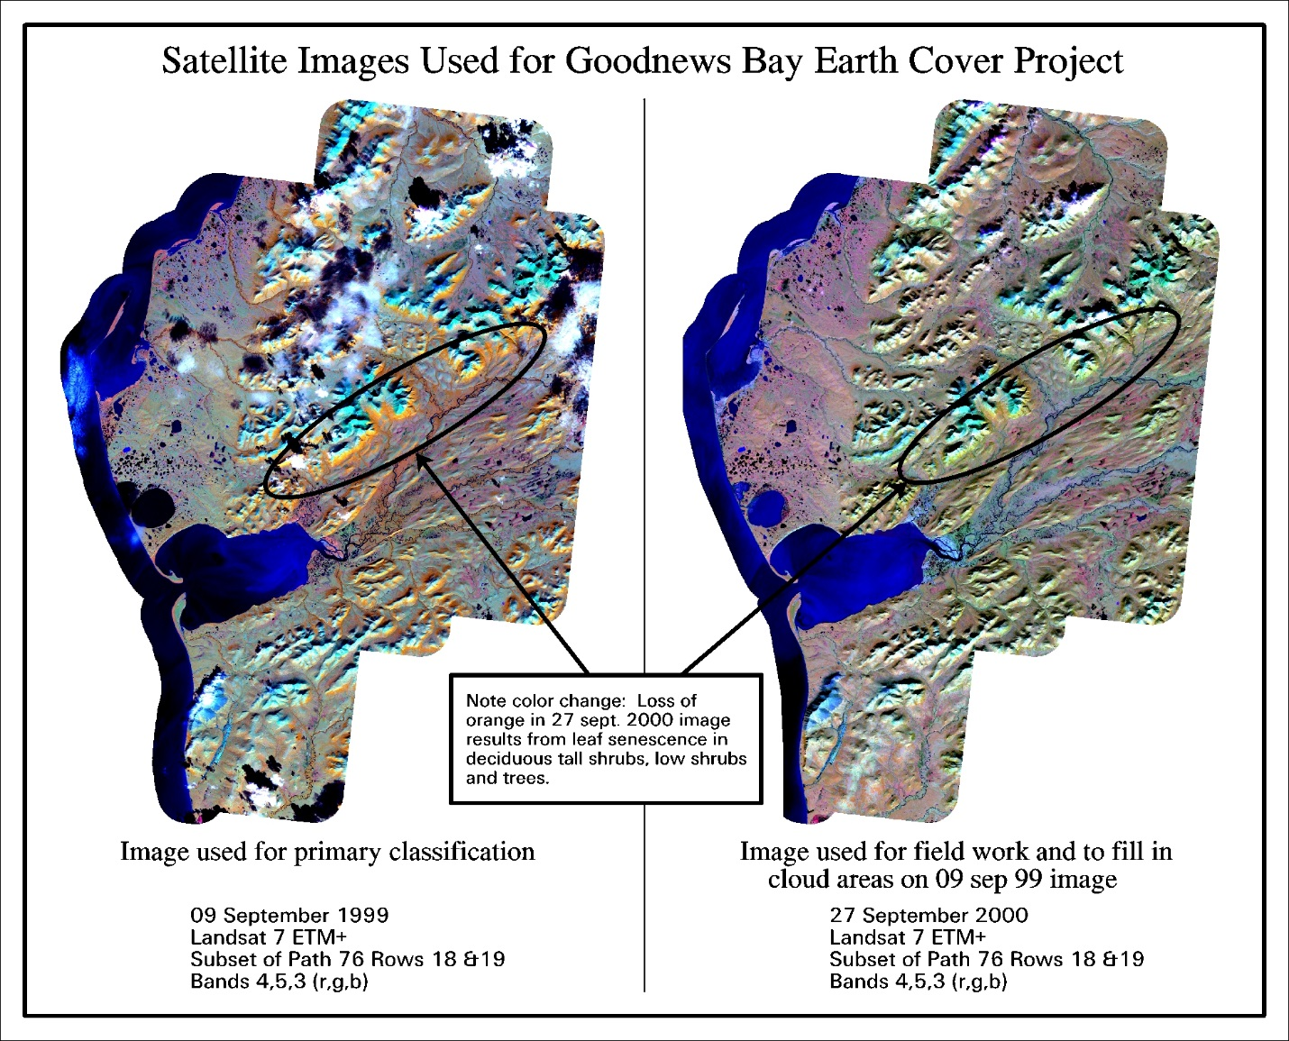

Figure 3. Satellite images used for fieldwork.

# 

# Methods

## 

## Classification Scheme

The classification system (Table 2) categorized the features to be mapped. The system was derived from the anticipated uses of the map information and the features of the earth that could be discerned by TM data. The classification system had two critical components: (1) a set of labels (e.g., forest, shrub, water); and (2) a set of rules, or a system for assigning labels. The set of rules for assigning labels was mutually exclusive and totally exhaustive (Congalton 1991). That is, any given area fell into only one category and every area was to be included in the classification.

In the past, BLM/DU classification systems were project specific. As projects expanded in size and as other cooperators began mapping and sharing data across Alaska, the necessity for a standardized classification system became apparent. At the BLM Earth Cover Workshop in Anchorage on 3-6 March 1997, a classification system (Ducks Unlimited, Inc., 1998) based on the existing Alaska Vegetation Classification (Viereck et al., 1992) was designed to address this need. The goal of this meeting was to (1) develop an earth cover classification system for the state of Alaska that can be used in large regional mapping efforts, and (2) build consensus for the system among multiple land management agencies. The classification system has been slightly improved since this meeting.

The classification scheme consisted of 10 major categories and 24 subcategories. A

classification decision tree and written class descriptions (Appendices A and B) were developed to clarify the classification. Though based largely on Level III of the Viereck et al. (1992) classification, some classes have been modified, added or omitted for the earth cover mapping projects: e.g., rock, water, ice, cloud and shadow classes were added. Other classes that could not reliably be discerned from satellite imagery were collapsed, such as open and closed shrub classes, or *dryas*, ericaceous, willow, and dwarf shrub classes. Because of the importance of lichen for site characterization and wildlife, and because the presence of lichen can be detected by satellite imagery, shrub and forested classes with and without a component of lichen were distinguished.

## Image preprocessing

Each image was examined for quality and consistency. Each band was examined visually and statistically by reviewing histograms. Combinations of bands were displayed to check for band-to-band registration and for clouds, shadows, and haze. Comparing the image to available ancillary data such as hydrography, adjacent imagery, and DEMs assessed positional accuracy.

To optimize helicopter efficiency during fieldwork, field sites were identified and plotted on field maps before fieldwork began. Sufficient samples for each mapped class were selected to span the variation of spectral responses within that class throughout the entire image. For example, a

**Table 2.** Classification scheme developed at the BLM Earth Cover Workshop

|  |  |  |
| --- | --- | --- |
| Level II | Level III | Level IV |
| 1.0 Forest | 1.1 Closed Needleleaf |  |
|  | 1.2 Open Needleleaf | 1.21Open Needleleaf Lichen |
|  | 1.3 Woodland Needleleaf | 1.31 Woodland Needleleaf Lichen |
|  | 1.4 Closed Deciduous | 1.41 Closed Paper Birch |
|  |  | 1.42 Closed Aspen |
|  |  | 1.43 Closed Balsam Poplar/Cottonwood |
|  |  | 1.44 Closed Mixed Deciduous |
|  | 1.5 Open Deciduous | 1.51 Open Paper Birch |
|  |  | 1.52 Open Aspen |
|  |  | 1.53 Open Balsam Poplar/Cottonwood |
|  |  | 1.54 Open Mixed Deciduous |
|  | 1.6 Closed Mixed Needleleaf/Deciduous |  |
|  | 1.7 Open Mixed Needleleaf/Deciduous |  |
|  |  |  |
| 2.0 Shrub | 2.1 Tall Shrub |  |
|  | 2.2 Low Shrub | 2.21 Low Shrub Willow/Alder |
|  |  | 2.22 Low Shrub Tussock Tundra |
|  |  | 2.23 Low Shrub Lichen |
|  |  | 2.24 Low Shrub Other |
|  | 2.3 Dwarf Shrub | 2.31 Dwarf Shrub Lichen |
|  |  | 2.32 Dwarf Shrub Other |
|  |  |  |
| 3.0 Herbaceous | 3.1 Bryoid | 3.11 Lichen |
|  |  | 3.12 Moss |
|  | 3.2 Wet Herbaceous | 3.21Wet Graminoid |
|  |  | 3.22 Wet Forb |
|  | 3.3 Mesic/Dry Herbaceous | 3.31 Tussock Tundra |
|  |  | 3.32 Mesic/Dry Sedge Meadow |
|  |  | 3.33 Mesic/Dry Grass Meadow |
|  |  | 3.34 Mesic/Dry Graminoid |
|  |  | 3.35 Mesic/Dry Forb |
|  |  |  |
| 4.0 Aquatic Vegetation | 4.1 Aquatic Bed |  |
|  | 4.2 Emergent Vegetation |  |
|  |  |  |
| 5.0 Water | 5.1 Snow |  |
|  | 5.2 Ice |  |
|  | 5.3 Clear Water |  |
|  | 5.4 Turbid Water |  |
|  |  |  |
| 6.0 Barren | 6.1 Sparsely Vegetated |  |
|  | 6.2 Rock/Gravel |  |
|  | 6.3 Mud/Silt/Sand |  |
| 7.0 Urban |  |  |
|  |  |  |
| 8.0 Agriculture |  |  |
|  |  |  |
| 9.0 Cloud/Shadow | 9.1 Cloud |  |
|  | 9.2 Shadow |  |
| 10.0 Other |  |  |

shrub class in the southern part of an image may have a different spectral response than the same shrub class in the northern part of that image. Many factors contribute to such variation, including aspect, terrain shadow, or small differences in soil moisture. In addition, each earth cover type encompassed a variety of subtypes; e.g., the dwarf shrub class could include areas with 25%-100% dwarf shrub cover, a variety of dwarf shrub species, and a diverse composition of graminoids and/or forbs interspersed with the dwarf shrub component.

An unsupervised classification was used to identify spectrally unique areas within the study area. The image analyst individually selected training sites from these spectrally unique areas. Whenever possible, training sites were grouped in clusters to reduce the amount of travel time between sites. The image analyst also tried to place training sites near landmarks that were easily recognizable in the field, such as lakes, streams, or abrupt changes in cover type.

A tally of the estimated number of field sites per class was kept until all of the target map classes were adequately sampled throughout the project area. The coordinates of the center points of the field sites were then uploaded into a Y-code Rockwell Precision Lightweight GPS receiver (PLGR) for navigational purposes. Training sites were overlain with the satellite imagery and plotted at 1 inch = 1 mile scale. These field maps were used for recording field notes, placing additional field sample sites, and navigating to field sites.

## Field Verification

The purpose of field data collection was to assess, measure, and document the on-the-ground vegetation variation within the project area. This variation was correlated with the spectral variation in the satellite imagery during the image classification process. Low-level helicopter surveys were used as a very effective method of field data collection since a much broader area was covered with an orthogonal view from above, similar to a satellite sensor. In addition, aerial surveys were the most efficient alternative due to the large area and the lack of roads throughout the majority of the project area.

To obtain a reliable and consistent field sample, a custom field data collection form (Kempka et al., 1994) was developed and used to record field information (Figure 4). A five-person helicopter crew performed the field assessment. The crew consisted of a pilot, biologist, recorder, navigator, and alternate. The navigator operated the GPS equipment and interpreted the satellite image derived field maps to guide the pilot to the pre-defined field site. It was valuable for the image processor to gain first-hand knowledge of the project area, therefore the image processor also fulfilled the role of the navigator. The biologist identified plant species, estimated the percent cover of each cover type, determined the overall earth cover class, and photographed the site. The recorder wrote species percentages and other data on the field form and generally assisted the biologist. The alternate was responsible for crew flight following, data entry, and substitution in case of sickness. The majority of sites were observed without landing the helicopter. Ground verification was performed when identification of dominant vegetation was uncertain.

These DU/BLM procedures for collecting field data have evolved into a very efficient and effective means of data collection. The navigator used a GPS to locate the site and verified the location on the field map. As the helicopter approached the site at about 300 meters above ground level the navigator described the site and the biologist took a picture with a digital camera. The pilot then descended to approximately 2-5 meters above the vegetation and laterally moved across the site while the biologist called out the vegetation to the recorder. The biologist took another picture with the digital camera for a close-up view of the site. The pilot then ascended to approximately 100 meters so that the biologist could estimate the percentages of each species to the recorder. The navigator then directed the pilot to the next site. On average, it took approximately 5-8 minutes to collect all of the information for one site.

Five days of fieldwork were planned. As part of the joint mapping effort between the BLM and the Togiak NWR, a 10-mile buffer into the Refuge was added to the Goodnews Bay mapping area for the fieldwork portion of the project. Two days of field time were scheduled for this area within the refuge. This provided the Refuge with an increased amount of field data, and still provided data that could be used by the DU image processor as training data for processing within the Goodnews Bay project area. In addition, the remoteness of Cape Pierce and Cape Newenham in the southwestern-most corner of the Refuge would have made it difficult for Refuge field crews to sample these areas while working out of their bases in Togiak or Dillingham. The area could easily be reached from the village of Goodnews Bay, so the Goodnews Bay field crew performed the fieldwork in this area.

The Goodnews Bay field crew consisted of personnel from the BLM, the Togiak NWR, and DU. The goal of this joint field crew was to provide consistent data collection techniques for the Goodnews Bay earth cover mapping effort and the Togiak NWR mapping effort. This would provide consistent field data that could be shared between image processors, especially in areas of overlap between the two efforts. BLM and DU crewmembers experienced with the procedures trained the Togiak NWR crewmembers, who were unfamiliar with the field methods at the onset of the project. Subsequently, the Togiak NWR crewmembers utilized these methods for their fieldwork within the remaining areas of the Refuge.

## Field Data Analysis

The data gathered during fieldwork was entered into a digital database using the Ducks Unlimited Field Form (DUFF) custom data entry application, designed jointly by the BLM and DU and programmed by GeoNorth. The relational database was powered by SQL Anywhere while the user interface was programmed in Visual Basic. The user interface was organized similarly to the field form to facilitate data entry (Figure 5). The application utilized pull down menus to minimize keystrokes and checked for data integrity to minimize data entry errors. The database program also calculated an overall class name for each site based on the recorded species and their cover percentages. Digital images from each site were stored in the database and were accessible from within the user interface. The number of field sites per earth cover class was tracked daily to ensure that adequate samples were being obtained within each class.

As requested by BLM/FWS biologists, wildlife observations made while visiting or traveling between field sites were recorded. A digital point coverage was created and delivered with the final products.

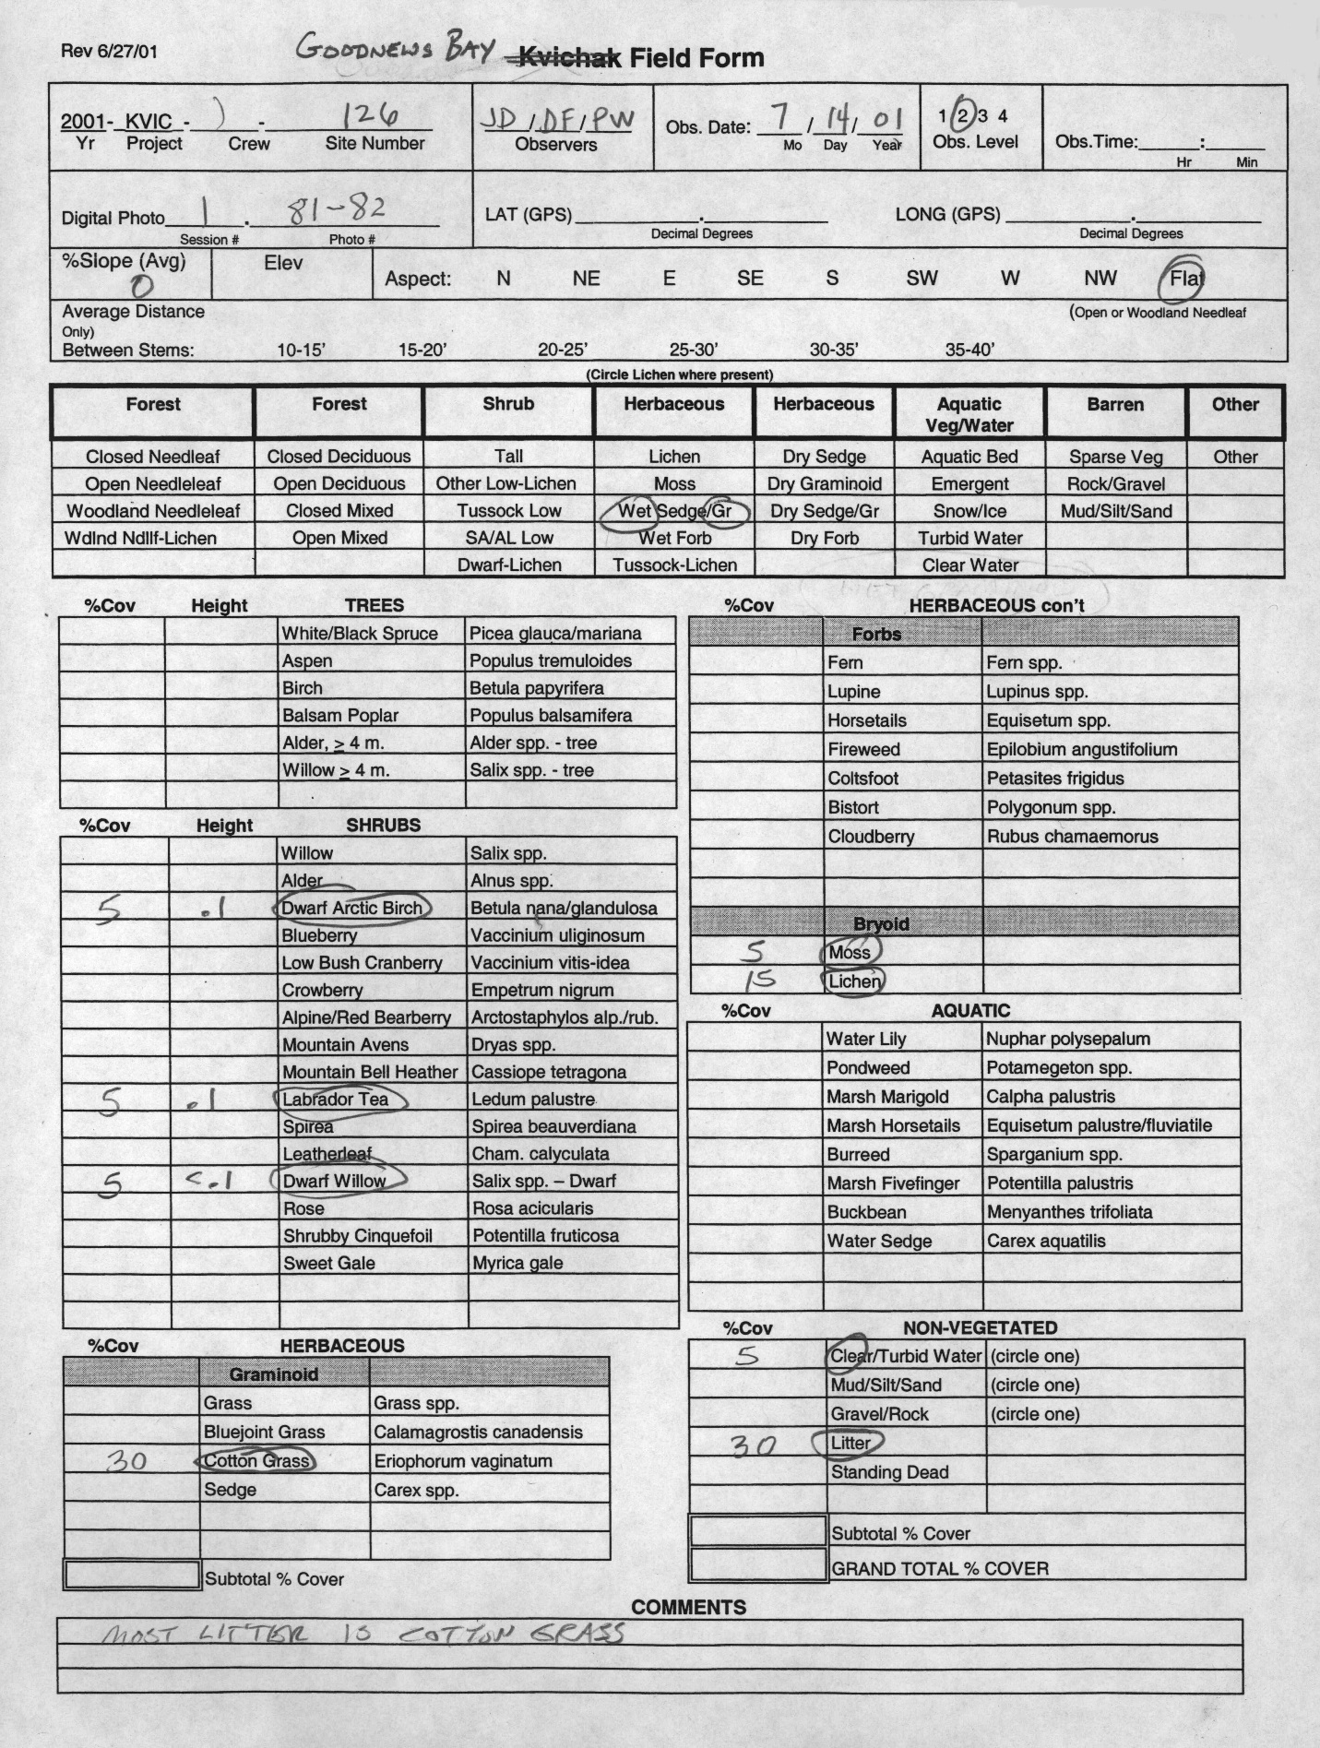

Figure 4. Example custom field data collection form.

**Sample Field Site – Wet Graminoid**

**High site photo Low site photo**

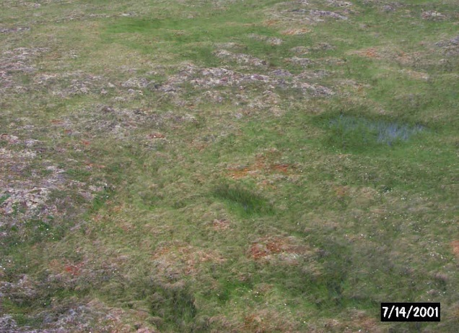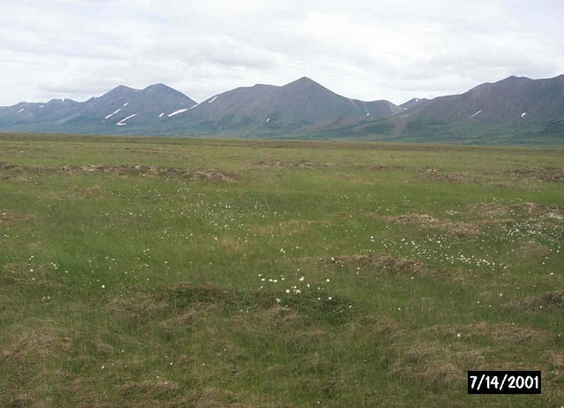

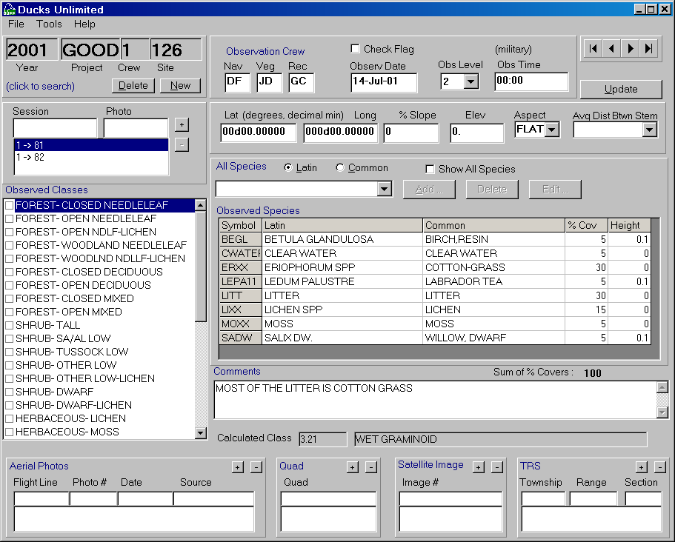

**DUFF Screen Capture**

Figure 5. Ducks Unlimited Field Form (DUFF) Software, the customized database and user interface for field data entry.

## Classification

Every image is unique and presents special problems in the classification process. The approach used in this project (Figure 6) has been proven successful over many years. The image processor was actively involved in the field data collection and had first hand knowledge of every training site. The image processor’s site-specific experience and knowledge in combination with high quality ancillary data overcame image problems and produced a high quality, useful product.

Erdas Imagine (vers. 8.5) was used to perform the classification. Arc Info (vers. 8.1.2) was utilized to manage the field site polygons. Various word processing and data analysis software were also used during the image classification including MS Word, Excel and Access.

The 27 September 2000 image was used for delineation of pre-selected field sites and for field map production. Upon receiving the 9 September 1999 image from FWS after fieldwork was complete, it was decided to use the 1999 image for all initial classification work. The early September image date had less leaf senescence and/or leaf loss present throughout the image and thus provided the best spectral data for vegetation class separation. The 9 September image also had significantly less terrain shadow present than did the 27 September image. The 1999 image did contain a greater amount of cloud cover than the 2000 image, however, and a secondary classification of the 2000 image was used to fill in the cloud areas in the 1999 image.

### Generation of New Bands

Landsat TM imagery contains 7 bands of data: 3 visible bands, 1 near-infrared band, 2 mid-infrared bands, and 1 thermal band. One new band, the Normalized Difference Vegetation Index (NDVI), was generated for this project. The NDVI was highly correlated with the 4/3 ratio, a band ratio that typically reduces the effect of shadows in the image and enhances the differences between vegetation types (Kempka et al. 1995, Congalton et al., 1993). In addition, the NDVI has been correlated with various vegetation canopy characteristics such as biomass and leaf area index. This NDVI band replaced the thermal band (band 6) to retain a 7-band image for classification.

### Removal of Clouds and Shadows

Clouds and cloud shadows in the 27 September 2000 image were removed using an unsupervised classification and manual on-screen digitizing prior to the selection of field sites. Clouds and cloud shadows in the 9 September 1999 image were identified using the same techniques. Once identified they were “masked” out of the image to be replaced with the classification from the 27 September 2000 image.

Terrain shadows were identified with models using unsupervised classifications and shaded relief images as inputs. The shaded relief images were produced in Erdas Imagine using USGS 1:63,360 scale Digital Elevation Models (DEMs). Sun azimuth and sun angle values for use in the shaded relief algorithm were obtained from the header files of the Landsat TM images. This allowed the shaded relief image to most closely mimic the terrain shadows present at the time of the Landsat TM image acquisition. The terrain shadow image contained values ranging from 0.0 to 1.0 with the most shaded areas equal to 0.0 and the brightest or least shaded areas equal to 1.0. Terrain shadows were most often spectrally confused with earth cover classes that appeared very dark on the image, e.g. water, emergent vegetation, and wet graminoid. An unsupervised classification was used to identify spectral classes that confused terrain shadowed areas with these spectrally “dark” classes. The model compared the pixels from these spectral classes to the most shaded areas in the shaded relief image. If a pixel fell within one of these classes and had a value less than .5 in the shaded relief image, it was labeled as a terrain shadow. Additional on-screen digitizing was used to identify terrain shadowed pixels that were not identified by the modeling procedure. All the remaining “non-shadow” pixels were put back into the image for further iterations of unsupervised classifications that were used to identify earth cover classes.

### Seeding Process

Spectral signatures for the field sites to be used as training areas were extracted from the imagery using a “seeding” process in Erdas Imagine. A pixel within each training area was chosen as a “seed” and adjoining pixels in the training site were evaluated for inclusion using a threshold value based on a spectral Euclidean distance. The standard deviations of the seeded areas were kept close to or below 3 and all seeded areas were required to be over 15 pixels (approximately 3.75 acres) in size. Along with the field training areas, additional “seeds” were generated for clear water and turbid water. These classes were easily recognizable on the imagery and aerial photography. The output of the seeding process in Imagine was a signature file that contained all of the statistics for the training areas. The signature file was then used in the modified supervised/unsupervised classification.

### Generation of Unsupervised Signatures

An unsupervised classification was generated using the six raw bands and the NDVI ratio. Fifty signatures were derived from the unsupervised classification using the ISODATA program in Imagine. The output of this process was a signature file similar to that of the seeding process but containing the 50 unsupervised signatures. A maximum likelihood classification of the 50 unsupervised signatures was generated using the supervised classification program in Imagine.

### Modified Supervised/Unsupervised Classification

A modified supervised/unsupervised classification approach (Chuvieco and Congalton 1988) was used for the classification. This approach uses a statistical program to group the spectrally unique signatures from the unsupervised classification with the signatures of the supervised training areas. In this way, the spectrally unique areas were labeled according to the supervised training areas. This classification approach provided three major benefits: (1) it aided in the labeling of the unsupervised classes by grouping them with known supervised training sites; (2) it helped to identify classes that possessed no spectral uniqueness (i.e., training sites that were spectrally inseparable); and (3) it identified areas of spectral reflectance present in the imagery that had not been represented by a training site. This approach was an iterative process because all of the supervised signatures do not cluster perfectly with the unsupervised signatures the first time. The unsupervised signatures that matched well with the supervised signatures were inspected, labeled with the appropriate class label, and removed from the classification process. The remaining

Figure 6. The Image processing flow diagram.

confused clusters were grouped into general categories (e.g., forest, shrub, non-vegetation) and the process was repeated. This process continued until all of the spectral classes were adequately matched and labeled, or until the remaining confused classes were spectrally inseparable. Throughout this iterative process, interim checks of classification accuracy were performed by intersecting the classified image with a coverage of the training sites to determine if the training sites were being accurately labeled by the classification. Areas with incorrectly classified training sites were run through further iterations of the supervised/unsupervised classification and further refined. The iterative process of interim accuracy assessments and refining classifications was terminated when the accuracy assessments indicated no improvements between one iteration and the next.

### Editing and Modeling

Models that incorporated ancillary data sets such as elevation, slope, aspect, shaded relief, or hydrography helped to separate confused classes. For instance, terrain shadow/water confusion was easily corrected by creating a model using a shaded relief layer derived from DEMs. For this project, the final steps of the classification process were to model the confused classes remaining after the iterative supervised/unsupervised classification process and to make final edits in areas that still had classification errors. Editing of classification errors was a process of comparing the classified image to the raw satellite image, aerial photography, and notes on field maps to identify errors remaining in the classification. These errors were then corrected by manually changing the class value for the pixels that were classified in error to their correct class value.

## Accuracy Assessment

There were two primary motivations for accuracy assessment: (1) to understand the errors in the map (so they can be corrected), and (2) to provide an overall assessment of the reliability of the map (Gopal and Woodcock, 1992). Factors affecting accuracy included the number and location of test samples and the sampling scheme employed. Congalton (1991) suggested that 50 samples be selected for each map category as a rule of thumb. This value has been empirically derived over many projects. A second method of determining sample size includes using the multinomial distribution and specifying a given confidence in the estimate (Tortora 1978). The results of this calculation tend to favorably agree with Congalton’s rule of thumb. Once a sample size is determined, it must be allocated among the categories in the map. A strictly proportional allocation is possible. However, the smaller categories in area extent will have only a few samples that may severely hamper future analysis. The other extreme is to force a given number of samples from each category. Depending on the extent of each category, this approach can significantly bias the results. Finally, a sampling scheme must be selected. A purely random approach has excellent statistical properties, but is practically difficult and expensive to apply. A purely systematic approach is easy to apply, but could result in sampling from only limited areas of the map.

### 

### Alaska Perspective

Obtaining adequate reference data for performing an accuracy assessment can be extremely expensive in remote areas. Aircraft is the only means of transportation throughout most of Alaska. Aerial photographs are available for most of Alaska, but most are at a scale that makes it difficult if not impossible to distinguish some vegetation classes. Ideally, fieldwork would be performed during one summer, the classification would be performed during the winter, and the reference data would be collected the next summer. This procedure would allow a stratified random sample of the classification and ensure adequate sampling of all the classes. Unfortunately, this methodology is not typically feasible due to the cost of obtaining the field data in Alaska.

In this project, the fieldwork for obtaining the training sites for classifying the imagery and the reference data for the accuracy assessment was accomplished at the same time. Special care was taken during the preprocessing stage and in the field to make sure adequate samples were obtained. However, funding limitations did not allow for the number of samples suggested for each class (n=50) for the accuracy assessment. Some earth cover classes were naturally limited in size and distribution so that a statistically valid accuracy assessment sample could not be obtained without additional field time. For classes with low sample sizes few, if any, field sites were withheld for the accuracy assessment. This does not indicate that the classification for these types is inaccurate but rather that no statistically valid conclusions can be made about the accuracy of these classes. However, withholding even a small percentage of sites for the accuracy assessment provided some confidence in the classification and guided the image processor and end user in identifying areas of confusion in the classification.

### Selection of Accuracy Assessment Sites

Approximately 39% of the field sites collected within the mapped area were set aside for use in the assessment of map accuracy and the remaining sites were utilized in the classification process. Unfortunately, given time and budget constraints it was not always possible to obtain enough sites per class to perform both the classification and a statistically valid accuracy assessment. A minimum of 15 sites in an individual class (5 for accuracy assessment, 10 for image processing training sites) was desired before any attempt was made to assess the accuracy of that class. Classes with less than 15 field sites were still classified, but all field sites were typically utilized during the classification process and none were withheld for later use in accuracy assessment. Accuracy assessment sites were selected randomly across the project area to reduce bias.

### Qualification of Accuracy Assessment Standards

While the accuracy assessment performed in this project was not a statistically robust test of the classification, it gives the user some confidence in using the classification. It also provides enough detail for the end user to determine where discrepancies in the classification may cause a problem while using the data. It is also important to note the variations in the dates of the imagery, aerial photographs, and field data. For this project, the imagery was from 1999 and 2000; the aerial photographs spanned a seven-year period from 1980 through 1987, and the field data was collected in July 2001. Differences due to environmental changes from the different sources may impact the accuracy assessment. Changes may have resulted from river/stream channel meandering, re-vegetation of formerly sparse or barren areas such as gravel bars, or annual climatic differences. For example, lakes, ponds, wet graminoid and emergent areas appear to have higher water levels in the 1999 image than in the 2000 image. In addition, the tide level appears to be significantly lower in the 2000 image than in the 1999 image. The objective of this mapping project was to classify and map earth cover conditions as they existed at the dates of the satellite images: 1999 for the September 9 image, and 2000 for the areas mapped with the September 27 image. Capturing field data in 2001 for training and accuracy assessment of 1999 and 2000 imagery may result in the potential introduction of error and/or variation in human interpretation of land cover composition that may impact the reliability and consistency of the reference accuracy assessment and training site data.

A major assumption of quantitative accuracy assessments is that the label from the reference information represents the “true” label of the site and that all differences between the remotely sensed map classification and the reference data are due to classification and/or delineation errors (Congalton and Green, 1993). Unfortunately, error matrices can be inadequate indicators of map error because they are often confused by non-map error differences. Some of the non-map errors that can cause confusion are: registration differences between the reference data and the remotely sensed map classification, digitizing errors, data entry errors, changes in land cover between the date of the remotely sensed data and the date of the reference data, mistakes in interpretation of reference data, and variation in classification and delineation of the reference data due to inconsistencies in human interpretation of vegetation.

Special effort was made to carefully define field site locations to eliminate registration errors. Field data entry was closely monitored and carefully checked for quality to avoid data entry errors. In an effort to account for some of the variation in human interpretation in the accuracy assessment process, overall classification accuracies were also generated assuming a +/- 5% variation in estimation of vegetation compositions for each of the accuracy assessment sites. In other words, if a variation in interpretation of +/- 5% would have resulted in the generation of a different reference site label, this new label was also considered an acceptable mapping label for the reference site.

### Error Matrix

The standard method for assessing the accuracy of a map was to build an error matrix, also known as a confusion matrix, or contingency table. The error matrix compared the reference data (field site) with the classification. The matrix was designed as a square array of numbers set out in rows and columns that expressed the number of sites assigned to a particular category in the reference data relative to the number of sites assigned to a particular category in the classification. The columns represented the reference data while the rows indicated the classification (Lillesand and Kiefer, 1994). An error matrix was an effective way to represent accuracy in that the individual accuracy of each category was plainly described along with both the errors of inclusion (commission errors) and errors of exclusion (omission errors) present in the classification. A commission error occurred when an area was included in a category to which it did not belong. An omission error was excluding that area from the category in which it did belong. Every error was an omission from the correct category and a commission to a wrong category. Note that the error matrix and accuracy assessment was based on the assumption that the reference data was 100% correct. This assumption was not always true.

In addition to clearly showing errors of omission (producer’s accuracy) and commission (user’s accuracy), the error matrix was used to compute overall accuracy. (Story and Congalton 1986). Overall accuracy was allocated as the sum of the major diagonal (i.e., the correctly classified samples) divided by the total number of samples in the error matrix. This value is the most commonly reported accuracy assessment statistic. Producer’s and user’s accuracies are ways of representing individual category accuracy instead of using just the overall classification accuracy.

# Results

## Field Verification

Data was collected on 139 field sites during a 5-day field season from July 13, 2001 through July 17, 2001. A total of approximately 18.5 hours of helicopter flight time were used, equating to approximately 8 minutes per field site. The limited number of sites visited resulted from the relatively short field season, compounded by weather related issues. First, poor weather delayed delivery of fuel for the helicopter until late in the afternoon of July 13. Second, rain and high winds grounded the helicopter for the entire day on July 15 and half the day on July 16. Seventy-one sites were visited within the mapping boundary (Figure 7), and sixty-eight sites were visited within the 10-mile buffer area extending into the Togiak NWR. In addition, the Togiak NWR field crew visited 78 sites within the 10-mile buffer strip and 4 sites within the Goodnews Bay mapping boundary. This provided for a grand total of 221 sites; 75 sites within the mapping boundary that could be utilized as either accuracy assessment sites or training sites, and an additional 146 sites that could be utilized as training sites only (Table 3). Of the 75 sites within the mapping boundary, 29 were withheld for accuracy assessment and the remaining 46 were used as training sites (Table 4). A tally of species

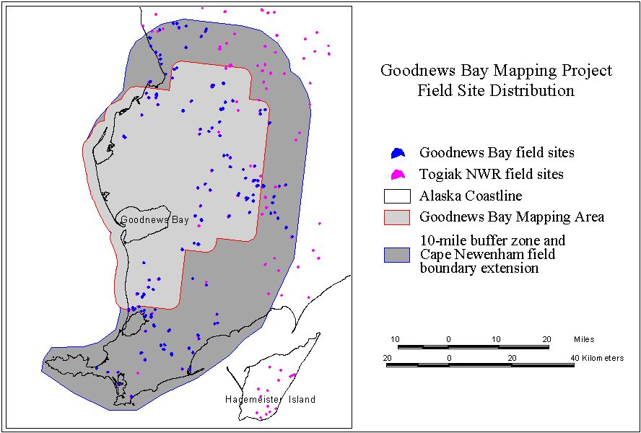

Figure 7. Distribution of field sites for the Goodnews Bay mapping project.

**Table 3.** Field sites per class for Goodnews Bay project.

|  |  |  |  |  |
| --- | --- | --- | --- | --- |
| Class Name | # of Field Sites within mapping boundary | # of Field Sites within  10-mile buffer area | Total Number of Field Sites | Percentage of  Field Sites by Class |
| CLOSED DECIDUOUS | 3 | 4 | 7 | 3.2% |
| OPEN DECIDUOUS | 1 | 1 | 2 | 0.9% |
| TALL SHRUB | 14 | 20 | 34 | 15.4% |
| LOW SHRUB – LICHEN | 1 | 1 | 2 | 0.9% |
| LOW SHRUB – WILLOW/ALDER | 3 | 1 | 4 | 1.8% |
| DWARF SHRUB – OTHER | 24 | 27 | 51 | 23.1% |
| DWARF SHRUB – LICHEN | 9 | 40 | 49 | 22.2% |
| WET GRAMINOID | 8 | 14 | 22 | 9.5% |
| WET FORB |  | 1 | 1 | 0.5% |
| LICHEN |  | 5 | 5 | 2.3% |
| MOSS | 2 | 13 | 15 | 6.8% |
| MESIC/DRY GRAMINOID | 4 | 10 | 14 | 6.3% |
| Mesic/Dry Graminoid | (0) | (1) | (1) |  |
| Mesic/Dry Grass Meadow | (4) | (8) | (12) |  |
| Mesic/Dry Sedge Meadow | (0) | (1) | (1) |  |
| MESIC/DRY FORB | 1 | 1 | 2 | 0.9% |
| EMERGENT VEGETATION | 2 | 0 | 2 | 0.9% |
| SPARSE VEGETATION | 1 | 6 | 7 | 3.2% |
| ROCK/GRAVEL/SAND | 2 | 2 | 4 | 1.8% |
| **TOTAL** | **75** | **146** | **221** | **100.0%** |

**Table 4.** Summary of Accuracy Assessment and Training Sites, by class.

|  |  |  |  |
| --- | --- | --- | --- |
| Class Name | Field Sites used for Accuracy Assessment | Field Sites used for Training | Total Number of Field Sites within mapping boundary |
| CLOSED DECIDUOUS | 0 | 3 | 3 |
| OPEN DECIDUOUS | 0 | 1 | 1 |
| TALL SHRUB | 6 | 8 | 14 |
| LOW SHRUB – LICHEN | 0 | 1 | 1 |
| LOW SHRUB – WILLOW/ALDER | 0 | 3 | 3 |
| DWARF SHRUB – OTHER | 11 | 13 | 24 |
| DWARF SHRUB – LICHEN | 5 | 4 | 9 |
| WET GRAMINOID | 5 | 3 | 8 |
| WET FORB | 0 | 0 | 0 |
| LICHEN | 0 | 0 | 0 |
| MOSS | 2 | 0 | 2 |
| MESIC/DRY GRAMINOID | 0 | 4 | 4 |
| MESIC/DRY FORB | 0 | 1 | 1 |
| EMERGENT VEGETATION | 0 | 2 | 2 |
| SPARSE VEGETATION | 0 | 1 | 1 |
| ROCK/GRAVEL/SAND | 0 | 2 | 2 |
| OTHER | 0 | 0 | 0 |
| **TOTAL** | **29** | **46** | **75** |

The proportions of sites per class largely reflected the proportions of corresponding earth cover types within the project area, though proportionally more sites were collected for classes that exhibited greater variation in growth form and/or spectral response on the satellite imagery.

An A-Star helicopter was utilized to gain access to field sites. Field operations were based out of the village of Goodnews Bay, and all fuel was stored on the village’s airstrip.

## Classification

Seventeen earth cover classes were mapped in the final earth cover map (Figure 8).

Appendix A provides class descriptions and notes about individual classes specific to the project area, as well as notes indicating which classes in the Alaska Earth cover Classification Scheme that were not observed in the project area. Note that the “Saltwater” class is based somewhat on spectral response but mostly on visual interpretation by the image processor. Significant spectral confusion occurred between saltwater and inland waterbodies, and on-screen editing was used to eliminate

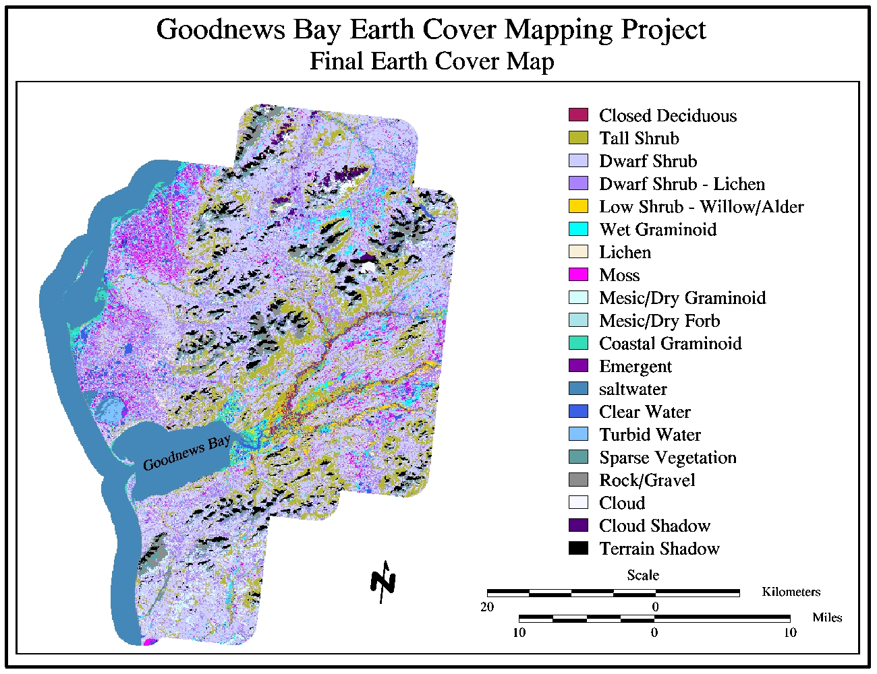

Figure 8. Goodnews Bay earth cover map.

saltwater from inland areas. The transition between saltwater and freshwater at river outlets and bays as portrayed in the earth cover map is a result of unsupervised classification and on-screen editing. The distinction between Saltwater and Clear or Turbid water does not represent a specific or measured change in salinity levels.

Table 5 presents the total acreage for all earth cover classes. Percent area values in Table 5 are calculated using “land” and clear/turbid water classes only. The Saltwater, Cloud, Cloud Shadow, and Terrain Shadow classes are excluded from the percent area calculations.

The project area was dominated by dwarf shrub, dwarf shrub lichen, bryoid and dry graminoid cover types, which accounted for 70% of the final earth cover map. Exceptions to this occurred along riparian strips, river floodplains, and well-drained slopes, where tall shrubs became the dominant cover class. Additionally, coastal graminoids, primarily *Elymus spp*., dominated narrow strips along the coast in the northwestern portion of the project area. The Rock/Gravel/Sand and Sparsely Vegetated classes were primarily found at the highest elevations, or along gravel bars and ocean beaches.

In general, the project area was nearly treeless. The closed deciduous cover type was the only forested class observed in the project area. It was found only at the lowest

**Table 5.** Acreage of earth cover classes within the project area.

|  |  |  |  |
| --- | --- | --- | --- |
| CLASS NAME | ACRES | PERCENT  AREA | |
| Closed Deciduous | 4,210 | 0.7% | |
| Tall Shrub | 91,521 | 14.2% | |
| Dwarf Shrub | 274,610 | 42.7% | |
| Dwarf Shrub – Lichen | 110,987 | 17.3% | |
| Low Shrub – Willow/Alder | 8,405 | 1.3% | |
| Wet Graminoid | 24,482 | 3.8% | |
| Lichen | 15,380 | 2.4% | |
| Moss | 24,428 | 3.8% | |
| Mesic/Dry Graminoid | 20,134 | 3.1% | |
| Mesic/Dry Forb | 2,068 | 0.3% | |
| Coastal Graminoid | 5,473 | 0.9% | |
| Emergent Vegetation | 2,365 | 0.4% | |
| Saltwater | 114,588 | n/a | |
| Clear Water | 16,134 | 2.5% | |
| Turbid Water | 2,828 | 0.4% | |
| Sparse Vegetation | 23,935 | 3.7% | |
| Rock/Gravel/Sand | 16,153 | 2.5% | |
| Cloud | 2,868 | n/a | |
| Cloud Shadow | 4,199 | n/a | |
| Terrain Shadow | 33,667 | n/a | |
| **Total** | **798,436** | | **100%** |

elevations and was always associated with the floodplains of the larger rivers in the study area. These closed deciduous cover types always consisted of relatively short balsam poplar (*P. balsamifera*) trees or a tree-like willow species, and the sites could easily have been labeled as tall shrub sites. Spectrally, they were nearly identical to the tall shrub training sites, which when found along river floodplains were typically dominated by willow species also.

No lichen sites were visited within the mapping area, but two lichen sites were visited within the 10-mile buffer zone for fieldwork and numerous field notes indicated the presence of lichen types within the mapped area. An attempt was made to identify lichen areas in the final map, but no data is available to assess the accuracy of areas mapped to this class.

Field sites were visited for the open deciduous (n=1) and low shrub lichen (n=2) cover classes, but there was insufficient spectral information to separate these two cover classes from other classes in the map. These two cover types were very rarely observed while in the field. In general, open deciduous areas will most likely be represented in the final earth cover map by the closed deciduous or tall shrub class. Low shrub lichen areas will most likely be represented by the dwarf shrub lichen or dwarf shrub class.

### Modeling

Modeling was performed using shaded relief, slope and elevation images derived from USGS DEMs at 1:63,360 scale. The elevation layer was created by grouping the DEM into 100- foot elevation zones. The slope image was created using the “Slope” function in Erdas Imagine. The slope unit was defined as percent slope rather than degree of slope. This allowed for ease of comparison with the field site data sets in which slope was also estimated as percent slope. It is important to note that the modeling process was used primarily to identify *potentially* misclassified cover types throughout the study area. In order to maximize the reliability and classification accuracy in this mapping effort, manual review and editing of model outputs was utilized to relabel misclassified pixels to their appropriate mapping classification.

Approximately 33,700 acres (Table 5) of the project area was modeled and/or edited to the terrain shadow class. A much larger portion of the image was affected by shadows, but not completely blackened by those shadows. The majority of these areas were labeled with an earth cover class, but some areas were too dark to discriminate. Attempts were made to classify any areas that showed even a small degree of spectral reflectance, but it was left up to the image processor’s judgment whether or not to edit the shadowed area into the terrain shadow class. The large amount of terrain shadow is a direct result of the mid to late September image dates and the relatively low sun-angle at these dates.

The elevation zone image was used to model unsupervised signatures that confused cover types at varying elevations. For example, several signatures exhibited spectral confusion between dwarf shrub, mesic/dry graminoid, and sparse vegetation training sites. For several of these signatures, a thorough examination of the field sites, notes on field maps, and the elevation zone layer revealed that generally the signatures were identifying mesic/dry graminoid areas at lower elevations, dwarf shrub areas at mid to high elevations, and sparsely vegetated areas at the highest elevations. In these cases, threshold elevations were chosen and pixels from these signatures within each resulting elevation zone were relabeled to the appropriate vegetation class for that zone.

Elevation modeling was also used to identify potentially misclassified pixels associated with terrain shadows at high elevations. Although deeply shadowed areas were previously identified through models using the hillshade image, many other slightly shadowed areas remained in the image during the classification. These partially shadowed areas were often confused with other spectrally “dark” signatures like saltwater, clear water, emergent vegetation, and wet graminoid. In general these four “dark” cover types are not typically found at the highest elevations in the study area. Models were used to identify pixels of these four classes above threshold elevations. These areas were visually checked and, if needed, manual edits were used to relabel these pixels to the appropriate cover class. Typically these pixels were edited to dwarf shrub, dwarf shrub lichen, sparse vegetation, and rock/gravel cover types.

### Editing

Editing was performed on all classes to various extents depending on how well the iterative classification and modeling processes worked for each. The edits were verified with field sites, aerial photography and field notes wherever possible. In addition to this general editing, some editing centered on ecological differences across the project area. For example, Elymus spp. and other coastal graminoids were only found in close proximity to the coast, but there was some spectral confusion between these areas and inland signatures of open shrubs with a heavy grass understory. Editing in this case consisted of digitizing a zone along the coast that was used to relabel these confused signatures to the coastal graminoid class inside the coastal zone.

## Accuracy Assessment

The limited number of field sites available for this project precluded the possibility of performing a statistically valid accuracy assessment of the final earth cover map. The limited number of field sites was a direct result of 1) the limited field time allotted to the project due to budget constraints, 2) the loss of field time due to weather that grounded the helicopter, and 3) the time spent sampling within the 10-mile buffer strip within the Togiak NWR. In an attempt to validate the final map to the greatest extent possible, a sample of field sites was still withheld from the classification process and used only to assess map accuracy. Accuracy assessment sites were withheld from classes that had at least 15 field sites within the mapping boundary, as well as from a few classes that had fewer than 15 fieldsites within the mapping boundary, but had a larger number of field sites in the 10-mile buffer area. Additionally, a few accuracy assessment sites were withheld from classes like the moss class, that were deemed relatively easy to map even with a limited number of training sites.

Error matrices are presented in Appendices D-F. Three matrices are presented: one using accuracy assessment sites only, one using training sites only, and one combining all field sites into one error matrix. This gives the user at least some representation of class accuracy even for those cover types that did not have enough field sites to withhold any accuracy assessment sites.

The error matrices present values for user’s accuracy and producer’s accuracy of individual cover types, and the overall map accuracy at 0% and +/-5% variation in the vegetation caller’s interpretation of the reference data. In the error matrices, numbers along the main diagonal of the matrices indicate exact matches between the reference labels and map labels of the accuracy assessment sites. A tally of these numbers divided by the total number of sites indicates the overall accuracy of the map at the 0% level of variation in interpretation. If two numbers occupy a non-diagonal cell, the left number indicates an acceptable match between the reference data site and the map assuming a +/- 5% variation in reference data interpretation. The number on the right indicates the number of sites that are not acceptable matches. A tally of the numbers within the main diagonal, along with the acceptable numbers in the off-diagonal cells (left number(s)), divided by the total number of sites indicates the overall accuracy of the map at the +/- 5% variation in interpretation level.

Twenty-nine field sites in 5 earth cover classes were withheld for the accuracy assessment. Four of these classes had 5 or more accuracy assessment sites. The moss class had only 2 accuracy assessment sites. These were the only 2 moss field sites within the mapping boundary, but there were13 moss field sites in the 10-mile buffer zone, so both moss sites within the mapping boundary were withheld for accuracy assessment.

The overall accuracy for the 29 accuracy assessment sites was 83% at the +/-0% variation level and 86% at the +/-5% level of variation. The overall accuracy for the 46 training sites was 85% and 87% at the +/-0% and +/-5% levels of variation, respectively. When all sites were considered, overall accuracy was 84.0% and 86.7% at the +/-0% and +/-5% levels of variation, respectively.

## Discussion

The limited number of training sites and accuracy assessment sites within the mapping boundary severely limited the extent to which we could validate this earth cover map, although the results of the make-shift accuracy assessment do indicate a relatively high-quality, useful final product. The success of producing a quality map for this area is directly related to the lack of overall diversity in the project area. The entire study area was nearly treeless, and three earth cover types (dwarf shrub, dwarf shrub lichen, and tall shrub) accounted for 74% of the final earth cover map.

The most difficult task in producing this earth cover map was that of spectrally separating dwarf shrub, dwarf shrub lichen, mesic/dry graminoid, and lichen sites. Although these classes were distinctly defined by the classification decision tree, in reality they often contained a very similar list of individual plant species and were spectrally confusing. Typically, a site in one of these four cover types contained some combination of the following plant species: Sedge (*Carex spp*.), Dwarf Willow (*Salix spp*.), lichen, crowberry (*Empetrum nigrum*), Labrador tea (*Ledum palustre*), blueberry (*Vaccinium uliginosum*), moss, and/or dwarf birch (*Betula glandulosa/nana*) (Table 6). Slight variations in the percent cover of individual species could alter the calculated class for a site to any one of these four earth cover types. Put simply, the classification key imposed fixed boundaries on what was in actuality a continuous gradient between these cover types.

The coastal graminoid class was added to the earth cover map for two reasons. First, there was some confusion as to which class these areas and field sites should fall into. As observed in the field they tended to be labeled as mesic/dry graminoid sites due to the lack of water present in the site at the time they were observed. However, many of these sites appeared to be tidally influenced and would have been labeled as wet graminoids at other times throughout the day or year. Second, these coastal graminoid sites appeared, ecologically, to be very different from interior wet and dry graminoid types, and with a minimal amount of spectral work and manual editing, the coastal graminoid areas could be easily separated from the interior graminoids.

**Table 6**. 10 most common species observed in dwarf shrub, dwarf shrub lichen, mesic/dry graminoid and lichen field sites (n=65).

| **Common Name** | **Species Name** | **# sites** |
| --- | --- | --- |
| LITTER | LITTER | 61 |
| SEDGE SPP | CAREX SPP | 54 |
| WILLOW, DWARF | SALIX SPP. – dwarf varieties | 52 |
| LICHEN | LICHEN SPP | 50 |
| CROWBERRY,BLACK | EMPETRUM NIGRUM | 46 |
| LABRADOR TEA | LEDUM PALUSTRE | 42 |
| BLUEBERRY,BOG | VACCINIUM ULIGINOSUM | 37 |
| MOSS | MOSS | 36 |
| BIRCH,RESIN | BETULA GLANDULOSA | 34 |
| REEDGRASS,BLUE-JOINT | CALAMAGROSTIS CANADENSIS | 33 |

### Togiak NWR edgematching

Initial efforts to mosaic the Goodnews Bay Project earth cover map with the Togiak NWR earth cover map proved relatively successful, but did illuminate several discrepancies between the two mapped areas. Primarily, the Goodnews Bay final map includes significantly lower percentages of area classified as dwarf shrub lichen, lichen, and mesic/dry graminoid than the Togiak NWR final map and far greater percentages of Dwarf Shrub than the Togiak NWR map. Examining the field data from the two project areas sheds some light on the discrepancies. Most notably the distribution of dwarf shrub and dwarf shrub lichen training sites is dramatically different. Only 9 dwarf shrub lichen training sites were visited within the Goodnews Bay mapping area while 24 dwarf shrub sites were visited (Table 3). Outside the Goodnews Bay mapping this distribution was reversed with only 27 Dwarf Shrub sites visited but 40 Dwarf Shrub Lichen sites visited. Additionally, no lichen sites were visited within the Goodnews Bay mapping area and only 4 mesic/dry graminoid sites were visited. These observations would tend to indicate three possible conclusions: 1) an actual change in vegetation types occurs as one moves from the Goodnews Bay mapping area into the surrounding refuge area, 2) inconsistent vegetation cover estimates were made by the vegetation callers, or 3) dwarf shrub lichen, lichen, and mesic/dry graminoid sites were sampled disproportionately to their actual occurrence within the mapped area. It is likely that some combination of all three possibilities produced the effects seen in the final classifications, but without additional field data no further conclusions can be made.

It is the image processors opinion that the dwarf shrub class is slightly over-represented in the final classification, but the training site data and limited accuracy assessment site data provided no evidence of this. Several iterations of the classification process were performed in attempts to identify additional dwarf shrub lichen areas, but interim accuracy assessment figures were continually lower when additional areas were labeled as dwarf shrub lichen rather than dwarf shrub.

## Final Products

The final products for this project included a digital earth cover classification, a hard-copy map of the entire project area, and a digital database of field data collected for the 139 field sites visited as part of this project. The digital map was delivered in Arc Info Grid and Erdas Imagine format. The field site database, and vegetative species list were stored as digital tables in Dbase IV format. Digital photographs of the field sites are stored in .jpg format. Hardcopy maps of the entire project area at 1:250,000 scale, and selected 1:63,360 scale quadrangles were also produced as requested by cooperators. All of the delivered datasets were loaded into Arcview projects for display purposes.

# Conclusions

The Bureau of Land Management (BLM) – Alaska and Ducks Unlimited, Inc. (DU) have been cooperatively mapping wetlands and associated uplands in Alaska using remote sensing and GIS technologies since 1988. This project continued with the mapping effort by completing earth cover maps for the Goodnews Bay Block of BLM land in the Southwest portion of the state. Classification was performedusing Landsat TM satellite scenes, Path 76, Rows 18. Images were acquired on September 9, 1999 and September 27, 2000. The project area was classified into 17 earth cover categories with an overall accuracy of greater than 80% at the +/- 5% level of variation in interpretation. The digital database and map of the classification were the primary products of this project along with hard copy maps of the classification, a complete field database including digital site photos, and an ArcView project.

# 

# Literature Cited

Chuvieco, E., and R. G. Congalton. 1988. Using cluster analysis to improve the selection for training statistics in classifying remotely sensed data. Photogrammetric Engineering and Remote Sensing 54:1275-1281.

Congalton, R., and K. Green. 1993. A practical look at the sources of confusion in error matrix generation. Photogrammetric Engineering & Remote Sensing 59:641-644.

Congalton, R. G., K. Green, and J. Teply. 1993. Mapping Old Growth Forest on National Forest and Park Lands in the Pacific Northwest from Remotely Sensed Data. Photogrammetric Engineering and Remote Sensing 59:529-535.

Congalton, R. G. 1991. A review of assessing the accuracy of classifications of remotely sensed data. Remote Sensing of Environment 37:35-46.

Ducks Unlimited Inc., 1998. Earth Cover Classification System –Draft. Unpublished Report. Rancho Cordova, California, USA.

Gopal, S., and C. Woodcock. 1992. Accuracy assessment of the Stanislaus vegetation map using fuzzy sets. Pages 378-394. Remote Sensing and Natural Resource Management: Proceedings of the Fourth Forest Service Remote Sensing Applications Conference. American Society for Photogrammetry and Remote Sensing, City, State, USA.

Kempka, R. G., R. D. Macleod, J. Payne, F. A. Reid, D. A. Yokel, and G. R. Balogh. 1995. National Petroleum Reserve Alaska Landcover Inventory: Exploring Arctic Coastal Plain Using Remote Sensing. Pages 788-798 in Ninth Annual Symposium on Geographic Information Systems in Natural Resources Management, GIS World Inc., editor. GIS 95 Symposium Proceedings, Vancouver, British Columbia, Canada.

Kempka, R. G., B. S. Maurizi, F. A. Reid, R. C. Altop, and J.W. Denton. 1994. Standardizing reference data collection for satellite land cover mapping in Alaska. Pages 419-426 in Eighth Annual Symposium on Geographic Information Systems in Forestry, Environmental, and Natural Resources Management, GIS World Inc., editor. GIS 94 Symposium Proceedings Vancouver, British Columbia, Canada.

Kempka, R. G., F. A. Reid, and R. C. Altop. 1993. Developing large regional databases for waterfowl habitat in Alaska using satellite inventory techniques: a case study of the Black River. Pages 1-1 in Seventh Annual Symposium on Geographic Information Systems in Forestry, Environment, and Natural Resources Management, GIS World Inc., editor. GIS 93 Symposium Proceedings Vancouver, British Columbia, Canada.

Lillesand, T., and R. Kiefer. 1994. Remote Sensing and Image Interpretation. Wiley and Sons, Inc., New York, USA.

Ritter, R. A., G. T. Koeln, and C. Altop. 1989. Use of Landsat Thematic Mapper Data for Waterfowl Habitat Inventory in Alaska.

Story, M., and R. G. Congalton. 1986. Accuracy Assessment: A User’s Perspective. Photogrammetric Engineering and Remote Sensing 16:529-535.

Tortora, R. 1978. A note on sample size estimation for multinomial populations. The American Statistician 43:1135-1137.

Viereck, L. A., Dryrness, C. T., Batten, and A. R. Wenzlick. 1992. The Alaska Vegetation Classification*.* General Technical Report PNW-GTR-286. U.S. Department of Agriculture, Forest Service, Pacific Northwest Research Station, Portland, Oregon, USA.

# APPENDICES

## Appendix A. Alaska Earth Cover Classification Class Descriptions.

1. **Forest**

Needleleaf and Deciduous Trees-

No needleleaf forest classes were identified during the fieldwork conducted for this project. No needleleaf tree species were observed on field sites visited for the project, although both white spruce (*Picea glauca*) and black spruce (*P. mariana*) were occasionally observed as individual scattered trees within isolated sections of the project area.

The deciduous forest class was found only in riparian areas of the project, and included only balsam poplar (P. balsamifera) and a willow species (Salix spp.) exhibiting a tree-like growth form. The Togiak NWR field crews observed occasional deciduous forest sites on well-drained hillside slopes, but these were not noted during fieldwork within the Goodnews Bay mapping area.

**1.1 Closed Needleleaf**

At least 60% of the cover was trees, and >75% of the trees were needleleaf trees. *This class was not observed within the project area.*

**1.2 Open Needleleaf**

From 25-59% of the cover was trees, and >75% of the trees were needleleaf. *This class was not observed within the project area.*

**1.21 Open Needleleaf Lichen**

From 25-59% of the cover was trees, >75% of the trees were needleleaf, and > 20% of the understory was lichen. *This class was not observed within the project area.*

* 1. **Woodland Needleleaf**

From 10-24% of the cover was trees, and >75% of the trees were needleleaf. *This class was not observed within the project area.*.

**1.31 Woodland Needleleaf Lichen**

From 10-24% of the cover was trees, >75% of the trees were needleleaf, and > 20% of the understory was lichen. *This class was not observed within the project area.*

**1.4 Closed Deciduous**

At least 60% of the cover was trees, and >75% of the trees were deciduous. Occurred in stands of limited size on the floodplains of major rivers.

* 1. **Open Deciduous**

From 25-59% of the cover was trees, and >75% of the trees were deciduous. This was an uncommon class that was associated and interspersed with the closed deciduous class along the major rivers.

* 1. **Closed Mixed Needleleaf/Deciduous**

At least 60% of the cover was trees, but neither needleleaf nor deciduous trees made up >75% of the tree cover. *This class was not observed within the project area.*

**1.7** **Open Mixed Needleleaf/Deciduous**

From 25-59% of the cover was trees, but neither needleleaf nor deciduous trees made up >75% of the tree cover. *This class was not observed within the project area.*

1. **Shrub**

The tall and low shrub classes were dominated by willow (*Salix* spp.), alder (*Alnus* spp.), dwarf birch (*Betula nana* and *Betula glandulosa*) and *Vaccinium* species. Dwarf shrub was usually composed of dwarf ericaceous shrubs at middle and lower elevations and *Dryas*, dwarf willow, *Loiseluria*, *Arctostaphylos* and rock at the highest elevations. All dwarf shrub sites typically included a variety of other forbs and graminoids. BLM biologists indicate that the high elevation dwarf shrub class is the most likely class to contain rare plant species, although the presence of these rare species is probably not indicated in the field site database due to the helicopter sampling methods used for this project.

**2.1 Tall Shrub**

Shrubs made up 25 -100% of the cover and shrub height was >1.3 meters. This class generally had a major willow component that was mixed with dwarf birch and/or alder, but could also have been dominated by nearly pure stands of alder. It was found most often in wet drainages, at the head of streams, or on slopes.

**2.21 Willow/Alder Low Shrub**

Shrubs made up 25-100% of the cover, shrub height was 0.25-1.3 meters, and >75% of the shrub cover was willow and/or alder.

**2.22 Other Low Shrub/Tussock Tundra**

Shrubs made up 25-100% of the cover, shrub height was 0.25-1.3 meters, and >35% of the cover was made up of tussock-forming cotton grass *(Eriophorum vaginatum*). *This class was not observed within the project area.*

**2.23 Other Low Shrub/Lichen**

Shrubs made up 25-100% of the cover, shrub height was 0.25-1.3 meters, and >20% of the cover was made up of lichen. This class was uncommon within the Goodnews Bay mapping area, and although 2 fieldsites were visited, the class was not included in the final map. There was too much spectral confusion with other classes to reliably identify this class.

**2.24 Other Low Shrub**

Shrubs made up 25-100% of the cover, shrub height was 0.25-1.3 meters. *This class was not observed within the project area. Whenever shrubs within this height range dominated a site, the site always fell into the willow/alder subclass.*

**2.31 Dwarf Shrub/Lichen**

Shrubs made up 25-100% of the cover, shrub height was < 025 meters, and >20% of the cover was made up of lichen. This class was generally made up of dwarf ericaceous shrubs, or *Dryas* species at high elevations, but often included a variety of forbs and graminoids. It was common throughout the project area.

**2.32 Other Dwarf Shrub**

Shrubs made up 25-100% of the cover and shrub height was < 025 meters. This class was generally made up of dwarf ericaceous shrubs, or *Dryas* species at high elevations. This class always included a variety of other forbs and graminoids. It was ubiquitous throughout the project area.

1. **Herbaceous**

The classes in this category included bryoids, forbs, and graminoids. Bryoids and forbs were present as a component of most of the other classes but also occurred in pure stands. Graminoids such as *Carex* spp., *Eriophorum* spp., or bluejoint grass (*Calamagrostis canadensis*) may have dominated a community.

**3.11 Lichen**

Composed of >40% herbaceous species, < 25% water, and >60% lichen or moss species, with lichen being the majority of the moss/lichen component.

**3.12 Moss**

Composed of >40% herbaceous species, <25% water, and >60% lichen or moss species, with moss being the majority of the moss/lichen component. This class occurred in very wet locations and was often found around the perimeter of shallow ponds and partially drained ponds. It was also commonly found interspersed with dwarf shrub, dwarf shrub lichen, and lichen areas on the coastal flats in the northwestern portions of the project area.

**3.21 Wet Graminoid**

Composed of >40% herbaceous species, 5% to 25% water, and where > 60% of the herbaceous cover was graminoid, or >20% of the graminoid cover was made up of *Carex aquatilis*. This class represented wet or seasonally flooded sites. It was common throughout the lowlands in the study area, especially surrounding small lakes and ponds. This class varied greatly in appearance and ranged from very moist graminoid dominated sites that were similar in species composition to the dwarf shrub and mesic/dry graminoid classes, to totally inundated wet graminoid sites that were very similar in appearance to the emergent class.

**3.31 Tussock Tundra**

Composed of >40% herbaceous species, <25% water, where >50% of the herbaceous cover was graminoid, and >35% of the graminoid cover was made up of tussock-forming cotton grass (*Eriophorum vaginatum*). *This class was not observed within the project area.*

**3.311 Tussock Tundra - Lichen**

Composed of >40% herbaceous species, <25% water, where >50% of the herbaceous cover was graminoid, and >20% of the cover was lichen, and >35% of the graminoid cover was made up of tussock forming cotton grass. *This class was not observed within the project area.*

**3.34 Mesic/Dry Graminoid**

Composed of >40% herbaceous species, <5% water, with >50% graminoids excluding tussock forming cotton grass and *Carex aquatilis*. This class was common and was found throughout the project area on flats and gentle slopes.

**3.35 Mesic/Dry Forb**

Composed of >40% herbaceous species, <5% water, with <50% graminiods. This class was observed at middle to high elevations on lush hillslopes, but was uncommon. Typically sites with a large forb component also have a large enough shrub component to be labeled as a tall, low, or dwarf shrub class.

1. **Aquatic Vegetation**

The aquatic vegetation was divided into Aquatic Bed and Emergent classes. The Aquatic Bed class was dominated by plants with leaves that float on the water surface, generally pond lilies (*Nuphar polysepalum*). The Emergent Vegetation class was composed of species that were partially submerged in the water, and included freshwater herbs such as Horsetails (*Equisetum* spp.), Marestail (*Hippuris* spp.), and Buckbean (*Menyanthes trifoliata*).

**4.1 Aquatic Bed**

Aquatic vegetation made up >20% of the cover, and >20% of the vegetation was composed of plants with floating leaves. *This class was not observed within the project area.*

4.2 Emergent Vegetation

Aquatic vegetation made up >20% of the cover, and >20% of the vegetation was composed of plants other than pond lilies. Generally included freshwater herbs such as Horsetails, Marestail, or Buckbean. This class was always found on the edges of ponds and lakes within the project area. Emergent vegetation stands are often too narrow or too small to map using the Landsat TM imagery.

* 1. **Clear Water**

Composed of >80% clear water.

* 1. **Turbid Water**

Composed of >80% turbid water.

**6.0 Barren**

This class included sparsely vegetated sites, e.g., abandoned gravel pits or riparian gravel bars, along with non-vegetated sites, e.g., barren mountaintops or beaches.

**6.1 Sparse Vegetation**

At least 50% of the area was barren, but vegetation made up >20% of the cover. This class was often found on riparian gravel bars, on rocky or very steep slopes and in abandoned mining areas. The plant species were generally herbs, graminoids, bryoids, and/or scattered alder and willow seedlings.

**6.2 Rock/Gravel**

At least 50% of the area was barren, >50% of the cover was composed of rock and/or gravel, and vegetation made up less than 20% of the cover. This class was most often made up of mountaintops and ocean beaches.

**6.3 Non-vegetated Soil**

At least 50% of the area was barren, >50% of the cover was composed of mud, silt or sand, and vegetation made up less than 20% of the cover. *This type was not separated from the rock/gravel class, since there was insufficient training data to separate gravel beaches from sand beaches along the coast.*

1. **Urban**

At least 50% of the area was urban. *This class was not found in the project area. The village of Goodnews Bay could fall into this class, but most areas within the village exhibited a mix of vegetation, gravel roads, and structures that appeared, spectrally, as a sparsely vegetated area at the scale of the Landsat TM Imagery. The village airstrip and gravel pits were identified as Rock/Gravel.*

1. **Agriculture**

At least 50% of the area was agriculture. *This class was not found in the study area*.

* 1. **Cloud/Shadow**

Clouds or shadows dominatedand precluded spectral identification of earth cover classes.

* 1. Cloud

Clouds dominated and precluded spectral identification of earth cover classes.

* 1. Cloud Shadow

Cloud shadows dominated and precluded spectral identification of earth cover classes.

* 1. **Terrain Shadow**

Terrain Shadows dominated and precluded spectral identification of earth cover classes.

10.0 Other

Sites that did not fall into any other category were assigned to Other. For example, sites containing 25%-80% water, <25% shrub and <20% aquatic vegetation were classed as Other. Sites classed as Other may have also included extensive areas of vegetative litter, such as downed wood. Sites that had a “Calculated Class” of Other were relabeled using the “Observed Class” from the field data for use as training sites.

## Appendix B. Alaska earth cover classification decision tree.

1.1

1.21

1.2

1.41

1.42

1.43

1.44

1.51

1.52

1.53

1.54

1.6

1.7

1.31

1.3

no

no

yes

yes

yes

no

≥ 20% lichen

≥ 75% needleleaf **AND** height > 1 m

Trees 10-24%

yes

yes

29-59% closed canopy

≥ 60% closed canopy

yes

yes

yes

yes

yes

yes

yes

yes

no

no

no

no

no

no

≥ 75% single species

≥ 75% single species

25-59% closed canopy

≥ 60% closed canopy

≥ 75% deciduous

Closed Needleaf

Open Needleaf Lichen

Open Needleaf

Closed Birch

Closed Aspen

Closed Poplar

Closed Mixed Deciduous

Open Birch

Open Aspen

Open Poplar

Open Mixed Deciduous

Closed Mixed Needle/Decid

Open Mixed Needle/Decid

Woodland Needleleaf Lichen

Woodland Needleaf

≥ 20% lichen

25-59% closed canopy

≥ 60% closed canopy

≥ 75% needleleaf

Trees 25-100%

no

no

yes

yes

yes

yes

yes

yes

yes

no

yes

yes

yes

yes

no

no

no

no

no

no

no

no

≥ 50% grass

≥ 50% sedge

no

≥ 50% grass

and tussock

≥ 50% graminoid

(Sedge, Grass, Tussock)

≥ 35% tussock*

≥ 20% lichen*

no

≥ 50% graminoid (sedge, grass, tussock)

≥ 35% tussock*

5-25% water **OR**

> 20% Carex aquatilis

≥ 50% lichen

≥ 50% bryoid

≥ 40% herbaceous* **AND**

**≤ 25%** water*

2.1

2.21

2.22

2.23

2.24

2.31

2.32

3.11

3.12

3.21

3.22

3.311

3.312

3.32

3.33

3.34

3.35

no

no

no

no

yes

yes

yes

yes

yes

yes

yes

yes

Tall Shrub

Low Shrub Willow/Alder

Low Shrub Tussock Tundra

Low Shrub Lichen

Low Shrub Other

Dwarf Shrub Lichen

Dwarf Shrub Other

Lichen

Moss

Wet Graminoid

Wet Forb

Tussock Tundra Lichen

Tussock Tundra

Mesic/Dry Sedge Meadow

Mesic/Dry Grass Meadow

Mesic/Dry Graminoid

Mesic/Dry Forb

≥ 20% lichen*

≥ 20% lichen*

≥ 35% tussock*

≥ 75% willow / alder

Shrubs < 0.25 m tall are most common

> 25% of site is shrub 0.25 – 1.3 m tall , or shrubs 0.25 – 1.3 m tall are most common

>25% of site is shrub > 1.3 m tall, or shrubs > 1.3 m tall are most common

Shrubs 25-100%*

no

no

no

no

yes

yes

yes

yes

yes

yes

yes

yes

yes

yes

yes

no

4.1

4.2

5.3

5.4

6.1

6.2

6.3

7.0

8.0

8.1

8.2

9.1

9.2

10.0

no

no

no

no

yes

yes

≥ 50% Shadow*

≥ 50% Cloud*

≥ 50% Ice*

≥ 50% Snow*

≥ 50% Agriculture*

≥ 50% Urban*

≥ 50% rock/gravel

≥ 20% vegetation

≥ 50% Barren Ground*

clear water

≥ 80% Water*

Aquatic Bed

Emergent Vegetation

Clear Water

Turbid Water

Sparse Vegetation

Rock / Gravel

Non-Vegetated Soil

Urban

Agriculture

Snow

Ice

Cloud

Shadow

Other

≥ 20% aquatic bed

≥ 20% Aquatic Vegetation*

## Appendix C. Plant species and frequency.

|  |  |  |  |
| --- | --- | --- | --- |
| **Site Tally** | **Symbol** | **Species** | **Common Name** |
| 120 | LITT | LITTER | LITTER |
| 86 | CAXX | CAREX SPP | SEDGE SPP |
| 77 | MOXX | MOSS | MOSS |
| 75 | LIXX | LICHEN SPP | LICHEN |
| 74 | SADW | SALIX DW. | WILLOW, DWARF |
| 70 | CACA4 | CALAMAGROSTIS CANADENSIS | REEDGRASS,BLUE-JOINT |
| 62 | LEPA11 | LEDUM PALUSTRE | LABRADOR TEA |
| 58 | EMNI | EMPETRUM NIGRUM | CROWBERRY,BLACK |
| 55 | BEGL | BETULA GLANDULOSA | BIRCH,RESIN |
| 55 | SAX_ | SALIX SPP | WILLOW |
| 51 | VAUL | VACCINIUM ULIGINOSUM | BLUEBERRY,BOG |
| 41 | ERXX | ERIOPHORUM SPP | COTTON-GRASS |
| 37 | CWATER | CLEAR WATER | CLEAR WATER |
| 29 | GEER2 | GERANIUM ERIANTHUM | GERANIUM,WOOLY |
| 29 | SERO2 | SEDUM ROSEA | STONECROP,ROSEROOT |
| 23 | EQXX | EQUISETUM SPP | HORSETAILS SPP |
| 21 | RUCH | RUBUS CHAMAEMORUS | CLOUDBERRY |
| 19 | FEXX | FERN SPP | FERN SPP |
| 19 | GRASS | GRASS | GRASS |
| 17 | SPBE | SPIREA BEAUVERDIANA | SPIREA |
| 16 | PEFR5 | PETASITES FRIGIDUS | COLTSFOOT,ARCTIC SWEET |
| 15 | ALCR6 | ALNUS CRISPA | ALDER,GREEN |
| 15 | POFR4 | POTENTILLA FRUTICOSA | CINQUEFOIL,SHRUBBY |
| 15 | POPA14 | POTENTILLA PALUSTRIS | CINQUEFOIL,MARSH |
| 15 | SAST11 | SANGUISORBA STIPULATA | BURNET |
| 14 | ROCK | ROCK | ROCK |
| 13 | BARE | BARE GROUND | BARE GROUND |
| 13 | EPAN2 | EPILOBIUM ANGUSTIFOLIUM | FIREWEED |
| 13 | SENEC | SENECIO SPP | SENECIO,SPP |
| 12 | HELA4 | HERACLEUM LANATUM | COW-PARSNIP |
| 12 | LOPR | LOISELURIA PROCUMBENS | AZALEA, ALPINE |
| 12 | PEDIC | PEDICULARIS SPP | LOUSEWORT,SPP |
| 11 | POBI5 | POLYGONUM BISTORTA | BISTORT,MEADOW |
| 10 | CAAQ | CAREX AQUATILIS | SEDGE,WATER |
| 9 | SATRE | SALIX TREE | WILLOW TREE |
| 8 | ANLU | ANGELICA LUCIDA | ANGELICA,SEAWATCH |
| 7 | COSU4 | CORNUS SUECICA | DOGWOOD,SWEDISH DWARF |
| 7 | RUMEX | RUMEX SPP | DOCK,SPP |
| 7 | VASI | VALERIANA SITCHENSIS | VALERIAN,SITKA |
| 6 | ARCTO3 | ARCTOSTAPHYLOS SPP | BEARBERRY |
| 6 | POAC | POLEMONIUM ACUTIFLORUM | JACOB'S-LADDER,STICKY TALL |
| 5 | OFORB | OTHER FORBS | OTHER FORBS |
| 4 | DRXX | DRYAS SPP | MOUNTAIN-AVENS |
| 4 | LITT2 | LITTER STANDING | LITTER STANDING |
| 4 | MIAR3 | MINUARTIA ARCTICA | STITCHWORT, ARCTIC |
| **Site Tally** | **Symbol** | **Species** | **Common Name** | |
| 4 | OSHRB | OTHER SHRUB | OTHER SHRUB | |
| 4 | VAVI | VACCINIUM VITIS-IDAEA | CRANBERRY,LOWBUSH | |
| 3 | ARTEM | ARTEMISIA SPP | SAGE, SPP | |
| 3 | GRAV | GRAVEL | GRAVEL | |
| 3 | MUDX | MUD | MUD | |
| 3 | MYGA | MYRICA GALE | SWEETGALE | |
| 3 | POBA2 | POPULUS BALSAMIFERA | POPLAR,BALSAM | |
| 2 | ANGE2 | ANGELICA GENUFLEXA | ANGELICA,KNEELING | |
| 2 | ELAR | ELYMUS ARENARIUS | LYME-GRASS,SEA | |
| 2 | LUAR2 | LUPINUS ARCTICUS | ARCTIC LUPINE | |
| 2 | METR3 | MENYANTHES TRIFOLIATA | BUCKBEAN | |
| 2 | SARA2 | SAMBUCUS RACEMOSA | ELDER,EUROPEAN RED | |
| 2 | VEVI | VERATRUM VIRIDE | FALSE-HELLEBORE,AMERICAN | |
| 1 | ALTRE | ALNUS SPP TREE | ALDER, TREE | |
| 1 | ANPO | ANDROMEDA POLIFOLIA | ROSEMARY,BOG | |
| 1 | ARAR9 | ARTEMISIA ARCTICA | SAGEBRUSH, BOREAL | |
| 1 | CAPA5 | CALTHA PALUSTRIS | MARSH-MARIGOLD,COMMON | |
| 1 | COCA13 | CORNUS CANADENSIS | BUNCHBERRY,CANADA | |
| 1 | EPLA | EPILOBIUM LATIFOLIUM | BEAUTY,RIVER | |
| 1 | EQFL | EQUISETUM FLUVIATILE | HORSETAIL,WATER | |
| 1 | FOXX | FORB SPP | FORB SPP | |
| 1 | GRXX | GRAMINOID SPP | GRAMINOID SPP | |
| 1 | JUAR2 | JUNCUS ARCTICUS | RUSH,ARCTIC | |
| 1 | LAJA | LATHYRUS JAPONICUS | PEAVINE,BEACH | |
| 1 | PAMA5 | PAPAVER MACOUNII | POPPY,MACOUN'S | |
| 1 | RANUN | RANUNCULUS SPP | BUTTERCUP,SPP | |
| 1 | RIBES | RIBES SPP | CURRANT,SPP | |

## Appendix D. Error Matrix for Accuracy Assessment Sites.



Total # of Accuracy Assessment Sites: 29

Diagonal Total: 24

Off-diagonal Total: 5

Off-diagonal Acceptable: 1

Overall Accuracy +/- 0% variation: 82.8%

Overall Accuracy +/- 5% variation: 86.2%

## Appendix E. Error Matrix for Training Sites.



Total # of Accuracy Assessment Sites: 46

Diagonal Total: 39

Off-diagonal Total: 7

Off-diagonal acceptable: 1

Overall Accuracy +/- 0%: 84.8%

Overall Accuracy +/- 5%: 87.0%

## Appendix F. Combined Error Matrix - Training and Accuracy Assessment Sites.



Total # of Training Sites: 75

Diagonal Total: 63

Off-diagonal Total: 12

Off-diagonal Acceptable: 2

Overall Accuracy +/- 0% variation: 84.0%

Overall Accuracy +/- 5% variation: 86.7%

## Appendix G. Goodnews Bay Earth Cover Mapping Classified Image Metadata.

Filename:Good_earthcov

Filetype:Arc/Info Grid

Metadata:

Identification_Information

Data_Quality_Information

Spatial_Reference_Information

Entity_and_Attribute_Information

Metadata_Reference_Information

Identification_Information: Citation:

Citation_Information: Originator:Ducks Unlimited,Inc. Publication_Date:092003 Publication_Time: Title: GOOD_earthcov Edition: Geospatial_Data_Presentation_Form:map

Description: Goodnews Bay Earth Cover Classification

Abstract:

The Bureau of Land Management (BLM) – Alaska and Ducks Unlimited, Inc. (DU) have been cooperatively mapping wetlands and associated uplands in Alaska using remote sensing and GIS technologies since 1988. The BLM’s plans to continue this mapping effort on their Goodnews Bay lands coincided with the Togiak National Wildlife Refuge’s (NWR) goal of producing earth cover data for their lands. Because the refuge surrounds the Goodnews Bay block of land, combining field data collection efforts resulted in the reduction of overall costs associated with the earth cover mapping projects. In addition to the cooperative field data collection, both agencies used standardized classification schemes and image processing procedures throughout the mapping process. This project mapped the BLM’s Goodnews Bay lands, as well as all surrounding State and Native lands that fall between the BLM lands and the Refuge boundary. The Togiak NWR is concurrently being mapped by Refuge personnel and will be mosaiced with this classification upon completion to provide a seamless earth cover database for the entire region. Landsat TM satellite images (Path 76, Rows 18 and 19, acquired 9 September 1999) were used to classify the project area into 17 earth cover categories. Cloud covered areas from the 1999 image were filled in using additional Landsat TM images (Path 76, Rows 18 and 19, acquired 27 September 2000). An unsupervised clustering technique was used to determine the location of field sites and a custom field data collection form and digital database were used to record field information. Helicopters were utilized to gain access to field sites throughout the project area. Global positioning system (GPS) technology was used both to navigate to pre-selected sites and to record the locations of new sites selected in the field. The project area is approximately 0.7 million acres. A total of 139 field sites were visited during 3 days of fieldwork. Approximately 20% (29) of these field sites were set aside for accuracy assessment. A modified supervised/unsupervised classification technique was performed to classify the satellite imagery. The classification scheme for the earth cover inventory was based on Viereck et al. (1992)and revised through a series of meetings coordinated by the BLM – Alaska and DU. The overall accuracy of major mapping categories was over 80% at the +/-5% level of variation.

Purpose:

The objective of this project was to develop a baseline earth cover inventory using Landsat TM imagery for the Goodnews Bay BLM lands and associated areas. More specifically, this project purchased, classified, field verified, and produced high quality, high resolution digital and hard copy resource base maps. The result of this project was an integrated GIS database that can be used for improved natural resources planning.

Time_Period_of_Content: Time_Period_Information: Multiple_Dates/Times: Single_Date/Time: Calendar_Date:09091999

Single_Date/Time:

Calendar_Date:09272000

Currentness_Reference:

Status:

Progress:complete

Maintenance_and_Update_Frequency:none

Spatial_Domain:

Bounding_Coordinates:

West_Bounding_Coordinate:-162.75

East_Bounding_Coordinate:-159.78

North_Bounding_Coordinate:60.00

South_Bounding_Coordinate:58.54

Keywords:

Theme:

Theme_Keyword_Thesaurus:

Theme_Keyword:Land Cover Classification

Theme_Keyword:Earth Cover Classification

Theme_Keyword:Landsat TM

Place:

Place_Keyword_Thesaurus:

Place_Keyword:Goodnews Bay

Place_Keyword:Togiak National Wildlife Refuge

Place_Keyword:Alaska

Temporal:

Temporal_Keyword_Thesaurus:

Temporal_Keyword:1999

Temporal_Keyword:2000

Point_of_Contact:

Contact_Information:

Contact_Organization:Ducks Unlimited, Inc.

Contact_Person:

Contact_Position:GIS Manager

Contact_Address:

Address_Type:

Address:3074 Gold Canal Drive

City:Rancho Cordova

State_or_Province:California

Postal_Code:95670

Country:U.S.A

Contact_Voice_Telephone:(916)852-2000

Data_Quality_Information:

Attribute_Accuracy:

Attribute_Accuracy_Report:See Final Report

Quantitative_Attribute_Accuracy_Assessment:

Attribute_Accuracy_Value:

Attribute_Accuracy_Explanation:

Lineage:

Source_Information:

Source_Citation:

Citation_Information:

Originator:EROS Data Center

Publication_Date:1992 and 1999

Publication_Time:

Title:Landsat7 ETM Imagery From Path 76, Rows 18-19 acquired 9/9/1999 and acquired 9/27/2000

Edition:

Geospatial_Data_Presentation_Form:remote sensing image

Source_Scale_Denominator:

Type_of_Source_Media:

Source_Time_Period_of_Content:

Time_Period_Information:

Multiple_Dates/Times:

Single_Date/Time:

Calendar_Date:1999

Single_Date/Time:

Calendar_Date:2000

Process_Step:

Process_Discription:See "Goodnews Bay Earth Cover Classification" report

Source_Used_Citation_Abbreviation:

Process_Date:2000/2003

Process_Time:

Source_Produced_Citation_Abbreviation:

Spatial_Data_Organization_Information:

Indirect_Spatial_Reference:

Direct_Spatial_Reference_Method:Raster

Raster_Object_Information:

Raster_Object_Type:Pixel

Row_Count:6048

Column_Count:5118

Vertical_Count:

Spatial_Reference_Information:

Horizontal_Coordinate_System_Definition:

Geographic:

Latitude_Resolution:

Longitude_Resolution:

Geographic_Coordinate_Units:

Planar:

Map_Projection:

Map_Projection_Name:

Albers_Conical_Equal_Area:

1st_Standard_Parallel:65

2nd_Standard_Parallel:55

Longitude_of_Central_Meridian:-154

Latitude_of_Projection_Origin:50

False_Easting:

False_Northing:

Geodetic_Model:

Horizontal_Datum_Name:NAD27 (Alaska)

Ellipsoid_Name:Clarke 1866

Semi-major_Axis:

Denominator_of_Flattening_Ratio:

Metadata_Reference_Information:

Metadata_Date:092003

Metadata_Review_Date:

Metadata_Future_Review_Date:

Metadata_Contact:

Contact_Information:

Contact_Person_Primary:

Contact_Person:

Contact_Organization:

Contact_Organization_Primary:

Contact_Organization:Ducks Unlimited

Contact_Person:

Contact_Position:GIS Manager

Contact_Address:

Address_Type:

Address:3074 Gold Canal Drive

City:Rancho Cordova

State_or_Province:California

Postal_Code:95670

Country:U.S.A

Contact_Voice_Telephone:(916)852-2000

Contact_TDD/TTY_Telephone:

Contact_Facsimile_Telephone:

Contact_Electronic_Mail_Address:

Hours_of_Service:

Contact_Instructions:

Metadata_Standard_Name:Goodnews Bay Earth Cover Classification Metadata

Metadata_Standard_Version:

Metadata_Time_Convention:

Metadata_Access_Constraints:

Metadata_Use_Constraints:

Metadata_Security_Information:

Metadata_Security_Classification_System:

Metadata_Security_Classification:

Metadata_Security_Handling_Description:

Metadata_Extensions:

Online_Linkage:

Profile_Name:

## Appendix G. Goodnews Bay Earth Cover Mapping Field Sites Metadata

Filename:GOOD_fld_sts

Filetype:Arc/Info coverage

Metadata:

Identification_Information

Data_Quality_Information

Spatial_Reference_Information

Entity_and_Attribute_Information

Metadata_Reference_Information

Identification_Information:

Citation:

Citation_Information:

Originator:Ducks Unlimited, Inc.

Publication_Date:09/2003

Publication_Time:

Title:GOOD_fld_sts

Edition:

Geospatial_Data_Presentation_Form:map

Description:

Abstract:

The field data collected for the Goodnews Bay Earth Cover Mapping Project is included on the final product CD’s. GOOD_fld_sts is an Arcinfo coverage of all sites that were visited in the field. GOOD_fld_sts includes site information about each polygon. Three DBASE files (GOOD_photo.dbf, GOOD_site_species.dbf, and GOOD_species.dbf) are also included on the final products CD’s. All three of these files can be linked to the ArcInfo polygon coverage to provide the complete database of information collected for each fieldsite. The links are made by the duff.avx ArcView extension included on the final products CD’s.

Purpose:

The objective of this project was to develop a baseline earth cover inventory using Landsat TM imagery for the Goodnews Bay BLM lands and associated areas. More specifically, this project purchased, classified, field verified, and produced high quality, high resolution digital and hard copy resource base maps. The result of this project was an integrated GIS database that can be used for improved natural resources planning.

Time_Period_of_Content:

Time_Period_Information:

Single_Date/Time:

Calendar_Date:07/2000

Currentness_Reference:07/2000

Status:

Progress:complete

Maintenance_and_Update_Frequency:none

Spatial_Domain:

Bounding_Coordinates:

West_Bounding_Coordinate:-162.212

East_Bounding_Coordinate:-160.017

North_Bounding_Coordinate:59.983

South_Bounding_Coordinate:58.667

Keywords:

Theme:

Theme_Keyword_Thesaurus:

Theme_Keyword:Field Sites

Theme_Keyword:ArcInfo Coverages

Theme_Keyword:Land Cover Classification

Theme_Keyword:Earth Cover Classification

Place:

Place_Keyword_Thesaurus:

Place_Keyword:Goodnews Bay

Place_Keyword:Togiak National Wildlife Refuge

Place_Keyword:Alaska

Stratum:

Stratum_Keyword_Thesaurus:

Stratum_Keyword:

Temporal:

Temporal_Keyword_Thesaurus:

Temporal_Keyword:2000

Access_Constraints:

Use_Constraints:

Point_of_Contact:

Contact_Information:

Contact_Person_Primary:

Contact_Person:

Contact_Organization:

Contact_Organization_Primary:

Contact_Organization:Ducks Unlimited, Inc.

Contact_Person:

Contact_Position:GIS Manager

Contact_Address:

Address_Type:

Address:3074 Gold Canal Drive

City:Rancho Cordova

State_or_Province:California

Postal_Code:95670

Country:U.S.A.

Contact_Voice_Telephone:916 852-2000

Contact_TDD/TTY_Telephone:

Contact_Facsimile_Telephone:

Contact_Electronic_Mail_Address:

Hours_of_Service:

Contact_Instructions:

Data_Quality_Information:

Attribute_Accuracy:

Attribute_Accuracy_Report:See Final Report

Lineage:

Source_Information:

Source_Citation:

Citation_Information:

Originator:Ducks Unlimited, Inc.

Publication_Date:2003

Publication_Time:

Title:ArcInfo polygon coverage for Goodnews Bay field sites and associated Dbase files.

Edition:

Geospatial_Data_Presentation_Form:ArcInfo polygon coverage. DBASE files.

Process_Step:

Process_Description:See "Goodnews Bay Earth Cover Classification"

Source_Used_Citation_Abbreviation:

Process_Date:2000

Process_Time:

Source_Produced_Citation_Abbreviation:

Process_Contact:

Contact_Information:

Contact_Person_Primary:

Contact_Person:

Contact_Organization:

Contact_Organization_Primary:

Contact_Organization:Ducks Unlimited, Inc.

Contact_Person:

Contact_Position:GIS Manager

Contact_Address:

Address_Type:

Address:3074 Gold Canal Drive

City:Rancho Cordova

State_or_Province:California

Postal_Code:95670

Country:U.S.A

Contact_Voice_Telephone:916-852-2000

Contact_TDD/TTY_Telephone:

Contact_Facsimile_Telephone:

Contact_Electronic_Mail_Address:

Hours_of_Service:

Contact_Instructions:

Cloud_Cover:

Spatial_Reference_Information:

Horizontal_Coordinate_System_Definition:

Planar:

Map_Projection:

Map_Projection_Name:

Albers_Conical_Equal_Area:

1st_Standard_Parallel:65

2nd_Standard_Parallel:55

Longitude_of_Central_Meridian:-154

Latitude_of_Projection_Origin:50

False_Easting:

False_Northing:

Planar_Coordinate_Information:

Planar_Coordinate_Encoding_Method:

Coordinate_Representation:

Abscissa_Resolution:

Ordinate_Resolution:

Geodetic_Model:

Horizontal_Datum_Name:NAD27 (Alaska)

Ellipsoid_Name:Clarke1866

Semi-major_Axis:

Denominator_of_Flattening_Ratio:

Entity_and_Attribute_Information:

Overview_Description:

Entity_and_Attribute_Overview:

See Appendix F in “Goodnews Bay Earth Cover Classification Final Report" or see Fielddata_documentation.doc on final deliverable CD.

Entity_and_Attribute_Detail_Citation:

Metadata_Reference_Information:

Metadata_Date:09/2003

Metadata_Review_Date:

Metadata_Future_Review_Date:

Metadata_Contact:

Contact_Information:

Contact_Person_Primary:

Contact_Person:Scott Guyer

Contact_Organization:Bureau of Land Management Alaska

Contact_Organization_Primary:

Contact_Organization:

Contact_Person:

Contact_Position:

Contact_Address:

Address_Type:

Address:222 West 7th avenue

City:Anchorage

State_or_Province:Alaska

Postal_Code:99513

Country:U.S.A

Contact_Voice_Telephone:907-271-3284

Contact_TDD/TTY_Telephone:

Contact_Facsimile_Telephone:

Contact_Electronic_Mail_Address:

Hours_of_Service:

Contact_Instructions:

Metadata_Standard_Name:

Metadata_Standard_Version:

Metadata_Time_Convention:

Metadata_Access_Constraints:

Metadata_Use_Constraints:

Metadata_Security_Information:

Metadata_Security_Classification_System:

Metadata_Security_Classification:

Metadata_Security_Handling_Description:

Metadata_Extensions:

Online_Linkage:

Profile_Name:

## Appendix H. Attribute Descriptions for Field Site Coverage and Dbase Files.

Field Site Polygon Coverage Attribute Table

GOOD_fld_sts.pat:

**Field Width Output Type #Decimals Description**

AREA 4 12 F - ArcInfo internal fields

PERIMETER 4 12 F - ArcInfo internal fields

coverage# 4 5 B - ArcInfo internal fields

coverage-ID 4 5 B - ArcInfo internal fields

SITE_NUM 4 4 I - Field site number

YEAR 4 4 I - Year of field data collection.

AREA_NAME 10 10 C - Name of project area.

CREW_NUM 1 1 I - Id number of crew that collected data

OBS_NAV 2 2 C - Navigator for field data collection

OBS_VEG 2 2 C - Vegetation caller for field data collection

OBS_REC 2 2 C - Recorder for field data collection

OBS_DATE 8 8 D - Date of field data collection

PERCNT_SLP 3 3 I - Percent slope of site

ASPECT_DIR 2 2 C - Aspect of site (8 compass points – N,NE,E,etc., FL=Flat)

LATITUDE 10 10 N 5 Latitude of polygon labelpoint – Decimal Degrees

LONGITUDE 11 11 N 5 Longitude of polygon labelpoint – Decimal Degrees

OBS_LEVEL 1 1 I - Observation level, where:

1 = site visited on the ground,

2 = viewed from above (ie from helicopter),

3 = viewed from a distance, 4 = viewed on air photos.

STEM_DIST 2 2 I - Distance between tree stems(applies to Open or Woodland Needleaf only).

OBS_ID 2 2 I - Id of site class as observed by the vegetation caller.

MAJ_OBS 20 20 C - Level 1 class of classification hierarchy.

OBS_CLASS 25 25 C - Vegetation caller’s observed class for site.

COMMENTS 200 200 C - Notes made by vegetation caller while at the site.

CALC_CLASS 50 50 C - Classification of site as calculated using the project decision tree

CALC_CL_ID 6 6 N 3 ID number of calculated class

AA_FLAG 1 1 I - Indicates if site was used as accuracy assessment or training data. 0 = site used for training. 1 = site used for accuracy assessment.

Data exported from Ducks Unlimited Field Form Software.

**GOOD_SITE_PHOTO.dbf**Dbase IV file containing site photo information.

YEAR Year of field data collection

AREA_NAME Name of project area

CREW_NUM Id number of crew that collected data

SITE_NUM Field site number; relates to SITE_NUM of field site polygon coverage in a one-to-many relationship (i.e. each site may have multiple photos).

SESS_NUM Session number for field data collection. Photos are uniquely numbered within each session.

PHOTO_NUM Photo number. Photos are numbered consecutively within each session.

**GOOD_SITE_SPECIES.dbf.** Dbase IV file containing species composition information for each site. Each record describes an individual species observed at a site. Each site can have multiple records in this table, depending on how many different species were observed within the site.

YEAR Year of field data collection

AREA_NAME Name of project area

CREW_NUM Id number of crew that collected data

SITE_NUM Field site number; relates to SITE_NUM of field site polygon coverage in a one-to-many relationships. Each site may have multiple species records in this table.

PCT_COVER Percent cover of the species at site observed by the vegetation caller.

HEIGHT Height of tree or shrub species at site as observed by the vegetation caller.

NOTE: The data in site_species Dbase IV file are based on the PLANTS National Database developed by the National Resource Conservation Service. Edits have been made to some species codes to facilitate use of the data with the DUFF data entry program. Also species have been added to the list as necessary when compiling field data. Non-vegetated identifiers (Rock, Sand, Litter, etc.) have also been added.

GOOD_SPECIES.dbf

SYMBOL Species code - usually a combination of the first two letters of the genus and first two letters of the species.

FAMILY Plant family.

SPECIES Plant genus and species.

AUTHOR Author citation for species information.

COMMON Common name.

ALT_NAME Alternate name.

GENERAL General plant type; used to pipe information correctly through the decision tree.

SPECIFIC Specific plant type; used to pipe information correctly through the decision tree.

## 

## Appendix I. Contact Information

The following data is available on the final product CDs:

ARC/INFO coverages

Good_fld_sts Field site coverage – Goodnews Bay and Togiak NWR fieldsites in TM path 76

Good_bnd Goodnews Bay initial project boundary

Good_bndbuf Goodnews Bay Mapping Area (2 mile buffer around good_bnd)

Good_fld_bnd Goodnews Bay fieldwork boundary (10 mile buffer of good_bnd + Cape Pierce)

Good_genstat Goodnews Bay General Status (land ownership)

Good_wildlife Wildlife observations made during Goodnews Bay fieldwork

Togiak_nwr Togiak NWR boundary

Towns Alaska towns and villages

Ak_bnd Alaska state boundary

Ak_majriv Alaska major rivers (used in project area graphics)

Final earth cover classification in ERDAS Imagine format (vers. 8.5) and in ArcGrid format

Final map compositions in .pdf format

Raw Landsat TM and DEM imagery

Field database files (dbf format)

Digital photos of field sites

For more information please contact:

Bureau of Land Management

Alaska State Office

222 West 7th Avenue, #13

Anchorage, AK 99513-7599

907-271-3431

Ducks Unlimited, Inc.

3074 Gold Canal Drive

Rancho Cordova, CA 95670-6116

916-852-2000

U.S. Department of the Interior

U.S. Fish and Wildlife Service

101 12th Ave., Rm 262

Fairbanks, AK 99701